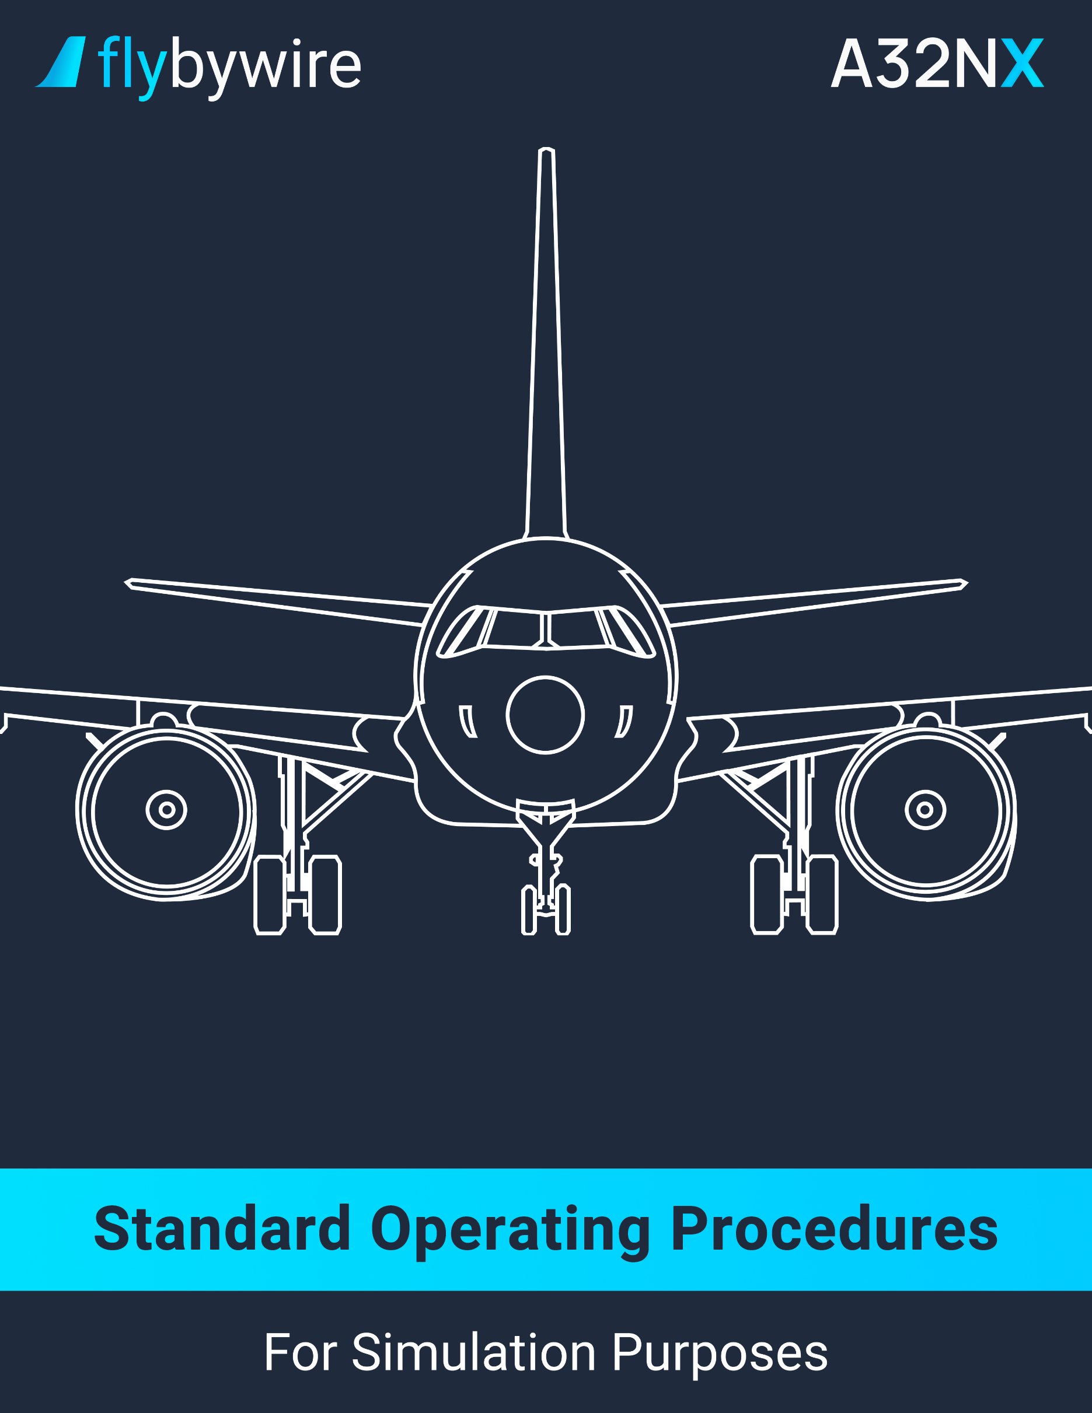

Table of Contents

PRELIMINARY COCKPIT PREPARATION. . . . . . . . . . . . . . . . . . . . . . . . . . . . . . . . . . . **3**

EXTERIOR INSPECTION. . . . . . . . . . . . . . . . . . . . . . . . . . . . . . . . . . . . . . . . . . . . . . . .**10**

COCKPIT PREPARATION. . . . . . . . . . . . . . . . . . . . . . . . . . . . . . . . . . . . . . . . . . . . . . . **16**

BEFORE PUSHBACK OR START. . . . . . . . . . . . . . . . . . . . . . . . . . . . . . . . . . . . . . . . . **25**

ENGINE START. . . . . . . . . . . . . . . . . . . . . . . . . . . . . . . . . . . . . . . . . . . . . . . . . . . . . . . **29**

AFTER START. . . . . . . . . . . . . . . . . . . . . . . . . . . . . . . . . . . . . . . . . . . . . . . . . . . . . . . . **31**

TAXI. . . . . . . . . . . . . . . . . . . . . . . . . . . . . . . . . . . . . . . . . . . . . . . . . . . . . . . . . . . . . . . . . **34**

BEFORE TAKEOFF. . . . . . . . . . . . . . . . . . . . . . . . . . . . . . . . . . . . . . . . . . . . . . . . . . . . **38**

TAKEOFF. . . . . . . . . . . . . . . . . . . . . . . . . . . . . . . . . . . . . . . . . . . . . . . . . . . . . . . . . . . . **40**

AFTER TAKEOFF. . . . . . . . . . . . . . . . . . . . . . . . . . . . . . . . . . . . . . . . . . . . . . . . . . . . . . **44**

CLIMB. . . . . . . . . . . . . . . . . . . . . . . . . . . . . . . . . . . . . . . . . . . . . . . . . . . . . . . . . . . . . . . **46**

CRUISE. . . . . . . . . . . . . . . . . . . . . . . . . . . . . . . . . . . . . . . . . . . . . . . . . . . . . . . . . . . . . . **49**

DESCENT PREPARATION. . . . . . . . . . . . . . . . . . . . . . . . . . . . . . . . . . . . . . . . . . . . . . . **51**

DESCENT. . . . . . . . . . . . . . . . . . . . . . . . . . . . . . . . . . . . . . . . . . . . . . . . . . . . . . . . . . . . **54**

APPROACH - GENERAL. . . . . . . . . . . . . . . . . . . . . . . . . . . . . . . . . . . . . . . . . . . . . . . . **57**

APPROACH – LOC G/S GUIDANCE. . . . . . . . . . . . . . . . . . . . . . . . . . . . . . . . . . . . . . . **61**

APPROACH – FINAL APP GUIDANCE. . . . . . . . . . . . . . . . . . . . . . . . . . . . . . . . . . . . . **65**

APPROACH – FPA GUIDANCE. . . . . . . . . . . . . . . . . . . . . . . . . . . . . . . . . . . . . . . . . . . **68**

LANDING. . . . . . . . . . . . . . . . . . . . . . . . . . . . . . . . . . . . . . . . . . . . . . . . . . . . . . . . . . . . . **71**

GO AROUND. . . . . . . . . . . . . . . . . . . . . . . . . . . . . . . . . . . . . . . . . . . . . . . . . . . . . . . . . .**75**

AFTER LANDING. . . . . . . . . . . . . . . . . . . . . . . . . . . . . . . . . . . . . . . . . . . . . . . . . . . . . . **77**

PARKING. . . . . . . . . . . . . . . . . . . . . . . . . . . . . . . . . . . . . . . . . . . . . . . . . . . . . . . . . . . . .**79**

SECURING THE AIRCRAFT. . . . . . . . . . . . . . . . . . . . . . . . . . . . . . . . . . . . . . . . . . . . . .**82**

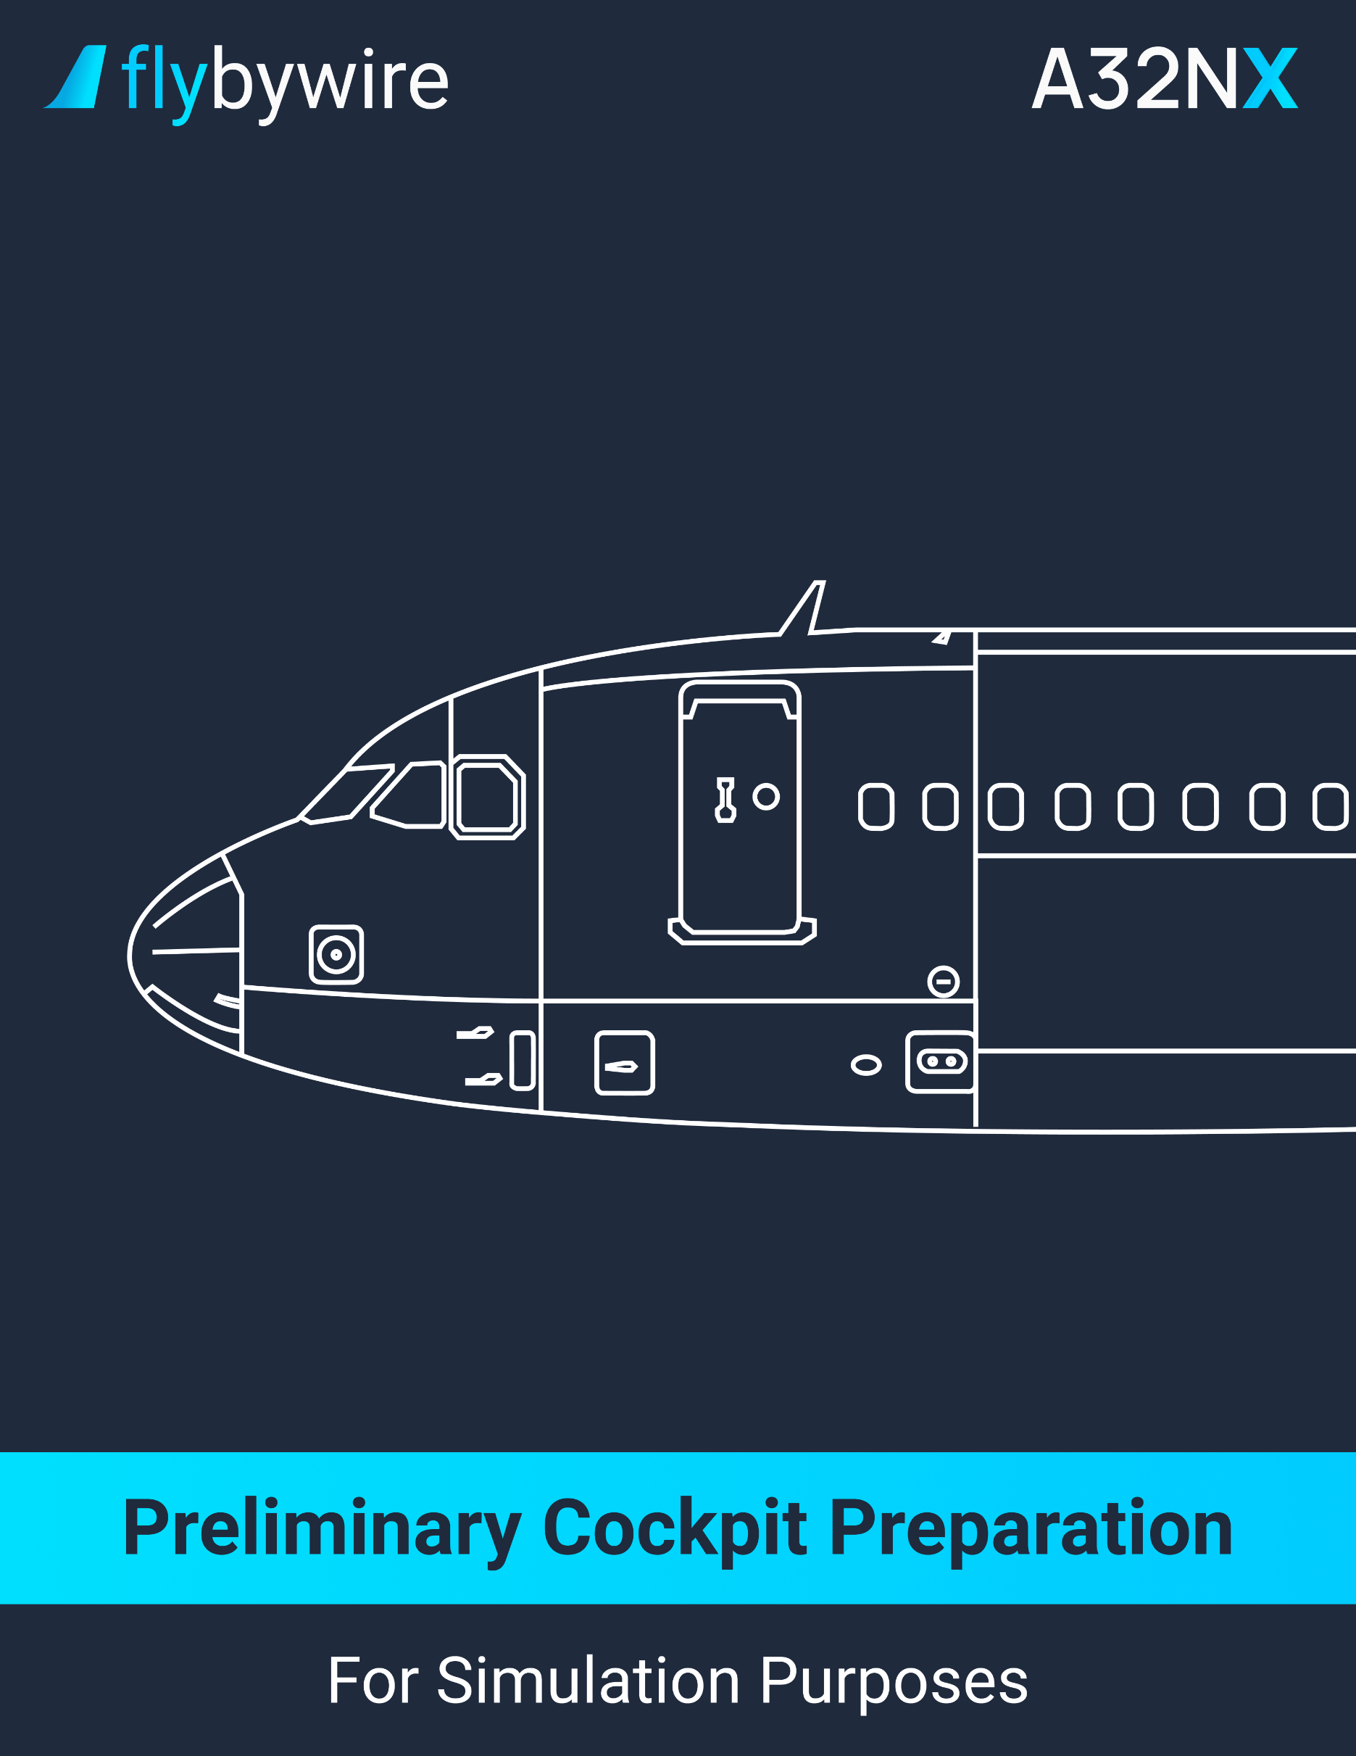

|  |
| --- |
| **Aircraft Setup** |

**Engines**

PM | ENGINE MASTER 1,2 switch . . . . . . . . . . . . . . . . . . . . . . . . . . . . . . . . . . **OFF**

PM | ENGINE MODE selector . . . . . . . . . . . . . . . . . . . . . . . . . . . . . . . . . . . **NORM**

**Weather Radar**

PM | RADAR switch . . . . . . . . . . . . . . . . . . . . . . . . . . . . . . . . . . . . . . . . . . . . . **OFF**

PM | WINDSHEAR / PWS switch . . . . . . . . . . . . . . . . . . . . . . . . . . . . . . . . . . . **OFF**

PM | GAIN knob . . . . . . . . . . . . . . . . . . . . . . . . . . . . . . . . . . . . . . . . . . **AUTO/CAL**

PM | MODE selector . . . . . . . . . . . . . . . . . . . . . . . . . . . . . . . . . . . . **AS REQUIRED**

**Landing Gear**

PM | LANDING GEAR lever . . . . . . . . . . . . . . . . . . . . . **VERIFY DOWN POSITION**

**Wipers**

PM | WIPERS selector . . . . . . . . . . . . . . . . . . . . . . . . . . . . . . . . . . . . . . . . . . . **OFF**

|  |
| --- |
| **Battery Verification** |

* **If the aircraft hasn’t been electrically supplied for 6 hours or more**

PM | BATTERY 1 AND 2 pushbuttons . . . . . . . . . . . . . . . . . . . . . . . . **VERIFY OFF**

PM | BATTERY 1 AND 2 voltages . . . . . . . . . . . . . . . . . . .**VERIFY ABOVE 25.5 V**

The battery voltage should be above 25.5 volts.

* **If battery voltage is below 25.5 Volt :**

PM | BATTERY 1 AND 2 pushbuttons . . . . . . . . . . . . . . . . . . . **AUTO**

PM | EXTERNAL POWER pushbutton . . . . . . . . . . . . . . . . . . . . . **ON**

Verify on the ECAM ELEC PAGE that the battery contactor is closed, and the battery is charging.

* **After 20 minutes :**

PM | BATTERY 1 AND 2 pushbuttons . . . . . . . . . . . . . . . **OFF**

PM | BATTERY 1 AND 2 voltages . . **VERIFY ABOVE 25.5 V**

PM | BATTERY 1 AND 2 pushbuttons . . . . . . . . . . . . . **AUTO**

* **If battery voltage is above 25.5 Volt:**

PM | BATTERY 1 AND 2 pushbuttons . . . . . . . . . . . . . . . . . . . **AUTO**

If the flight crew decides to start the APU using the batteries only, it is recommended to start the APU 30 minutes within the selection of the batteries to AUTO.

* **If the aircraft has been electrically supplied during the last 6 hours**

PM | BATTERY 1 AND 2 pushbuttons . . . . . . . . . . . . . . . . . . . . . . . . . . . . . . **AUTO**

PM | EXTERNAL POWER pushbuttons . . . . . . . . . . . . . . . . . . . . . . . . . . . . . . . **ON**

|  |
| --- |
| **APU Fire test / APU Start** |

**APU Fire Test**

PM | APU FIRE pushbutton . . . . . . . . . . . . . . . . . . . . . . . . . . . **IN AND GUARDED**

PM | AGENT lights . . . . . . . . . . . . . . . . . . . . . . . . . . . . . . . . . . . . . . . **VERIFY OFF**

PM | APU FIRE TEST Pushbutton . . . . . . . . . . . . . . . . . . . . . . . . . . . . . . . **PRESS**

Verify that the APU Fire warning is displayed on the ECAM, the APU Fire pushbutton is illuminates in red, the SQUIB and DISCH lights are on, the master warning light is on, and there is an audible continuous repetitive chime.

**APU Start**

* **If external power AVAIL light is on:**

PM | APU MASTER pushbutton . . . . . . . . . . . . . . . . . . . . . . . . . . . . . . . . . **PRESS**

PM | APU START pushbutton . . . . . . . . . . . . . . . . . . . . . . . . . . . . . . . . . . . . . . **ON**

It is recommended to wait 3 seconds before pressing the APU START pushbutton.

PM | EXTERNAL POWER pushbutton . . . . . . . . . . . . . . . . . . . . . . **AS REQUIRED**

It is recommended to keep the external power ON to reduce the load on the APU.

* **If external power AVAIL light is out:**

PM | APU MASTER pushbutton . . . . . . . . . . . . . . . . . . . . . . . . . . . . . . . . . . . . . **ON**

PM | APU START pushbutton . . . . . . . . . . . . . . . . . . . . . . . . . . . . . . . . . . . . . . **ON**

It is recommended to wait 3 seconds before pressing the APU START pushbutton.

|  |
| --- |
| **Air Conditioning** |

**Air Conditioning**

* **When the APU is available:**

PM | APU BLEED pushbutton. . . . . . . . . . . . . . . . . . . . . . . . . . . . . . . . . . . . . . . **ON**

The flight crew should ensure that there is no low-pressure or high-pressure ground air unit connected to the aircraft. In case of a connection to a lp or hp ground air unit, do not use the APU bleed.

|  |
| --- |
| **Cargo Heat** |

**Cargo Heat**

PM | TEMPERATURE selector. . . . . . . . . . . . . . . . . . . . . . . . . . . . **AS REQUIRED**

|  |
| --- |
| **Cockpit Lightning** |

**Cockpit Lights**

PM | COCKPIT LIGHTS . . . . . . . . . . . . . . . . . . . . . . . . . . . . . . . . . **AS REQUIRED**

Set the integral light, standby compass light, dome light, floodlight switches as required. It is recommended to set the dome light to ON, due to it being the only light source in the EMER ELEC configuration. It is also recommended to set the dome light to the OFF position for takeoff.

|  |
| --- |
| **EFB / ACARS Initialization** |

**EFB Start**

PM | EFB. . . . . . . . . . . . . . . . . . . . . . . . . . . . . . . . . . . . . . . . . . . . . . . . . . . . **START**

**ACARS Initialization**

PF | ACARS. . . . . . . . . . . . . . . . . . . . . . . . . . . . . . . . . . . . . . . . . . . . . . **INITIALIZE**

**FMGS Pre-initialization**

PF | ENGINE & AIRCRAFT TYPE. . . . . . . . . . . . . . . . . . . . . . . . . . . . . . . . **VERIFY**

PF | FM DATABASE VALIDITY. . . . . . . . . . . . . . . . . . . . . . . . . . . . . . . . . . **VERIFY**

Verify the database validity and stored waypoints, navaids, runway, and routes, if any.

PF | FLIGHT NUMBER. . . . . . . . . . . . . . . . . . . . . . . . . . . . . . . . **INSERT / VERIFY**

It is recommended to not insert the flight number if the flight plan is received by ACARS.

PF | FROM/TO. . . . . . . . . . . . . . . . . . . . . . . . . . . . . . . . . . . . . . . **INSERT / VERIFY**

It is recommended to not insert the FROM/TO if the flight plan is received by ACARS.

|  |
| --- |
| **ECAM / Logbook Verification** |

CM1 | RCL pushbutton. . . . . . . . . . . . . . . . . . . . . . . . . . . . . . . . . **PRESS FOR 3 SECONDS**

This action will recall all the warnings that the flight crew cleared or cancelled during the last flight.

CM | LOGBOOK. . . . . . . . . . . . . . . . . . . . . . . . . . . . . . . . . . . . . . . . . . . . . . . . . . **VERIFY**

CM | MEL/CDL ITEMS. . . . . . . . . . . . . . . . . . . . . . . . . . **VERIFY DISPATCH CONDITION**

CM1 | AIRCRAFT ACCEPTANCE. . . . . . . . . . . . . . . . . . . . . . . . . . . . . . . . . . . **PERFORM**

|  |
| --- |
| **Preliminary Performance Determination** |

CM | AIRFIELD DATA. . . . . . . . . . . . . . . . . . . . . . . . . . . . . . . . . . . . . . . . . . . . . . **OBTAIN**

The airfield data should include the following information: the runway in use, the altimeter settings, and the weather data.

* **If the loadsheet application is used:**

CM | PRELIMINARY LOADING. . . . . . . . . . . . . **COMPUTE AND CROSSCHECK**

* **If dispatch under MEL and in accordance with the logbook:**

CM | MEL/CDL ITEMS. . . . . . . . . . . . . . . . . . . . . . . . . . . . . . **VERIFY ACTIVATED**

CM | PRELIMINARY TAKEOFF DATA. . . . . . . . . . . . . . . . . . . . . . . . . . . . . . . **COMPUTE**

CM | PRELIMINARY TAKEOFF DATA. . . . . . . . . . . . . . . . . . . . . . . . . . . **CROSSCHECK**

The flight crew should compare both preliminary takeoff data results and ensure that the computations are the same.

|  |
| --- |
| **Operation Engineering Bulletins** |

CM | OEB. . . . . . . . . . . . . . . . . . . . . . . . . . . . . . . . . . . . . . . . . . . . . . . . . . . . . . . . **VERIFY**

|  |
| --- |
| **Before Walkaround** |

**ECAM pages**

* **On the DOOR system display page:**

PM | OXYGEN . . . . . . . . . . . . . . . . . . . . . . . . . . . . . . . . . . . . **VERIFY PRESSURE**

* + **If the oxygen pressure is half boxed in amber:**

PM | MIN FLT CREW OXY CHART. . . . . . . . . . . . . . . **VERIFY PRESSURE**

* **On the HYD system display page:**

PM | RESERVOIR FLUID LEVEL. . . . . . . . . . **VERIFY WITHIN NORMAL RANGE**

The volume of the hydraulic fluid level in the reservoirs may be altered due to the outside air pressure. It is recommended to verify with the maintenance crew to validate the issue and resolve the situation.

* **On the ENG system display page:**

PM | ENGINE OIL QUANTITY. . . . . . . . . . . . **VERIFY WITHIN NORMAL RANGE**

If there is no indication of the engine oil quantity on the engine system display page, push the ENG 1 and 2 FADEC GND PWR to the ON position. The indication will then appear. After verification, set the ENG 1 and 2 FADEC GND PWR to the OFF position. The oil quantity should indicate at or above 8.9 qt + estimated consumption and not below 10.6 qt. The estimated consumption is 0.45 qt/h.

**Flight Controls**

PM | FLAPS lever . . . . . . . . . . . . . . . . . . . . . . . . . . . . . . . . . . . **VERIFY POSITION**

Ensure that the upper ECAM displays the same position as the flap lever position.

PM | SPEEDBRAKES lever. . . . . . . . . . . . **VERIFY RETRACED AND DISARMED**

**Parking Brake**

PM | ACCU PRESS indicator. . . . . . . . . . . . . . . . . . . . . . . . . . . . . . . . . . . . **VERIFY**

The ACCU PRESS indicator should indicate within the green band. If it is not in the green band, the flight crew may turn the electric pump on the yellow hydraulic system to recharge the brake accumulator.

PM | PARKING BRAKE handle. . . . . . . . . . . . . . . . . . . . . . . . . . . . . . . . . . . . . . **ON**

It is recommended to avoid applying the parking brake when one or multiple brake temperature is above 500°C.

PM | BRAKE PRESS indicator. . . . . . . . . . . . . . . . . . . . . . . . . . . . . . . . . . . **VERIFY**

**Alternate Braking System**

PM | Y ELECTRIC PUMP pushbutton . . . . . . . . . . . . . . . . . . . . . . . . **VERIFY OFF**

PM | CHOCKS . . . . . . . . . . . . . . . . . . . . . . . . . . . . . . . . . . . . . . **VERIFY IN PLACE**

PM | PARKING BRAKE handle . . . . . . . . . . . . . . . . . . . . . . . . . . . . . . . . . . . . **OFF**

PM | BRAKE Pedals . . . . . . . . . . . . . . . . . . . . . . . **PRESS MAXIMUM PRESSURE**

PM | BRAKE PRESSURE. . . . . . . . . . . . . . . . . . . . . . . . . . . . . . . . . . . . . . **VERIFY**

The flight crew should ensure that the pressure builds up symmetrically without delay. With full pedal deflection, the pressure must be within 2000 and 2700 psi.

PM | BRAKE Pedals . . . . . . . . . . . . . . . . . . . . . . . . . . . . . . . . . . . . . . . . **RELEASE**

PM | PARKING BRAKE handle . . . . . . . . . . . . . . . . . . . . . . . . . . . . . . . . . . . . . **ON**

The parking brake must be set for the exterior inspection. This allows the flight crew to verify the brake wear indicators.

**Emergency Equipment**

PM |EMERGENCY EQUIPMENT. . . . . . . . . . . . . . . . . . . . . . **VERIFY ONBOARD**

Ensure that the following emergency equipment is found onboard the aircraft: life jackets, axe, smoke hoods or portable oxygen equipment and full-face masks, portable fire extinguisher, smoke googles, oxygen masks, flashlights, and escape ropes.

**Rain Repellent**

**PM |** RAIN RPLNT indicators. . . . . . . . . . . **VERIFY PRESSURE AND QUANTITY**

It is not recommended to use rain repellent to wash the windshield. It is also not recommended to use it on a dry windshield.

**Circuit Breakers Panels**

PM | REAR AND OVERHEAD CIRCUIT BREAKER panels. . . . . . . . . . . . **VERIFY**

Ensure that all the breakers are set. Flight crew may reset as necessary.

**Landing gear pins and covers**

PM | GEAR PINS AND COVERS. . . . . . . . . . **VERIFY ONBOARD AND STOWED**

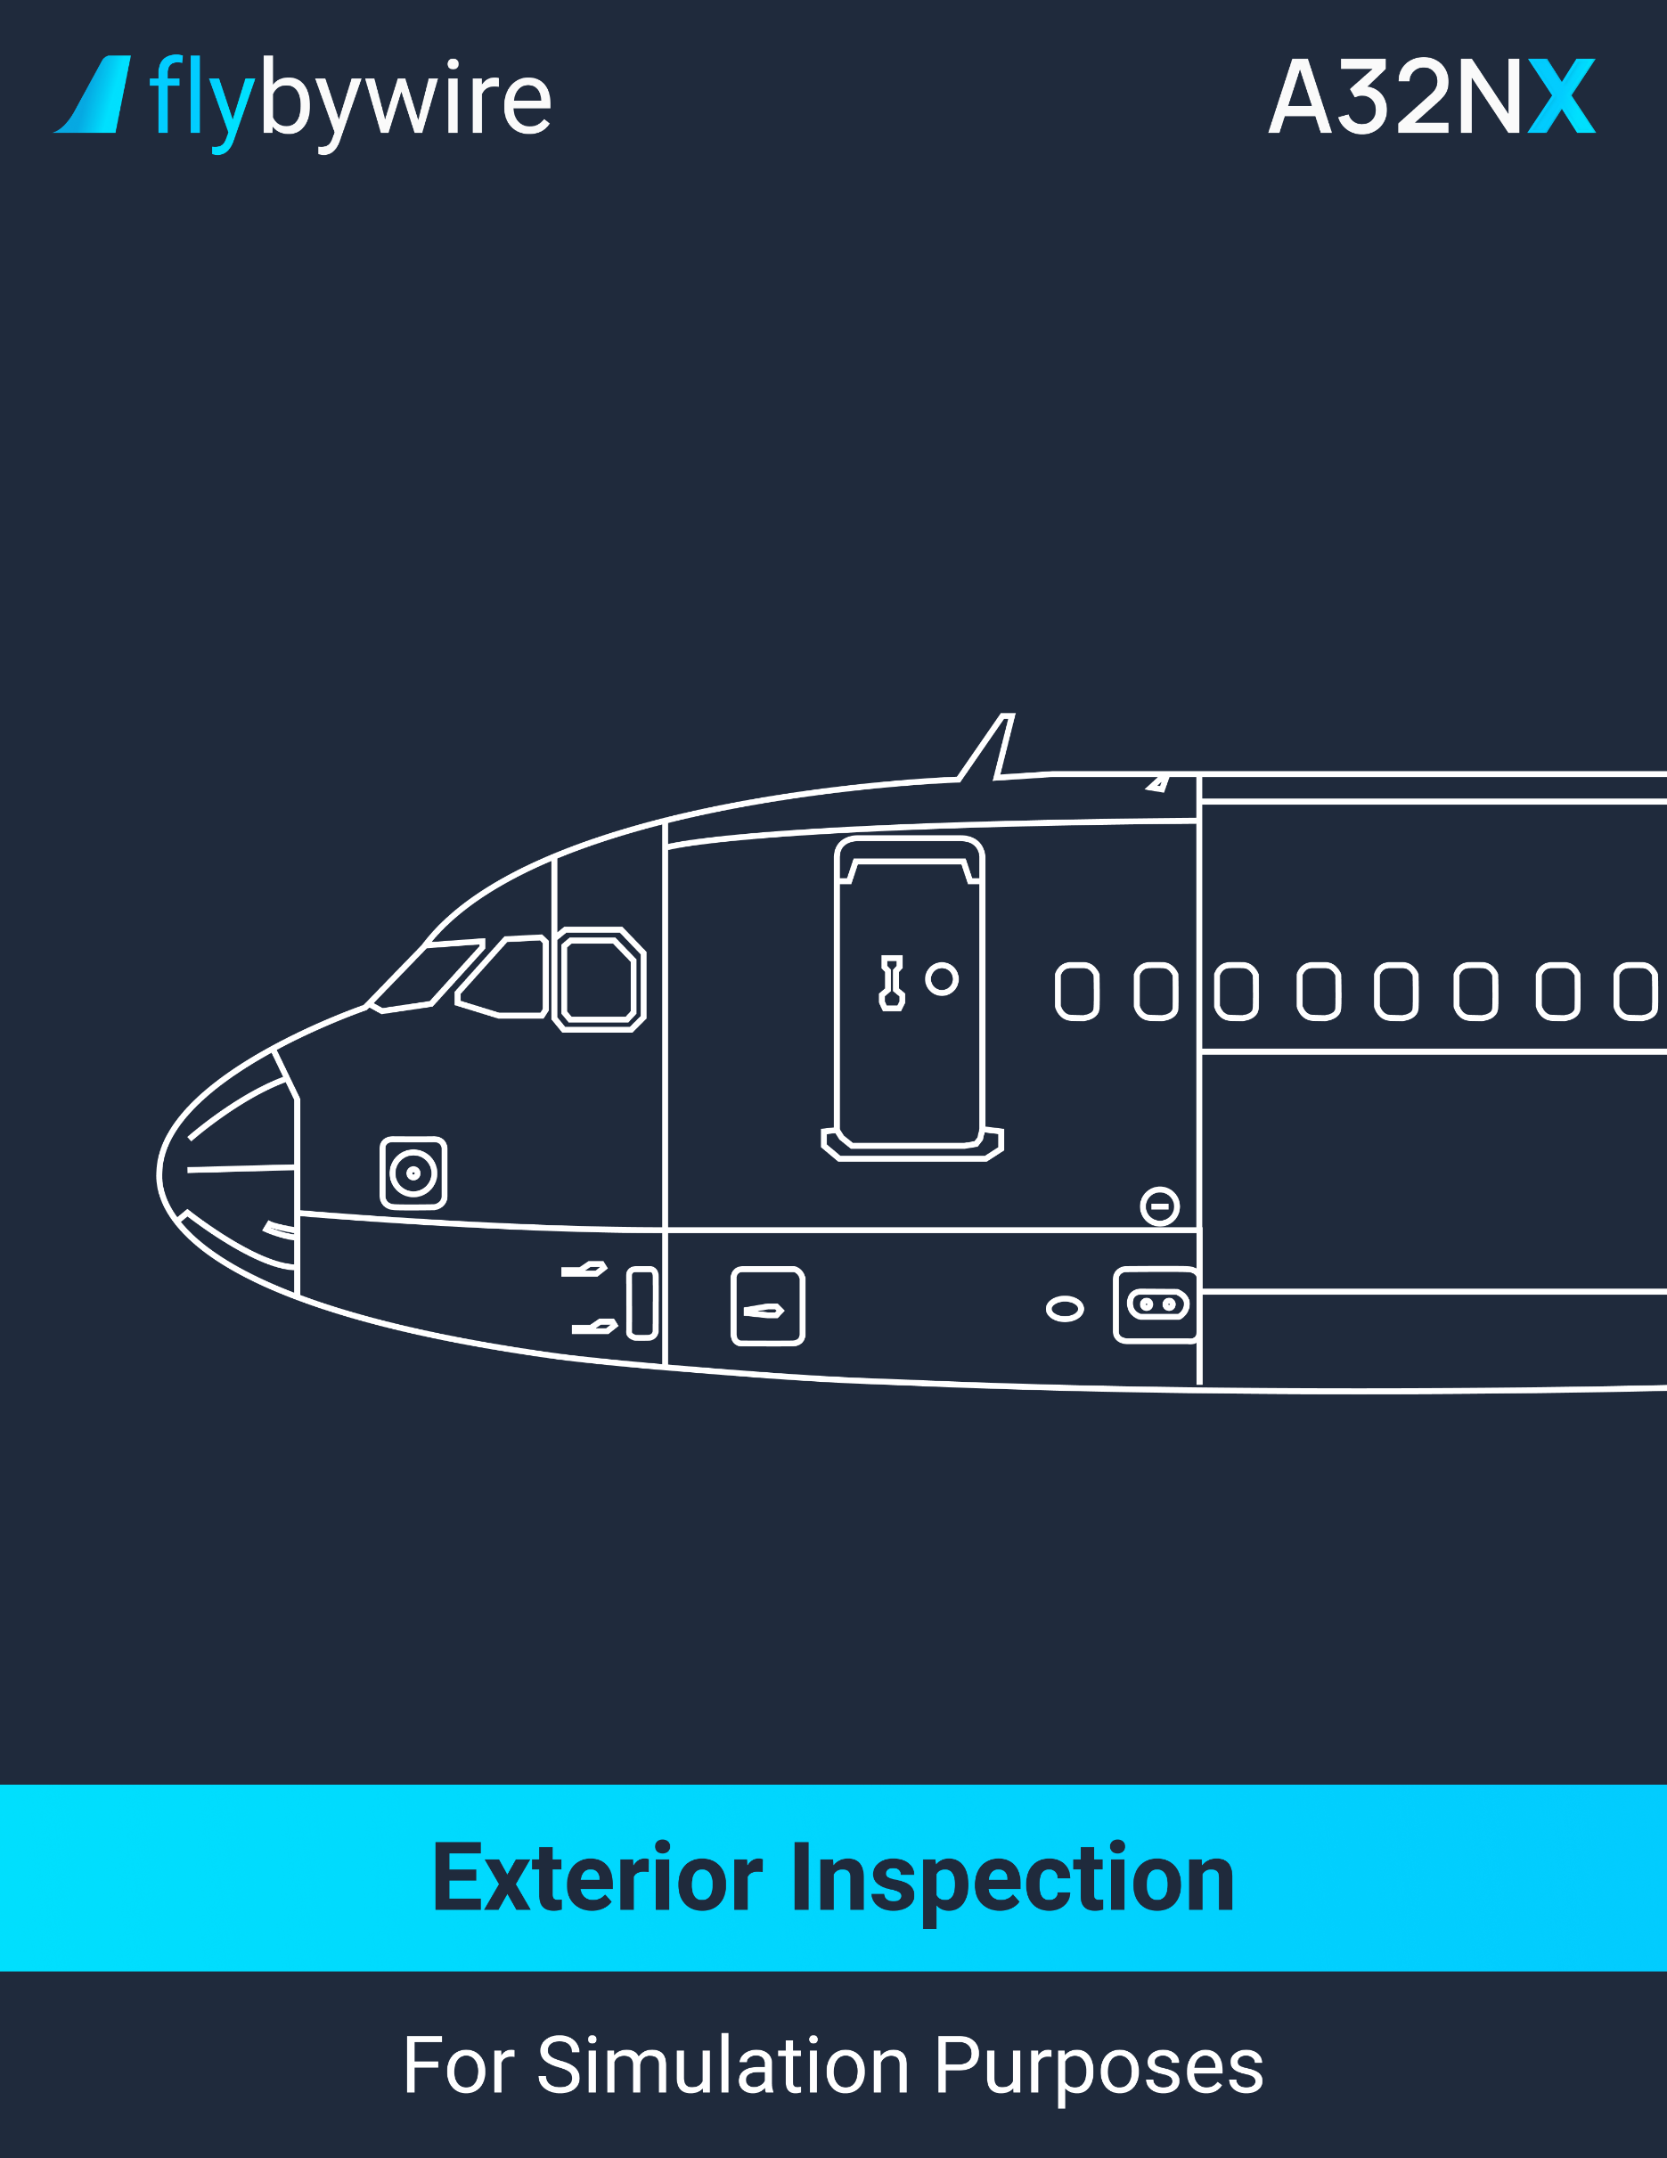

# **Left Forward Fuselage**

PM | AOA probes . . . . . . . . . . . . . . . . . . . . . . . . . . . . . . . . . . **VERIFY CONDITION**

PM | F/O AND CAPT static ports. . . . . . . . . . . . . . . . . . . . . . . . . . **VERIFY CLEAR**

PM | AVIONICS EQUIPMENT VENT AIR INLET VALVE . . . **VERIFY CONDITION**

PM | OXYGEN BAY. . . . . . . . . . . . . . . . . . . . . . . . . . . . . . . . . . . . . . . . . . **CLOSED**

PM | OXYGEN OVERBOARD DISCHARGE indicators . . . . . . . . . . . . . . . **GREEN**

PM | TOILET SERVICING DOOR . . . . . . . . . . . . . . . . . . . . . . . . . . . . . . **CLOSED**

**Nose section**

PM | PITOT probes . . . . . . . . . . . . . . . . . . . . . . . . . . . . . . . . **VERIFY CONDITION**

PM | STANDBY static ports . . . . . . . . . . . . . . . . . . . . . . . . . . . . . . . . . . . . . **CLEAR**

PM | TOTAL AIR TEMPERATURE probes . . . . . . . . . . . . . . **VERIFY CONDITION**

PM | RADOME AND LATCHES . . . . . . . . . . . . . **VERIFY CONDITION /LATCHED**

PM | FORWARD AVIONICS COMPARTMENT door . . . . . . . . . . . . . . . . **CLOSED**

PM | GROUND ELECTRICAL POWER DOOR (If not required) . . . . . . . **CLOSED**

**Nose Landing Gear**

PM | NOSE WHEEL CHOCKS . . . . . . . . . . . . . . . . . . . . . . . . . . . . . . . . **IN PLACE**

PM | WHEEL AND TIRES . . . . . . . . . . . . . . . . . . . . . . . . . . . **VERIFY CONDITION**

PM | NOSE GEAR STRUCTURE . . . . . . . . . . . . . . . . . . . . . **VERIFY CONDITION**

PM | TAXI, TO, TURN-OFF lights. . . . . . . . . . . . . . . . . . . . . . **VERIFY CONDITION**

PM | HYDRAULIC LINES AND ELECTRICAL WIRES . . . . . **VERIFY CONDITION**

PM | WHEEL WELL . . . . . . . . . . . . . . . . . . . . . . . . . . . . . . . . . . . . . . . . . . **VERIFY**

PM | SAFETY PIN . . . . . . . . . . . . . . . . . . . . . . . . . . . . . . . . . . . . . . . . . . **REMOVE**

**Right Forward Fuselage**

PM | RH + AFT AVIONICS COMPARTMENT doors . . . . . . . . . . . . . . . . **CLOSED**

PM | AVIONICS EQUIPMENT VENT AIR OUTLET VALVE . **VERIFY CONDITION**

PM | F/O AND CAPT static ports . . . . . . . . . . . . . . . . . . . . . . . . . . . . . . . . . **CLEAR**

PM | AOA probe . . . . . . . . . . . . . . . . . . . . . . . . . . . . . . . . . . . **VERIFY CONDITION**

PM | FWD CARGO DOOR AND SELECTOR PANEL . . . . . . . . . . . . . . . . **VERIFY**

**Lower Center Fuselage**

PM | POTABLE WATER DRAIN panel . . . . . . . . . . . . . . . . . . . . . . . . . . . **CLOSED**

PM | ANTENNAS . . . . . . . . . . . . . . . . . . . . . . . . . . . . . . . . . . **VERIFY CONDITION**

PM | DRAIN MAST . . . . . . . . . . . . . . . . . . . . . . . . . . . . . . . . **VERIFY CONDITION**

PM | EMERGENCY RAM AIR INLET FLAP . . . . . . . . . . . . . **VERIFY CONDITION**

PM | LP AND HP GROUND CONNECTION doors . . . . . . . . . . . . . . . . . **CLOSED**

PM | ANTICOLLISION light . . . . . . . . . . . . . . . . . . . . . . . . . . . . . . . . . . . . . **VERIFY**

PM | CENTER TANK MAGNETIC fuel level . . . . . . . . . . . . . . . . . . . . . . . . **FLUSH**

PM | PACK AIR INTAKES AND OUTLETS . . . . . . . . . . . . . . . . . . . . . . . . . **CLEAR**

**Right Center Wing**

PM | YELLOW HYDRAULIC BAY door . . . . . . . . . . . . . . . . . . . . . . . . . . **CLOSED**

PM | FUEL panel. . . . . . . . . . . . . . . . . . . . . . . . . . . . . . . . . . . . . . . . . . . . **CLOSED**

PM | INNER TANK MAGNETIC FUEL LEVEL . . . . . . . . . . . . . . . . . . . . . . **FLUSH**

PM | FUEL WATER DRAIN VALVE INNER TANK . . . . . . . . . . . . . . . . . **NO LEAK**

PM | LANDING lights . . . . . . . . . . . . . . . . . . . . . . . . . . . . . . . **VERIFY CONDITION**

PM | SLAT 1 . . . . . . . . . . . . . . . . . . . . . . . . . . . . . . . . . . . . . **VERIFY CONDITION**

**Engine 2 Left Side**

PM | OIL FILL ACCESS DOOR . . . . . . . . . . . . . . . . . . . . . . . . . . . . . . . . **CLOSED**

PM | FAN COWL doors . . . . . . . . . . . . . . . . . . . . . . . . . . . . . **CLOSED/LATCHED**

PM | DRAIN MAST . . . . . . . . . . . . . . . . . . . . . . . . **VERIFY CONDITION/NO LEAK**

PM | ENGINE INLET AND FAN BLADES. . . . . . . . . . . . . . . . . . . . . . . . . . **VERIFY**

**Engine 2 Right Side**

PM | PRESSURE RELIEF/START VALVE HANDLE ACCESS DOOR . . **CLOSED**

PM | PYLON ACCESS PANEL. . . . . . . . . . . . . . . . **VERIFY CONDITION/CLOSED**

**Right Wing Leading Edge**

PM | SLAT 2, 3, 4. 5 . . . . . . . . . . . . . . . . . . . . . . . . . . . . . . . . **VERIFY CONDITION**

PM | INNER AND OUTER CELLS MAGNETIC FUEL LEVEL . . . . . . . . . . . **FLUSH**

PM | FUEL WATER DRAIN VALVES (outer cell, surge tank) . . . . . . . . . **NO LEAK**

PM | REFUEL COUPLING . . . . . . . . . . . . . . . . . . . . . . . . . . . . . . . . . . . . **CLOSED**

PM | SURGE TANK AIR INLET . . . . . . . . . . . . . . . . . . . . . . . . . . . . . . . . . . **CLEAR**

PM | FUEL VENTILATION OVERPRESSURE DISC . . . . . . . . . . . . . . . . . **INTACT**

PM | NAVIGATION light . . . . . . . . . . . . . . . . . . . . . . . . . . . . . **VERIFY CONDITION**

PM | WING TIP . . . . . . . . . . . . . . . . . . . . . . . . . . . . . . . . . . . **VERIFY CONDITION**

**Right Wing Trailing Edge**

PM | STATIC DISCHARGERS . . . . . . . . . . . . . . . . . . . . . . . . . . . . . . . . . . **VERIFY**

PM | CONTROL SURFACES . . . . . . . . . . . . . . . . . . . . . . . . **VERIFY CONDITION**

PM | FLAPS AND FAIRING. . . . . . . . . . . . . . . . . . . . . . . . . . **VERIFY CONDITION**

**Right Landing Gear and Fuselage**

PM | CHOCKS . . . . . . . . . . . . . . . . . . . . . . . . . . . . . . . . . . . . . . . . . . . . **REMOVED**

PM | WHEEL AND TIRES . . . . . . . . . . . . . . . . . . . . . . . . . . . **VERIFY CONDITION**

PM | BRAKES AND WEAR INDICATION . . . . . . . . . . . . . . . **VERIFY CONDITION**

PM | TORQUE LINK DAMPER . . . . . . . . . . . . . . . . . . . . . . . **VERIFY CONDITION**

PM | HYDRAULIC lines . . . . . . . . . . . . . . . . . . . . . . . . . . . . . . . . . . . . . . . **VERIFY**

PM | LANDING GEAR STRUCTURE . . . . . . . . . . . . . . . . . . . . . . . . . . . . . **VERIFY**

PM | DOWNLOCK SPRINGS . . . . . . . . . . . . . . . . . . . . . . . . . . . . . . . . . . . **VERIFY**

PM | SAFETY PIN . . . . . . . . . . . . . . . . . . . . . . . . . . . . . . . . . . . . . . . . . **REMOVED**

PM | GROUND HYDRAULIC CONNECTION YELLOW. . . . . . . . . . . . . . **CLOSED**

PM | WATER DRAIN MAST . . . . . . . . . . . . . . . . . . . . . . . . . **VERIFY CONDITION**

PM | SHROUD FUEL DRAIN . . . . . . . . . . . . . . . . . . . . . . . . **VERIFY CONDITION**

**Right Aft fuselage**

PM | CARGO DOOR AND SELECTOR PANEL . . . . . . . . . . . . . . . . . . . . . **VERIFY**

PM | BULK door . . . . . . . . . . . . . . . . . . . . . . . . . . . . . . . . . . . . . . . . . . . . . **VERIFY**

PM | TOILET SERVICE ACCESS DOOR . . . . . . . . . . . . . . . . . . . . . . . . . **CLOSED**

PM | OUTFLOW VALVE. . . . . . . . . . . . . . . . . . . . . . . . . . . . . **VERIFY CONDITION**

PM | DRAIN . . . . . . . . . . . . . . . . . . . . . . . . . . . . . . . . . . . . . . **VERIFY CONDITION**

PM | FLIGHT RECORDER ACCESS DOOR . . . . . . . . . . . . . . . . . . . . . . **CLOSED**

**Tail**

PM | STABILIZER, ELEVATORS, FIN AND . . . . . . . . . . . . . **VERIFY CONDITION**

PM | STATIC DISCHARGERS. . . . . . . . . . . . . . . . . . . . . . . . . . . . . . . . . . **VERIFY**

PM | LOWER FUSELAGE STRUCTURE. . . . . . . . . . . . . . . . **VERIFY CONDITION**

**APU**

PM | APU ACCESS DOORS. . . . . . . . . . . . . . . . . . . . . . . . . . . . . . . . . . . **CLOSED**

PM | AIR INTAKE . . . . . . . . . . . . . . . . . . . . . . . . . . . . . . . . . **VERIFY CONDITION**

PM | DRAIN. . . . . . . . . . . . . . . . . . . . . . . . . . . . . . **VERIFY CONDITION /NO LEAK**

PM | OIL COOLER AIR OUTLET . . . . . . . . . . . . . . . . . . . . . . . . . . . . . . . . **CLEAR**

PM | EXHAUST . . . . . . . . . . . . . . . . . . . . . . . . . . . . . . . . . . . . . . . . . . . . . . **CLEAR**

PM | NAVIGATION light . . . . . . . . . . . . . . . . . . . . . . . . . . . . . **VERIFY CONDITION**

PM | FIRE EXTINGUISHER OVERPRESSURE INDICATION. . . . . . . . **IN PLACE**

**Left Aft Fuselage**

PM | STABILIZER, ELEVATOR, FIN, AND RUDDER . . . . . . **VERIFY CONDITION**

PM | POTABLE WATER SERVICE DOOR. . . . . . . . . . . . . . . . . . . . . . . . **CLOSED**

PM | GROUND HYDRAULIC CONNECTION BLUE AND GREEN DOORS . . . . . . . . . . . . . . . . . . . . . . . . . . . . . . . . . . . . . . . . . . . . . . . . . . . . . . . . . . . . . . . **CLOSED**

PM | HYDRAULIC RESERVOIR FILLING . . . . . . . . . . . . . . . . . . . . . . . . **CLOSED**

**Left Landing Gear**

PM | CHOCKS. . . . . . . . . . . . . . . . . . . . . . . . . . . . . . . . . . . . . . . . . . . . **REMOVED**

PM | WHEEL AND TIRES . . . . . . . . . . . . . . . . . . . . . . . . . . **VERIFY CONDITION**

PM | BRAKES AND BRAKE WEAR indicator . . . . . . . . . . . . **VERIFY CONDITION**

PM | TORQUE LINK. . . . . . . . . . . . . . . . . . . . . . . . . . . . . . . . **VERIFY CONDITION**

PM | HYDRAULIC lines . . . . . . . . . . . . . . . . . . . . . . . . . . . . . . . . . . . . . . . **VERIFY**

PM | LANDING GEAR STRUCTURE . . . . . . . . . . . . . . . . . . . . . . . . . . . . . **VERIFY**

PM | DOWNLOCK SPRINGS . . . . . . . . . . . . . . . . . . . . . . . . . . . . . . . . . . . **VERIFY**

PM | SAFETY PIN . . . . . . . . . . . . . . . . . . . . . . . . . . . . . . . . . . . . . . . . . **REMOVED**

**Left Wing Trailing Edge**

PM | FLAPS AND FAIRING. . . . . . . . . . . . . . . . . . . . . . . . . . **VERIFY CONDITION**

PM | STATIC DISCHARGERS . . . . . . . . . . . . . . . . . . . . . . . . . . . . . . . . . . **VERIFY**

PM | CONTROL SURFACES . . . . . . . . . . . . . . . . . . . . . . . . . **VERIFY CONDITION**

PM | STATIC DISCHARGERS . . . . . . . . . . . . . . . . . . . . . . . . . . . . . . . . . . **VERIFY**

**Left Wing Leading Edge**

PM | WING TIP . . . . . . . . . . . . . . . . . . . . . . . . . . . . . . . . . . . **VERIFY CONDITION**

PM | NAVIGATION light . . . . . . . . . . . . . . . . . . . . . . . . . . . . . **VERIFY CONDITION**

PM | SURGE TANK AIR INLET . . . . . . . . . . . . . . . . . . . . . . . . . . . . . . . . . . **CLEAR**

PM | FUEL VENTILATION OVERPRESSURE DISC . . . . . . . . . . . . . . . . . **INTACT**

PM | FUEL WATER DRAIN VALVES (outer cell, surge tank) . . . . . . . . . **NO LEAK**

PM | INNER AND OUTER CELLS MAGNETIC FUEL LEVEL . . . . . . . . . . **FLUSH**

PM | SLAT 2, 3, 4. 5 . . . . . . . . . . . . . . . . . . . . . . . . . . . . . . . **VERIFY CONDITION**

**Engine 1 Left Side**

PM | OIL FILL ACCESS DOOR . . . . . . . . . . . . . . . . . . . . . . . . . . . . . . . . **CLOSED**

PM | FAN COWL doors . . . . . . . . . . . . . . . . . . . . . . . . . . . . . **CLOSED/LATCHED**

PM | DRAIN MAST . . . . . . . . . . . . . . . . . . . . . . . . **VERIFY CONDITION/NO LEAK**

PM | ENGINE INLET AND FAN BLADES. . . . . . . . . . . . . . . . . . . . . . . . . . **VERIFY**

**Engine 1 Right Side**

PM | PRESSURE RELIEF/START VALVE HANDLE ACCESS DOOR . . **CLOSED**

PM | PYLON ACCESS PANEL. . . . . . . . . . . . . . . . **VERIFY CONDITION/CLOSED**

**Left Center Wing**

PM | SLAT 1 . . . . . . . . . . . . . . . . . . . . . . . . . . . . . . . . . . . . . **VERIFY CONDITION**

PM | WING LEADING EDGE VENTILATION INTAKE . . . . . . . . . . . . . . . . **CLEAR**

PM | FUEL WATER DRAIN VALVES. . . . . . . . . . . . . . . . . . . . . . . . . . . . **NO LEAK**

PM | INNER TANK MAGNETIC VALVES . . . . . . . . . . . . . . . . . . . . . . . . . . **FLUSH**

PM | LANDING lights . . . . . . . . . . . . . . . . . . . . . . . . . . . . . . . **VERIFY CONDITION**

PM | HYDRAULIC RESERVOIR pressurization door . . . . . . . . . . . . . . . . **CLOSED**

PM | RAT doors . . . . . . . . . . . . . . . . . . . . . . . . . . . . . . . . . . . . . . . . . . . . **CLOSED**

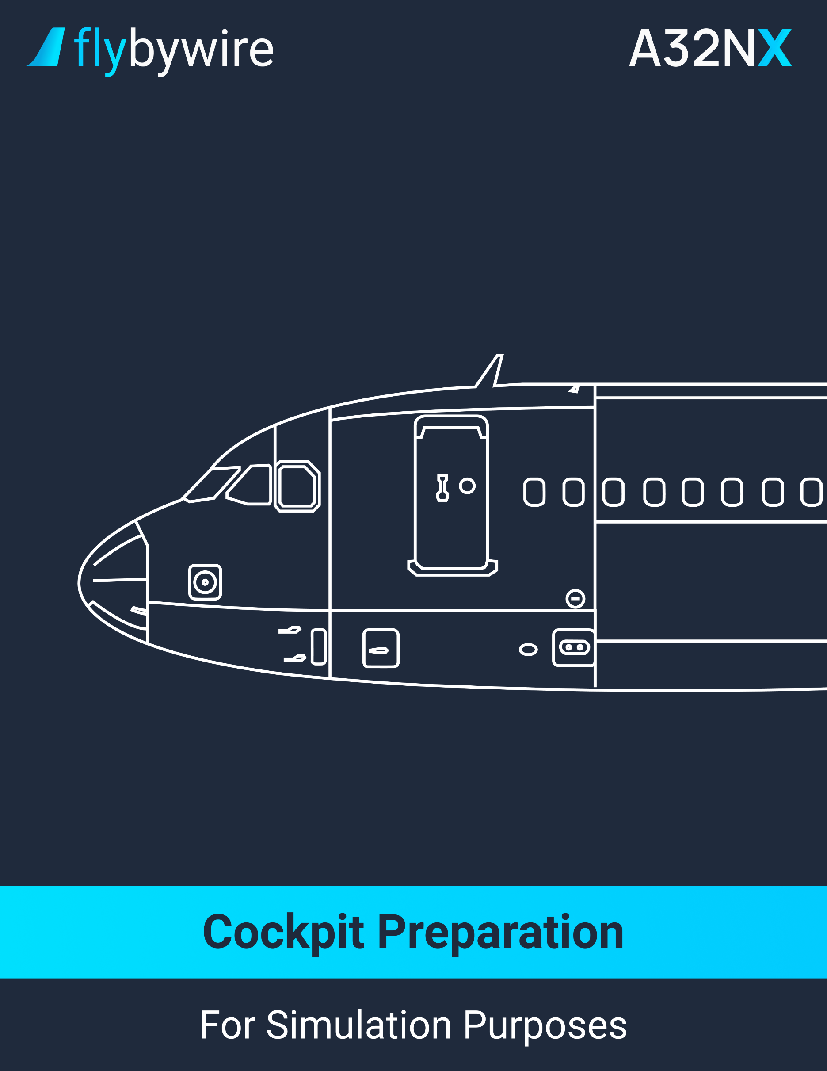

|  |
| --- |
| **Overhead Panel** |

**White lights on the overhead panel**

* **In the passing flow the overhead panel:**

PF | ALL WHITE LIGHTS . . . . . . . . . . . . . . . . . . . . . . . . . . . . . . . . . . . . . . . . . **OFF**

**Recorder**

PF | RCDR GND CTL pushbutton. . . . . . . . . . . . . . . . . . . . . . . . . . . . . . . . . . . . **ON**

PF | LOUDSPEAKER VOLUME knob. . . . . . . . . . . . . . . . . . . **BOTH SIDES – OFF**

PF | ACP INT/RAD switch. . . . . . . . . . . . . . . . . . . . . . . . . . . . . . . . . . . **SET TO INT**

PF | INTERPHONE VOLUME RECEPTION KNOB. . . . . . . . . . . . . . . . **RELEASE**

PF | CVR TEST pushbutton. . . . . . . . . . . . . . . . . . . . . . . **PRESS AND MAINTAIN**

To know the CVR result, the flight crew should hear an audio test signal through the loudspeakers. The audio test signal depends on the CVR model installed on the aircraft. A CVR 30 minutes will emit a continuous tone or a short tone, while the CVR 120 minutes will emit a short tone, or a short tone and a beep at every 4 seconds, or two short tones and a beep every 4 seconds.

**EVAC**

PF | CAPT & PURS/CAPT switch. . . . . . . . . . . . . . . . . . . . . . . . . . **AS REQUIRED**

This depends on the company policy.

**ADIRS**

PF | All IR MODE selectors. . . . . . . . . . . . . . . . . . . . . . . . . . . . . . . . . . . . . . . . **NAV**

It is recommended to align the inertial references as soon as possible. The initialization may take some time. It is also recommended to complete a full alignment if this is the first flight of the day, the flight crew has changed, the GPS is not available to all segments in the flight and the pilot expects long segments with low NAVAID coverage, or if the GPS is not available during a flight with an expected flight time that is over 3 hours. It is recommended to perform a fast alignment for all other flight conditions.

**Exterior lights**

PF | STROBE switch. . . . . . . . . . . . . . . . . . . . . . . . . . . . . . . . . . . . . . . . . . . **AUTO**

PF | BEACON switch. . . . . . . . . . . . . . . . . . . . . . . . . . . . . . . . . . . . . . . . . . . . . **OFF**

PF | NAV & LOGO switch. . . . . . . . . . . . . . . . . . . . . . . . . . . . . . . . **AS REQUIRED**

PF | REMAINING EXTERIOR LIGHTS. . . . . . . . . . . . . . . . . . . . . . **AS REQUIRED**

**Signs**

PF | SEAT BELTS sign . . . . . . . . . . . . . . . . . . . . . . . . . . . . . . . . . . . . . **ON / AUTO**

PF | NO SMOKING sign. . . . . . . . . . . . . . . . . . . . . . . . . . . . . . . . . . . . . . . . . **AUTO**

Leaving the SEAT BELTS sign or NO SMOKING sign prevents the emergency batteries from charging.

PF | EMER EXIT LT selector . . . . . . . . . . . . . . . . . . . . . . . . . . . . . . . . . . . . . . **ARM**

**Probe / Window Heat**

PF | PROBE/WINDOW HEAT pushbuttons. . . . . . . . . . . . . . . . . . . **VERIFY AUTO**

**Cabin Pressure**

PF | LDG ELEV knob. . . . . . . . . . . . . . . . . . . . . . . . . . . . . . . . . . . . . . . . . . . **AUTO**

**Air Conditioning**

PF | PACK FLOW selector . . . . . . . . . . . . . . . . . . . . . . . . . . . . . . . **AS REQUIRED**

It is recommended to set the PACK FLOW to NORM. The flight crew can select LO if the flight has less than 141 passengers. The flight crew can also select HI for abnormally hot and humid conditions.

Note: If the APU is supplying, the pack controllers will select HI flow automatically, no matter what the selector position is.

**Electrical**

PF | ECAM ELEC PAGE. . . . . . . . . . . . . . . . . . . . . . . . . . . . . . . . . . . . . . . **PRESS**

PF | BAT 1 & 2 pushbuttons. . . . . . . . . . . . . . . . . . . . . . . . . . . . . . . **OFF THEN ON**

After 10 seconds, the flight crew should ensure that the battery charge is below 60 A and is decreasing.

**Fuel**

* **If the fuel level in the center tank is less than 200 kg / 440 lbs. for the flight:**

PF | FUEL MODE SEL pushbutton. . . . . . . . . . . . . . . . . . . . . . . . . . . . . . . . . . **MAN**

PF | CTR TK PUMP 1 & 2 pushbuttons. . . . . . . . . . . . . . . . . . . . . . . . . . . . . . . **OFF**

* **If the fuel level in the center tank is not less than 200 kg / 440 lbs. for the flight:**

PF | FUEL MODE SEL pushbutton. . . . . . . . . . . . . . . . . . . . . . . . . . **VERIFY AUTO**

**Engine Fire Tests**

PF | ENG 1 FIRE & ENG 2 FIRE pushbuttons. . . . . . **VERIFY IN AND GUARDED**

PF | AGENT 1 & 2 lights. . . . . . . . . . . . . . . . . . . . . . . . . . . . . . . . . . . **VERIFY OFF**

PF | ENG 1 TEST & ENG 2 TEST. . . . . . . . . . . . . . . . . . **PRESS AND MAINTAIN**

The pilots hold the TEST pushbutton pressed throughout the test. The test result should be the following items:

* + a constant repetitive chime sound;
  + the master warning light flashes on the glareshield;
  + the ECAM displays the engine fire alert messages (ENG 1 FIRE, ENG 2 FIRE);
  + All engine fire pushbutton, the squib light of the engine agent pushbuttons are illuminated;
  + the disch light of the engine unit agent pushbuttom illuminates; and
  + all fire lights on the engine master panel illuminates.

**Audio Switching Panel**

PF | AUDIO SWITCHING selector. . . . . . . . . . . . . . . . . . . . . . . . . . . . . . . . . **NORM**

**Ventilation**

PF | ALL LIGHTS. . . . . . . . . . . . . . . . . . . . . . . . . . . . . . . . . . . . . . . . . **VERIFY OFF**

**ACT Control Panel**

PF | ACT XFR rotary selector. . . . . . . . . . . . . . . . . . . . . . . . . . . . . . . . . . . . . . **OFF**

**Third Occupant Audio Control Panel**

PF | PA knob. . . . . . . . . . . . . . . . . . . . . . . . . . . . . . . . . . . . . . . . . . . . . . . **RECEPT**

It is recommended to set the volume at or above medium range. This allows the cabin announcements to be recorded on the cockpit voice recorder.

**Maintenance Panel**

PF | ALL LIGHTS. . . . . . . . . . . . . . . . . . . . . . . . . . . . . . . . . . . . . . . . . **VERIFY OFF**

|  |
| --- |
| **Center Instrument Panel** |

**Center Instrument Panel – ISIS**

PF | ISIS. . . . . . . . . . . . . . . . . . . . . . . . . . . . . . . . . . . . . . . . . . . . . . . . . . . . **VERIFY**

The flight crew can adjust the brightness, the altimeter readings, and setting, and the attitude display. Ensure that no flags are shown. If necessary, reset the attitude.

Note: The use of the ISIS bugs functions is not recommended.

**Clock**

PF | CLOCK. . . . . . . . . . . . . . . . . . . . . . . . . . . . . . . . . . . . . . . . . . . . **VERIFY / SET**

The flight crew must ensure that the date is correct. If it is not correct, the flight crew can set the date manually and keep the clock mode in the internal mode for the flight.

**Nosewheel Steering**

PF | A/SKID & N/W STRG switch. . . . . . . . . . . . . . . . . . . . . . . . . . . . . . . . . . . . **ON**

|  |
| --- |
| **Pedestal** |

**ACP**

PF | INT knob. . . . . . . . . . . . . . . . . . . . . . . . . . . . **PRESS OUT / VERIFY VOLUME**

PF | VHF. . . . . . . . . . . . . . . . . . . . . . . . . . . . . . . . . . . . . . . . . . . . . . . . . . . **VERIFY**

PF | HF. . . . . . . . . . . . . . . . . . . . . . . . . . . . . . . . . . . . . . . . . . . . . . . . . . . . . **VERIFY**

Verify the transmission and the reception of the VHF and HF. It is prohibited to transmit on HF when the aircraft is refueling.

**Cockpit door**

PF | ANN LT selector. . . . . . . . . . . . . . . . . . . . . . . . . . . . . . . . . . . . . . . . . . . . **TEST**

On the pedestal, ensure that the OPEN, FAULT, and the three LED lights on the overhead panel illuminate.

PF | ANN LT selector. . . . . . . . . . . . . . . . . . . . . . . . . . . . . . . . . . . . . . . . . . . . . **BRT**

Ensure that all lights go off.

PF | CKPT DOOR. . . . . . . . . . . . . . . . . . . . . . . . **VERIFY CORRECT OPERATION**

PF | CKPT DOOR MECHANICAL OVERRIDE. . . . . . . . . . . . . . . . . . . . . . **VERIFY**

**Switching Panel**

PF | ALL SELECTORS. . . . . . . . . . . . . . . . . . . . . . . . . . . . . . . . . . **VERIFY NORM**

**Engine**

PF | THRUST lever. . . . . . . . . . . . . . . . . . . . . . . . . . . . . . . . . . . . . . . . . . . . . . **IDLE**

PF | ENG MASTER switches. . . . . . . . . . . . . . . . . . . . . . . . . . . . . . . . . . . . . . . **OFF**

PF | ENG MODE selector. . . . . . . . . . . . . . . . . . . . . . . . . . . . . . . . . . . . . . . **NORM**

**Parking Brake**

PF | ACCU PRESS indicator. . . . . . . . . . . . . . . . . . . . . . . . . . . . . . . . . . . . **VERIFY**

If the ACCU PRESS indicates outside of the green band, the flight crew may use the electric pump on the yellow hydraulic system to recharge the brake accumulator.

PF | PARK BRK handle. . . . . . . . . . . . . . . . . . . . . . . . . . . . . . . . . . . . . **VERIFY ON**

If the brakes are hot, and chocks are in place, the flight crew may leave the parking brakes off.

PF | BRAKES PRESS indicator. . . . . . . . . . . . . . . . . . . . . . . . . . . . . . . . . . **VERIFY**

**Gravity Gear Extension**

PF | GRAVITY GEAR EXTN. . . . . . . . . . . . . . . . . . . . . . . . . . . . **VERIFY STOWED**

**Air Traffic Control**

PF | ATC. . . . . . . . . . . . . . . . . . . . . . . . . . . . . . . . . . . . . . . . . . . . . . . . . . . . . **STBY**

PF | ALT RPTG. . . . . . . . . . . . . . . . . . . . . . . . . . . . . . . . . . . . . . . . . . . . . . . . . . **ON**

PF | ATC SYS 1. . . . . . . . . . . . . . . . . . . . . . . . . . . . . . . . . . . . . . . . . . . . . **SELECT**

It is recommended to select SYS 1 if AP 1 is used, and SYS 2 if AP 2 is used in RVSM operations.

|  |
| --- |
| **Radio Management Panel** |

PF | RMP . . . . . . . . . . . . . . . . . . . . . . . . . . . . . . . . . . . . . . . . . . . . . . . **VERIFY ON**

PF | GREEN NAV light. . . . . . . . . . . . . . . . . . . . . . . . . . . . . . . . . . . . **VERIFY OFF**

PF | SEL light. . . . . . . . . . . . . . . . . . . . . . . . . . . . . . . . . . . . . . . . . . . . **VERIFY OFF**

PF | COM FREQUENCIES. . . . . . . . . . . . . . . . . . . . . . . . . . . . . . . . . . . . . . . **TUNE**

It is recommended to use the VHF in the following ways to ensure the optimal operation of the system:

* VHF selected for the active Air Traffic Control communications and emergency frequencies.
* VHF 2 for the Automatic Terminal Information Service (ATIS)
* VHF 3 for the ACARS

|  |
| --- |
| **ATC Datalink Communication** |

PF | MSG RECORD. . . . . . . . . . . . . . . . . . . . . . . . . . . . . . . . . . . . . . . . . . . **ERASE**

To erase the message record, press the ATC COMM button on the MCDU and display the MSG RECORD page. Then, you can erase the MSG RECORD file.

|  |
| --- |
| **FMGS Preparation** |

PF | ENGINE & AIRCRAFT TYPE. . . . . . . . . . . . . . . . . . . . . . . . . . . . . . . . **VERIFY**

To display the status page, press the DATA key.

PF | FM database validity. . . . . . . . . . . . . . . . . . . . . . . . . . . . . . . . . . . . . . **VERIFY**

Verify the database validity and the stored waypoints, navaids, runway, and routes.

On the Honeywell FMS, the AIRAC has one day in common to the previous AIRAC. It is then recommended on the first day of the AIRAC cycle to select the new AIRAC cycle on the first flight of the day.

PF | NAVAID DESELECTION. . . . . . . . . . . . . . . . . . . . . . . . . . . . . **AS REQUIRED**

PF | FLIGHT PLAN INITIALIZATION. . . . . . . . . . . . . . . . . . . . . . . . . . **COMPLETE**

The flight crew should insert the company route or FROM/TO airport, verify ALTN/CO RTE, insert the flight number, enter the cost index, insert the estimated flight cruise level, verify the cruise flight level temperature, insert the expected ground temperature, and verify the alignment with the latitude and longitude.

PF | ADIRS POSITION INITIALIZATION. . . . . . . . . . . . . . . . . **AS APPROPRIATE**

PF | F-PLN A page. . . . . . . . . . . . . . . . . . . . . . . . . . . **COMPLETE AND VERIFIED**

First, perform a verification to the waypoints, routes, departure, arrival, and vertical climb speed limit or constraint. Then, modify the flight plan if appropriate. Verify the total distance calculated by the flight plan, and ensure that it is similar to the projected flight plan.

PF | WINDS. . . . . . . . . . . . . . . . . . . . . . . . . . . . . . . . . . . . . . . . **AS APPROPRIATE**

The flight crew can choose between using the trip wind and the forecast wind for climb, cruise, and descent phase.

PF | F-PLN. . . . . . . . . . . . . . . . . . . . . . . . . . . . . . . . . . . . . . . . . . . . . . . . . . **VERIFY**

Verify the total distance calculated by the flight plan using the DIST TO DEST function, and ensure that it is similar to the projected flight plan.

PF | SECONDARY FLIGHT PLAN. . . . . . . . . . . . . . . . . . . . . . **AS APPROPRIATE**

It is recommended the use of secondary flight plans. Secondary flight plan should be used to anticipate a runway change, an immediate return, or an emergency landing to the nearest airport. However, the pilot must ensure that any past secondary flight plans are deleted.

PF | RADIO NAV. . . . . . . . . . . . . . . . . . . . . . . . . . . . . . . . . . . . . . . . . . . . . **VERIFY**

Verify the VOR, ILS/GLS, MLS, and ADF chosen by the FMGC. If they are erroneous, modify them, and ensure the correct identifier is displayed on the navigation display and primary flight display.

**Gross Weight Insertion (INIT B page)**

PF | ZFWCG/ZFW. . . . . . . . . . . . . . . . . . . . . . . . . . . . . . . . . . . . . . . . . . . . **INSERT**

PF | BLOCK FUEL. . . . . . . . . . . . . . . . . . . . . . . . . . . . . . . . . . . . . . . . . . . . **INSERT**

If the data is not available yet, the pilot can insert the expected values to enable performance predictions and the optimal fuel distribution.

**Takeoff Data Insertion (PERF TAKEOFF page)**

PF | T.O SHIFT. . . . . . . . . . . . . . . . . . . . . . . . . . . . . . . . . **INSERT AS REQUIRED**

It is recommended to insert a T.O Shift value if the flight crew plan to take off from an intersection.

PF | V1, VR, V2. . . . . . . . . . . . . . . . . . . . . . . . . . . . . . . . . . . . . . . . . . . . . . **INSERT**

PF | FLX TO TEMP. . . . . . . . . . . . . . . . . . . . . . . . . . . . . . . . . . . . . . . . . . . **INSERT**

PF | THR RED/ACC altitude. . . . . . . . . . . . . . . . . . . . . . . . . . . . . **SET OR VERIFY**

PF | ENG OUT ACC altitude. . . . . . . . . . . . . . . . . . . . . . . . . . . . . **SET OR VERIFY**

PF | FLAPS/THS reminder. . . . . . . . . . . . . . . . . . . . . . . . . . . . . . . . . . . . . **INSERT**

**Climb, Cruise, Descent, Speed Preselection**

PF | PRESET SPEEDS. . . . . . . . . . . . . . . . . . . . . . . . . . . . . . . . . . **AS REQUIRED**

**FMGS Preparation Verification**

PF | FMS PREPARATION. . . . . . . . . . . . . . . . . . . . . . . . . . . . . . . . . . . . . . **VERIFY**

Verify all the data inserted in the FMS.

|  |
| --- |
| **Glareshield** |

**EFIS Control Panel**

CM | BAROMETRIC REFERENCE. . . . . . . . . . . . . . . . . . . . . . . . . . . . . . . . . . **SET**

Ensure to set the barometric on the EFIS control panel and on the standby altimeter. The flight crew must also verify that the difference in altitude of both PFDs are 20 feet, and the difference between a PFD and ISIS is no more than 100 feet.

CM | FD. . . . . . . . . . . . . . . . . . . . . . . . . . . . . . . . . . . . . . . . . . . . . . . . . **VERIFY ON**

CM | ILS/LS. . . . . . . . . . . . . . . . . . . . . . . . . . . . . . . . . . . . . . . . . . . **AS REQUIRED**

CM | ND MODE AND RANGE. . . . . . . . . . . . . . . . . . . . . . . . . . . . . **AS REQUIRED**

CM | ADF/VOR switch. . . . . . . . . . . . . . . . . . . . . . . . . . . . . . . . . . . **AS REQUIRED**

**FCU**

PF | SPD MACH window. . . . . . . . . . . . . . . . . . . . . . . . . . . . . . . . . . . . . . **DASHED**

PF | HDG V/S – TRK FPA pushbutton. . . . . . . . . . . . . . . . . . . . . . . . . . . . **HDG V/S**

PF | ALT window. . . . . . . . . , **SET INITIAL EXPECTED CLEARANCE ALTITUDE**

|  |
| --- |
| **Lateral Console** |

**Oxygen Mask Test**

CM | CREW SUPPLY pushbutton. . . . . . . . . . . . . . . . . . . . . . . . . . . . . **VERIFY ON**

CM | LOUDSPEAKERS. . . . . . . . . . . . . . . . . . . . . . . . . . . . . . . . . . . . . . . . . . . . **ON**

CM | INT reception knob. . . . . . . . . . . . . . . . . . . . . . . . . . . **PRESS OUT-ADJUST**

CM | INT/RAD switch. . . . . . . . . . . . . . . . . . . . . . . . . . . . . . . . . . . . . . . . . . . . . **INT**

* + **On the mask stowage box:**

CM | RESET/TEST pushbutton. . **PRESS IN DIRECTION OF THE ARROW**

Ensure that the blinker turn yellow, and after a short time goes black.

CM |RESET/TEST pushbutton. . . . . . . . . . . . . . . . . . . . . . . . . . **MAINTAIN**

CM | EMERGENCY PRESSURE selector. . . . . . . . . . . . . . . . . . . . . **PRESS**

Ensure that the blinker turn yellow and remain yellow. The flight crew must also notice an oxygen flow through the loudspeakers.

CM | REGUL LO PR message. . . . . . . . . . . . . . . . . . . . . . . . . **VERIFY OFF**

|  |
| --- |
| **Instrument Panel** |

CM | PFD and ND brightness knob. . . . . . . . . . . . . . . . . . . . . . . . . **AS REQUIRED**

CM | LOUDSPEAKER knob. . . . . . . . . . . . . . . . . . . . . . . . . . . . . . . . . . . . . . . . **SET**

It is recommended to set the LOUDSPEAKER knob to the 1 o’clock position.

CM | PFD. . . . . . . . . . . . . . . . . . . . . . . . . . . . . . . . . . . . . . . . . . . . . . . . . . . **VERIFY**

Ensure that the PFD displays the ATT and HDG when available, and the IAS, FMA, initial targeted altitude, altimeter readings, vertical speed indicator, heading and attitude.

CM | ND. . . . . . . . . . . . . . . . . . . . . . . . . . . . . . . . . . . . . . . . . . . . . . . . . . . . **VERIFY**

Ensure that the ND displays the heading, initial waypoint, and VOR ADF indications.

|  |
| --- |
| **ECAM Control Panel** |

**ECAM Control Panel**

PF | PRESS pushbutton. . . . . . . . . . . . . . . . . . . . . . . . . . . . . . . . . . . **PRESS**

Ensure that the CAB PRESS page displays the LDG ELEV AUTO to verify the correct position of the LDG ELEV knob.

PF | STS pushbutton. . . . . . . . . . . . . . . . . . . . . . . . . . . . . . . . . . . . . **PRESS**

Ensure that the INOP SYS displayed are compatible with the MEL.

|  |
| --- |
| **ADIRS** |

PM | IRS ALIGN. . . . . . . . . . . . . . . . . . . . . . . . . . . . . . . . . . . . . . . . . . . . . . . . . . . **VERIFY**

Ensure that the IRS are in the NAV mode, and that the aircraft position is consistent with the airport position.

|  |
| --- |
| **Takeoff Briefing** |

CM | TAKEOFF BRIEFING. . . . . . . . . . . . . . . . . . . . . . . . . . . . . . . . . . . **PERFORM**

The takeoff briefing should contain information about any adverse weather, the runway condition, the crew coordination in case of a rejected takeoff, a discussion of any unusual conditions that can affect the safety of the flight, the SID if the aircraft has one engine out, and any other operational risks.

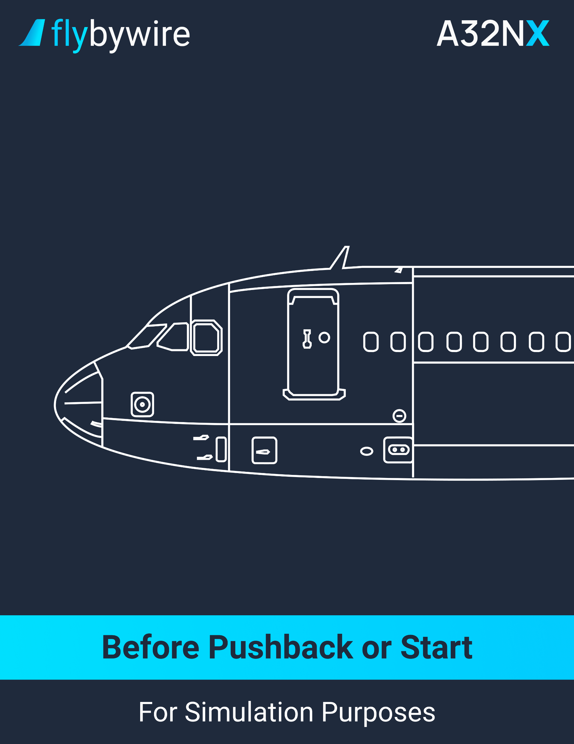

|  |
| --- |
| **Before Start Clearance** |

**Loadsheet**

CM | FINAL LOADSHEET. . . . . . . . . . . . . . . . . . . . . . . . . . . . . . . . . . . . . . **VERIFY**

Ensure that the loadsheet is accurate.

CM | ZFW/ZFWCG. . . . . . . . . . . . . . . . . . . . . . . . . . . . . . . . . . . . **VERIFY/REVISE**

The flight crew compare the ZFW and ZFWCG data with the previously entered data. If different, the flight crew must reinsert the data.

CM | ZFW/ZFWCG. . . . . . . . . . . . . . . . . . . . . . . . . . . . . . . . . . . . . **CROSSCHECK**

The pilot verify on both flight management system the values of the ZGW/ZFWCG.

CM | FOB. . . . . . . . . . . . . . . . . . . . . . . . . . . . . . . . . . . . . . . . . . . . . . . . . . . **VERIFY**

Verify the fuel on board (FOB) on the system display. Ensure that it corresponds to the flight plan and to the loadsheet.

**Takeoff Data**

* + **If takeoff conditions have changed:**

PF | FINAL TAKEOFF PERF DATA. . . . . . . . . . . . . . . . . . . . **RECOMPUTE**

The flight crew members independently recompute the takeoff performance data.

PF | FMS TAKEOFF DATA. . . . . . . . . . . . . . . . . . . . . . . . . . . . . . . . **REVISE**

Verify the takeoff speeds, flexible temperature, and takeoff configuration.

PM | FMS REVISED TAKEOFF PERF DATA. . . . . . . . . . . . **CROSSCHECK**

The PF ensures the PNF got the same performance data on the T.O page.

**Seating Position**

CM | SEATING POSITION. . . . . . . . . . . . . . . . . . . . . . . . . . . . . . . . . . . . . **ADJUST**

The pilot eyes should be in line with the red and white balls.

**MCDU**

PF | FMS PERF TO page. . . . . . . . . . . . . . . . . . . . . . . . . . . . . . . . . . . . . . **SELECT**

It is recommended to set the PERF TO page on the PF MCDU.

PM | FMS F-PLN page. . . . . . . . . . . . . . . . . . . . . . . . . . . . . . . . . . . . . . . . **SELECT**

It is recommended to set the F-PLN page on the PM MCDU.

**ELEC**

PM | EXT PWR. . . . . . . . . . . . . . . . . . . . . . . . . . . . . . . . . . . . . . . . . **VERIFY AVAIL**

PM | EXT PWR DISCONNECTION. . . . . . . . . . . . . . . . . . . . . . . . . . . . . **REQUEST**

**Before Start Checklist**

CM | BEFORE START CHECKLIST down to the line. . . . . . . . . . . . . . **COMPLETE**

|  |
| --- |
| **At Start Clearance** |

**Pushback/Start Up Clearance**

PM | PUSHBACK/START CLEARANCE. . . . . . . . . . . . . . . . . . . . . . . . . . **OBTAIN**

PM | ATC. . . . . . . . . . . . . . . . . . . . . . . . . . . . . . . . . . . . . . . . . . . . **SET FOR OPERATION**

**Windows and Doors**

CM | WINDOWS AND DOORS. . . . . . . . . . . . . . . . . . . . . . . . . . **VERIFY CLOSED**

Verify on the ECAM DOOR page that the doors are closed.

CM | SLIDES. . . . . . . . . . . . . . . . . . . . . . . . . . . . . . . . . . . . . . . . . **VERIFY ARMED**

Verify on the ECAM DOOR page that the slides are armed.

**Exterior Lights**

PF | BEACON switch. . . . . . . . . . . . . . . . . . . . . . . . . . . . . . . . . . . . . . . . . . . . . . **ON**

**Thrust Levers**

PF | THRUST LEVERS. . . . . . . . . . . . . . . . . . . . . . . . . . . . . . . . . . . . . . . . . . . **IDLE**

Ensure that the thrust levers are at the idle position. If the lever is beyond the idle detent, it can cause a hazardous situation at start-up.

**ACCU Pressure**

PF | ACCU PRESS indicator. . . . . . . . . . . . . . . . . . . . . . . . . . . . . . . . . . . . **VERIFY**

The ACCU PRESS must indicates within the green band. If this is not the case, use the electric pump of the yellow hydraulic system.

**Parking Brake and Nosewheel Steering**

* + **If pushback is not required:**

PF | PARK BRK handle. . . . . . . . . . . . . . . . . . . . . . . . . . . . . . . . **VERIFY ON**

PF | BRAKES PRESS indicator. . . . . . . . . . . . . . . . . . . . . . . . . . . . **VERIFY**

CM | BEFORE START CHECKLIST below the line. . . . . . . . . . **COMPLETE**

* + **If pushback is required:**

PF | N/W STRG DISC MEMO. . . . . . . . . . . . . . . . . . . **VERIFY DISPLAYED**

CM | BEFORE START CHECKLIST below the line. . . . . . . . . . **COMPLETE**

PF | PARK BRK handle. . . . . . . . . . . . . . . . . . . . . . . . . . . . . . . . . . . . . . **OFF**

* + - **When the pushback is completed:**

PF | PARK BRK handle. . . . . . . . . . . . . . . . . . . . . . . . . . . . . . . . . **ON**

PF | BRAKE PRESS indicator. . . . . . . . . . . . . . . . . . . . . . . . **VERIFY**

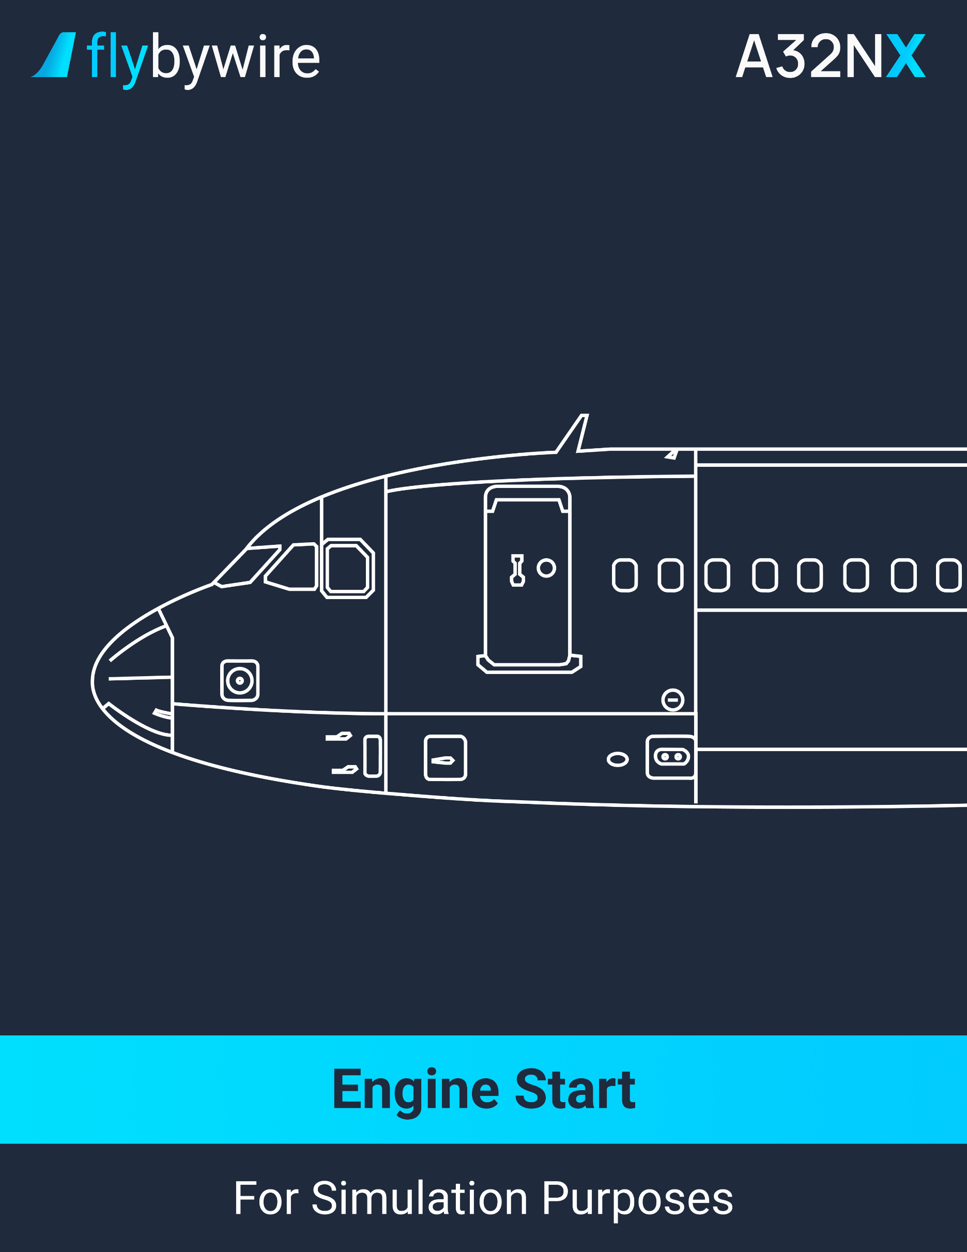

|  |
| --- |
| **Automatic Engine Start** |

PF | ENG MODE selector. . . . . . . . . . . . . . . . . . . . . . . . . . . . . . . . . . . . . . . . . **IGN/START**

The flight crew should look at the engine warning display for the indication of “COOLING”.

PF | ENGINE 2 START. . . . . . . . . . . . . . . . . . . . . . . . . . . . . . . . . . . . . . . . . . **ANNOUNCE**

The engine 2 is usually started first. This will add the ability to pressurize the yellow hydraulic system.

PF | ENG MASTER 2. . . . . . . . . . . . . . . . . . . . . . . . . . . . . . . . . . . . . . . . . . . . . . . . . . . **ON**

It is recommended to wait until all amber crosses and messages have disappeared from the upper ECAM display before setting the ENG MASTER 2 switch to ON.

* **When engine idle is reached (AVAIL indication is displayed)**

PF | ENG IDLE PARAMETERS. . . . . . . . . . . . . . . . . . . . . . . . . . . . . . . . . . **VERIFY**

At ISA sea level, the engine parameters should indicate the following:

* + 19% N1
  + 68% N2
  + 520°C EGT
  + 290 kg/h FF

PF | ENGINE 1 START. . . . . . . . . . . . . . . . . . . . . . . . . . . . . . . . . . . . . . . . . . **ANNOUNCE**

PF | ENG MASTER 1. . . . . . . . . . . . . . . . . . . . . . . . . . . . . . . . . . . . . . . . . . . . . . . . . . . **ON**

* **When engine idle is reached (AVAIL indication is displayed)**

PF | ENG IDLE PARAMETERS. . . . . . . . . . . . . . . . . . . . . . . . . . . . . . . . . . **VERIFY**

At ISA sea level, the engine parameters should indicate the following:

* + 19% N1
  + 68% N2
  + 520°C EGT
  + 290 kg/h FF

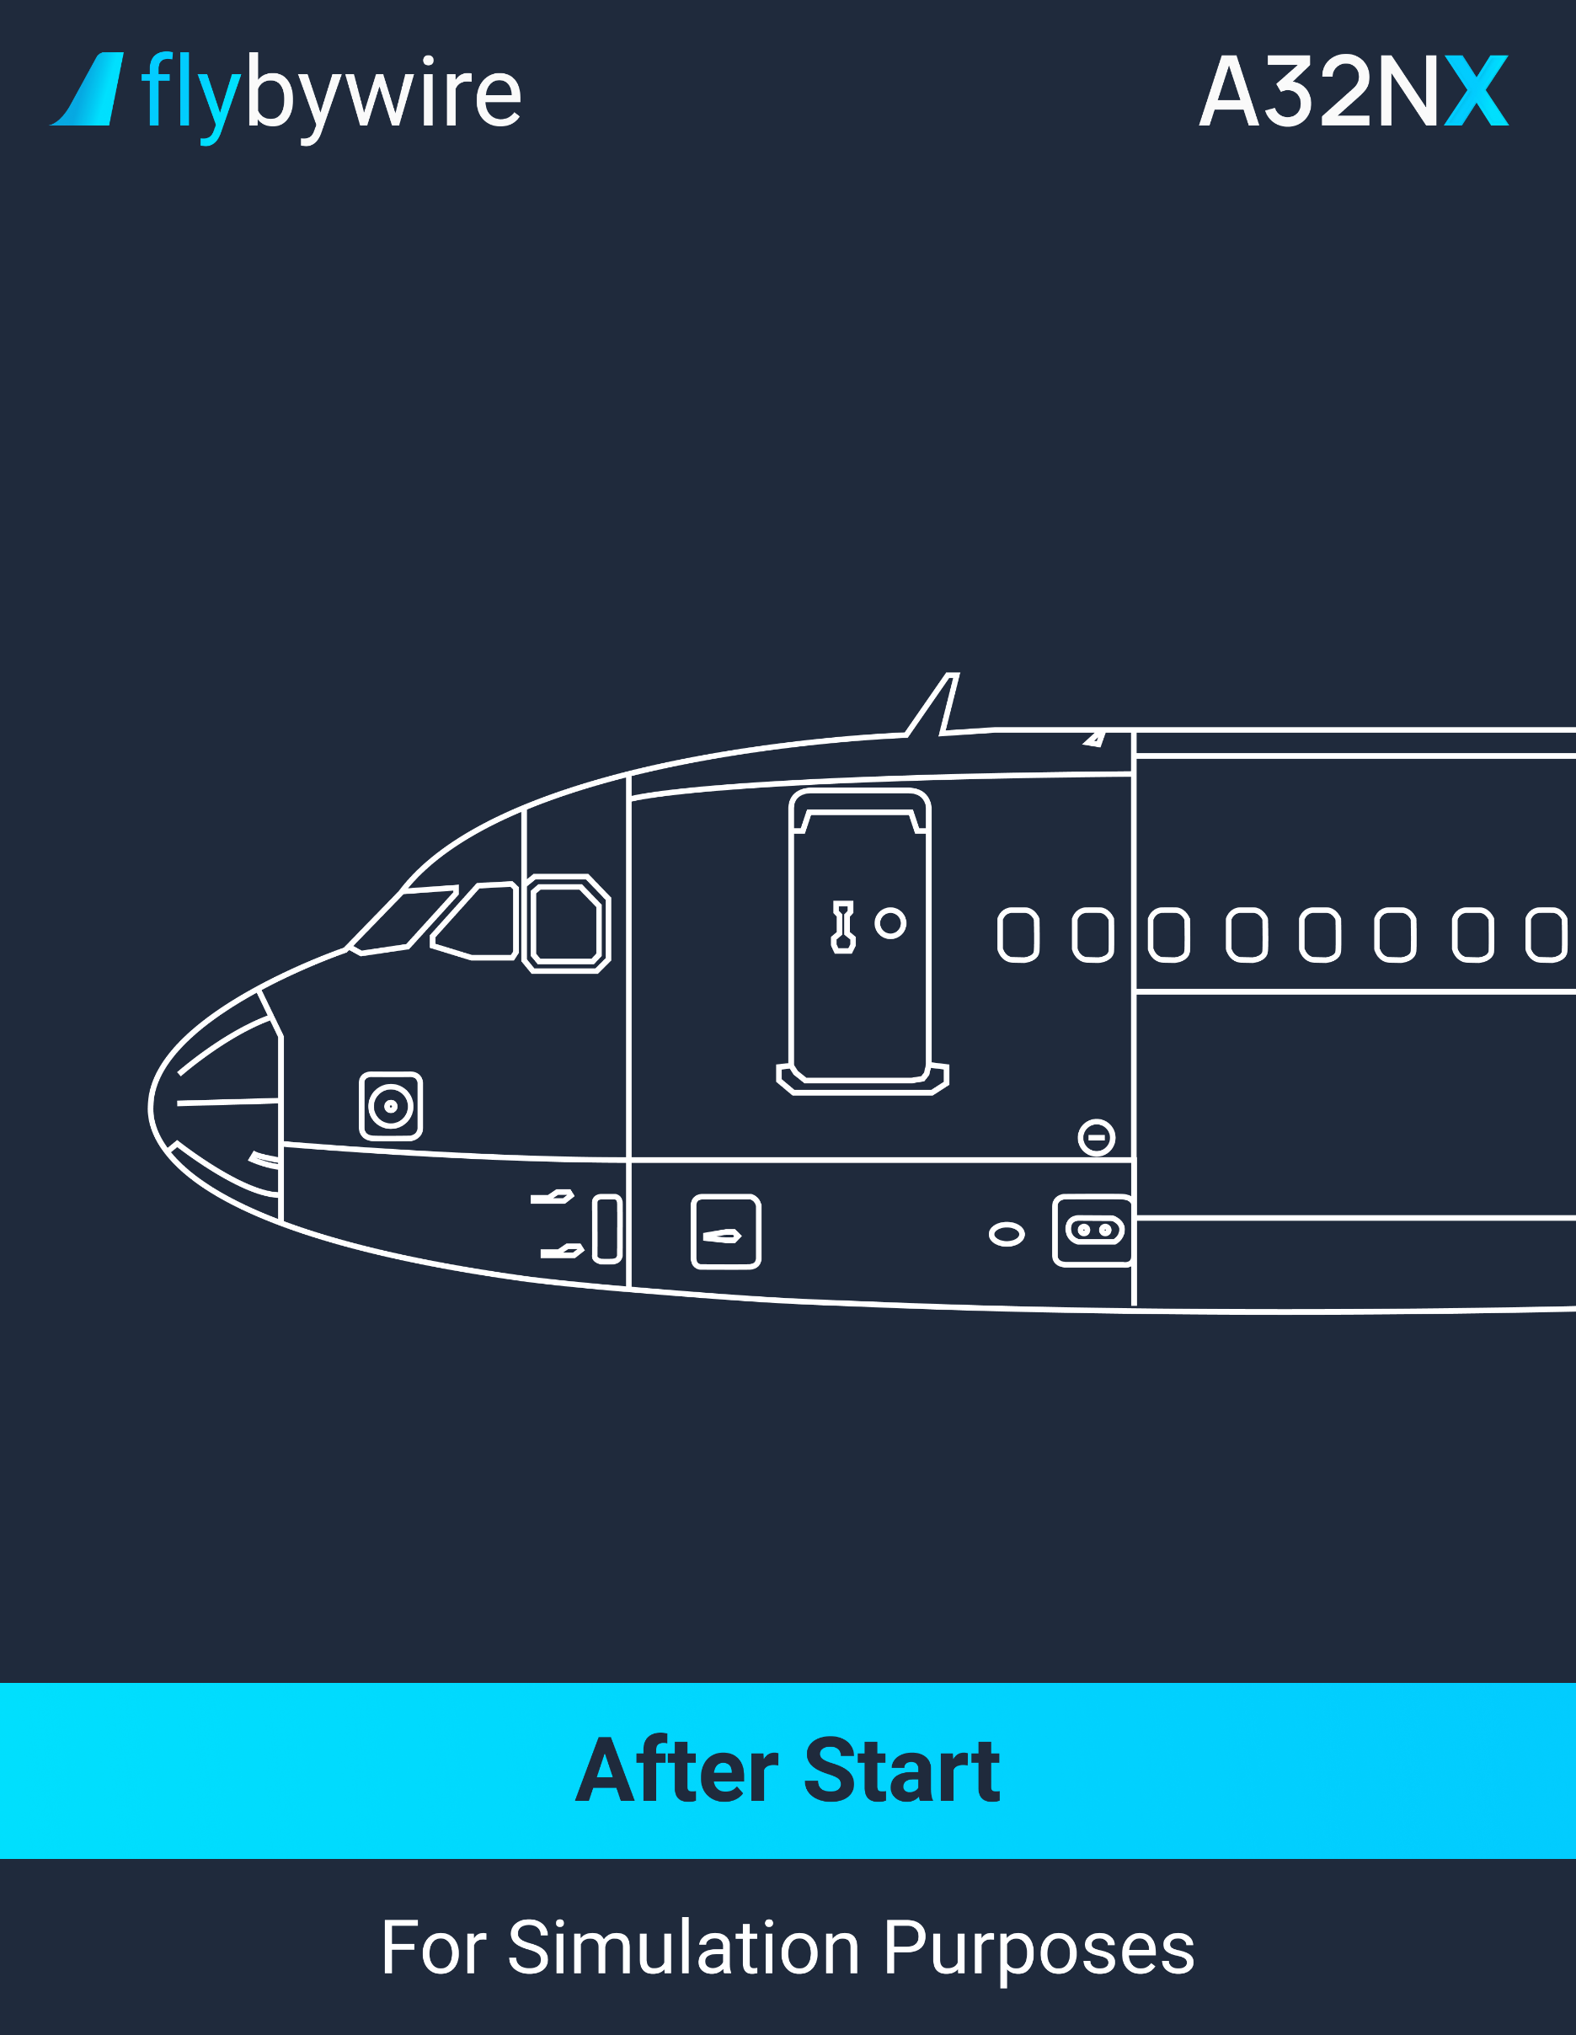

|  |
| --- |
| **After Start** |

**Engine Mode**

PF | ENG MODE selector. . . . . . . . . . . . . . . . . . . . . . . . . . . . . . . . . . . . . . . . **NORM**

It is recommended to wait 5 minutes before taking off to prevent a thermal shock. The taxi time can be included in the waiting period.

**APU Bleed**

PF | APU Bleed pushbutton. . . . . . . . . . . . . . . . . . . . . . . . . . . . . . . . . . . . . . . . **OFF**

The auxiliary power unit bleed valves close. All engine bleed valves automatically open.

**Anti-Ice**

PF | ENG ANTI-ICE pushbutton. . . . . . . . . . . . . . . . . . . . . . . . . . . **AS REQUIRED**

The engine anti-ice must be set to on during all ground operations if there is an icing condition. If ground surface and the environment allow, the flight crew can proceed to an engine de-icing run-up.

To proceed to an engine de-icing runup, set the parking brakes to ON, then accelerate the engines N1 to a minimum of 50% for 5 seconds.

PF | WING ANTI-ICE pushbutton. . . . . . . . . . . . . . . . . . . . . . . . . . **AS REQUIRED**

The flight crew should turn the wing anti-ice ON when icing conditions are encountered. After 30 seconds, the valve will close itself as a self-test is passed.

**APU**

* **If the APU is not required:**

PF | APU MASTER pushbutton. . . . . . . . . . . . . . . . . . . . . . . . . . . . . . . . . . . . . **OFF**

**Ground Spoilers**

PM | GROUND SPOILERS. . . . . . . . . . . . . . . . . . . . . . . . . . . . . . . . . . . . . . . **ARM**

**Rudder Trim**

PM | RUD TRIM position indication. . . . . . . . . . . . . . . . . . . . . . . . . . **VERIFY ZERO**

* + **If the RUD TRIM position indication does not indicates at zero:**

RESET pushbutton. . . . . . . . . . . . . . . . . . . . . . . . . . . . . . . . . . . . . . **PRESS**

**Flaps**

PM | FLAPS lever. . . . . . . . . . . . . . . . . . . . . . . . . . . . . **SET TAKEOFF POSITION**

PM | FLAPS. . . . . . . . . . . . . . . . . . . . . . . . . . . . . . . . . . . . . . . . **VERIFY POSITION**

If taxiing in icing condition, delay the flaps extension until the runway holding point. This prevents contamination in the mechanism.

**Pitch Trim**

PM | PITCH TRIM handwheel. . . . . . . . . . . . . . . . . . . . . . . . . . . . . . . . . . . . . . **SET**

Verify that the pitch trim is set to the takeoff trim position.

**ECAM Status**

PF | STATUS REMINDER. . . . . . . . . . . . . . . . . . . . . . . **VERIFY NOT DISPLAYED**

* + **If STS reminder is displayed:**

PF | STS pushbutton. . . . . . . . . . . . . . . . . . . . . . . . . . . . . . . . . . . . . **PRESS**

**N/W STEER DISC Memo**

PF | N/W STEER DISC MEMO. . . . . . . . . . . . . . . . . . . **VERIFY NOT DISPLAYED**

**Ground Crew**

PF | CLEAR TO DISCONNECT. . . . . . . . . . . . . . . . . . . . . . . . . . . . . . **ANNOUNCE**

When the clearance to disconnect is given, the ground crew should remove the chocks, remove the tow pin, disconnect the interphone and make a hand signal on one side of the aircraft.

**After Start Checklist**

CM | AFTER START Checklist. . . . . . . . . . . . . . . . . . . . . . . . . . . . . . .**COMPLETE**

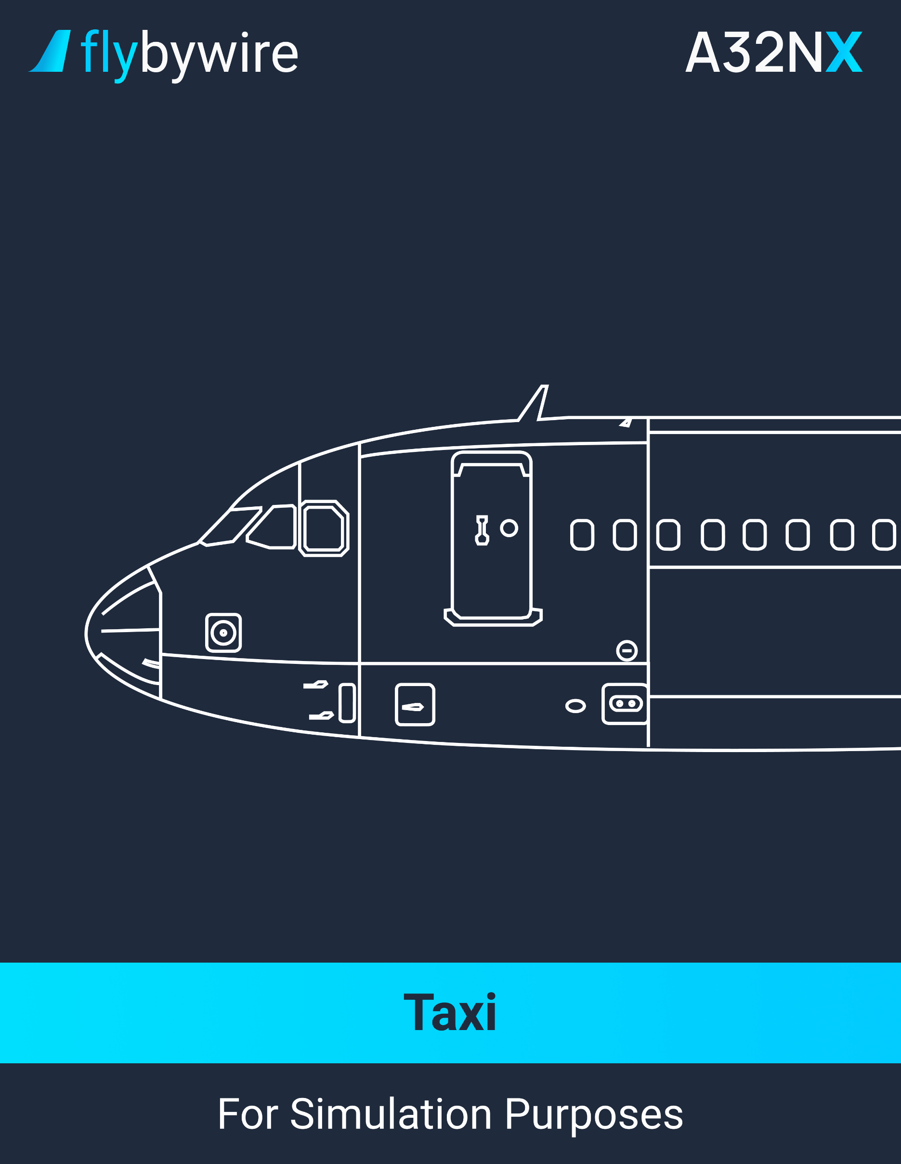

|  |
| --- |
| **Taxi** |

**Taxi Clearance**

PM | TAXI clearance. . . . . . . . . . . . . . . . . . . . . . . . . . . . . . . . . . . . . . . . . **OBTAIN**

**Exterior Lights**

PF | NOSE switch. . . . . . . . . . . . . . . . . . . . . . . . . . . . . . . . . . . . . . . . . . . . . . **TAXI**

PF | RWY TURN OFF switch. . . . . . . . . . . . . . . . . . . . . . . . . . . . . . . . . . . . . . . . **ON**

* + **When crossing a runway:**

PF | STROBE switch. . . . . . . . . . . . . . . . . . . . . . . . . . . . . . . . . . . . . . . . **ON**

**Parking Brakes**

PF | PARK BRK handle. . . . . . . . . . . . . . . . . . . . . . . . . . . . . . . . . . . . . . . . . . . **OFF**

PM | BRAKES PRESSURE. . . . . . . . . . . . . . . . . . . . . . . . . . . . **VERIFY AT ZERO**

**Thrust Lever**

PF | THRUST lever. . . . . . . . . . . . . . . . . . . . . . . . . . . . . . . . . . . . . **AS REQUIRED**

**Brakes**

PF | BRAKE PEDALS. . . . . . . . . . . . . . . . . . . . . . . . . . . . . . . . . . . . . . . . . . **PRESS**

PF | BRAKES. . . . . . . . . . . . . . . . . . . . . . . . . . . . . . . . . . . . . . . . . . . . . . . . **VERIFY**

The flight crew should monitor the WHEEL SD page on the ECAM display. If an arc is displayed above the brake temperature, it is recommended to set the brake fans to ON.

**Nosewheel Steering**

PF | TILLER or RUDDER PERDALS. . . . . . . . . . . . . . . . . . . **USE AS REQUIRED**

**Flight Controls**

CM | FLIGHT CONTROLS. . . . . . . . . . . . . . . . . . . . . . . . . . . . . . . . . . . . . . **VERIFY**

**ATC Clearance**

PM | ATC Clearance. . . . . . . . . . . . . . . . . . . . . . . . . . . . . . . . . . . . . . . . . **CONFIRM**

**Takeoff Data/Conditions**

* + **If takeoff conditions have changed:**

PM | FINAL TAKEOFF PERF DATA. . . . . . . . . . . . . . . . . . . . **RECOMPUTE**

The flight crew should independently compute the takeoff performance data again.

PM | FMS TAKEOFF DATA. . . . . . . . . . . . . . . . . . . . . . . . . . . . . . . **REVISE**

The flight crew should revise the takeoff data in the FMS. It is recommended to pay attention to the changes at the slats/flaps configuration at takeoff.

CM | FMS REVISED TAKEOFF PERF DATA. . . . . . . . . . . **CROSSCHECK**

PM | FLAPS lever. . . . . . . . . . . . . . . . . . . . . . . . . . . . . . **AS APPROPRIATE**

**AFS/Flight instruments**

PM | F-PLN (SID, TRANS) . . . . . . . . . . . . . . . . . . . . . . . . . . . . **REVISE or VERIFY**

Ensure that the ATC clearance is the same as with the inserted flight plan in the FMS.

PM | INITIAL CLIMB SPEED AND SPEED LIMIT. . . . . . . . . . **MODIFY or VERIFY**

It is recommended to use VERT REV at departure, or at a CLB waypoint.

PM | CLEARED ALTITUDE ON FCU. . . . . . . . . . . . . . . . . . . . . . . . . . . . . . . . **SET**

PM | HDG ON FCU. . . . . . . . . . . . . . . . . . . . . . . . . . . . . . . . . . . . . . . . . . . **PRESET**

Preset the heading if the air traffic control require a radar vector departure. However, please note that the RWY TRK mode maintains the aircraft on the runway heading until the heading mode engage.

PM | BOTH FD. . . . . . . . . . . . . . . . . . . . . . . . . . . . . . . . . . . . . . . . . . . **VERIFY ON**

CM | PFD/ND. . . . . . . . . . . . . . . . . . . . . . . . . . . . . . . . . . . . . . . . . . . . . . . . **VERIFY**

CM | TAKEOFF BRIEFING. . . . . . . . . . . . . . . . . . . . . . . . . . . . . . . . . . . **CONFIRM**

PM | RADAR. . . . . . . . . . . . . . . . . . . . . . . . . . . . . . . . . . . . . . . . . . . . . . . . . . . . **ON**

It is recommended to set the MULTISCAN switch to MAN. This allows the flight crew to verify the radar and the departure path. The flight crew can then set the radar to the AUTO position.

PM | PREDICTIVE WINDSHEAR SYSTEM. . . . . . . . . . . . . . . . . . . . . . . . . . **AUTO**

**ATC**

PM | ATC code/mode. . . . . . . . . . . . . . . . . . . . . **CONFIRM & SET FOR TAKEOFF**

**Terrain Radar**

CM | TERR ON ND. . . . . . . . . . . . . . . . . . . . . . . . . . . . . . . . . . . . . **AS REQUIRED**

It is recommended to set the weather radar display on the PF side, and the terrain radar on the PM side.

**Autobrakes**

PM | AUTO BRK MAX pushbutton. . . . . . . . . . . . . . . . . . . . . . . . . . . . . . . . . . . **ON**

**Final Verification**

PM | T.O CONFIG pushbutton. . . . . . . . . . . . . . . . . . . . . . . . . . . . . . . . . . . . . **TEST**

Ensure that the upper ECAM display shows the message “T.O CONFIG NORMAL”.

PM | T.O MEMO. . . . . . . . . . . . . . . . . . . . . . . . . . . . . . . . . . . . . **VERIFY NO BLUE**

CM | CABIN REPORT. . . . . . . . . . . . . . . . . . . . . . . . . . . . . . . . . . . . . . . . **RECEIVE**

Verify on the engine warning display the display of the message “CABIN READY” or obtain the report from the chief flight attendant “Cabin ready for takeoff”.

**Before Takeoff Checklist**

CM | BEFORE TAKEOFF CHECKLIST down to the line. . . . . . . . . . . **COMPLETE**

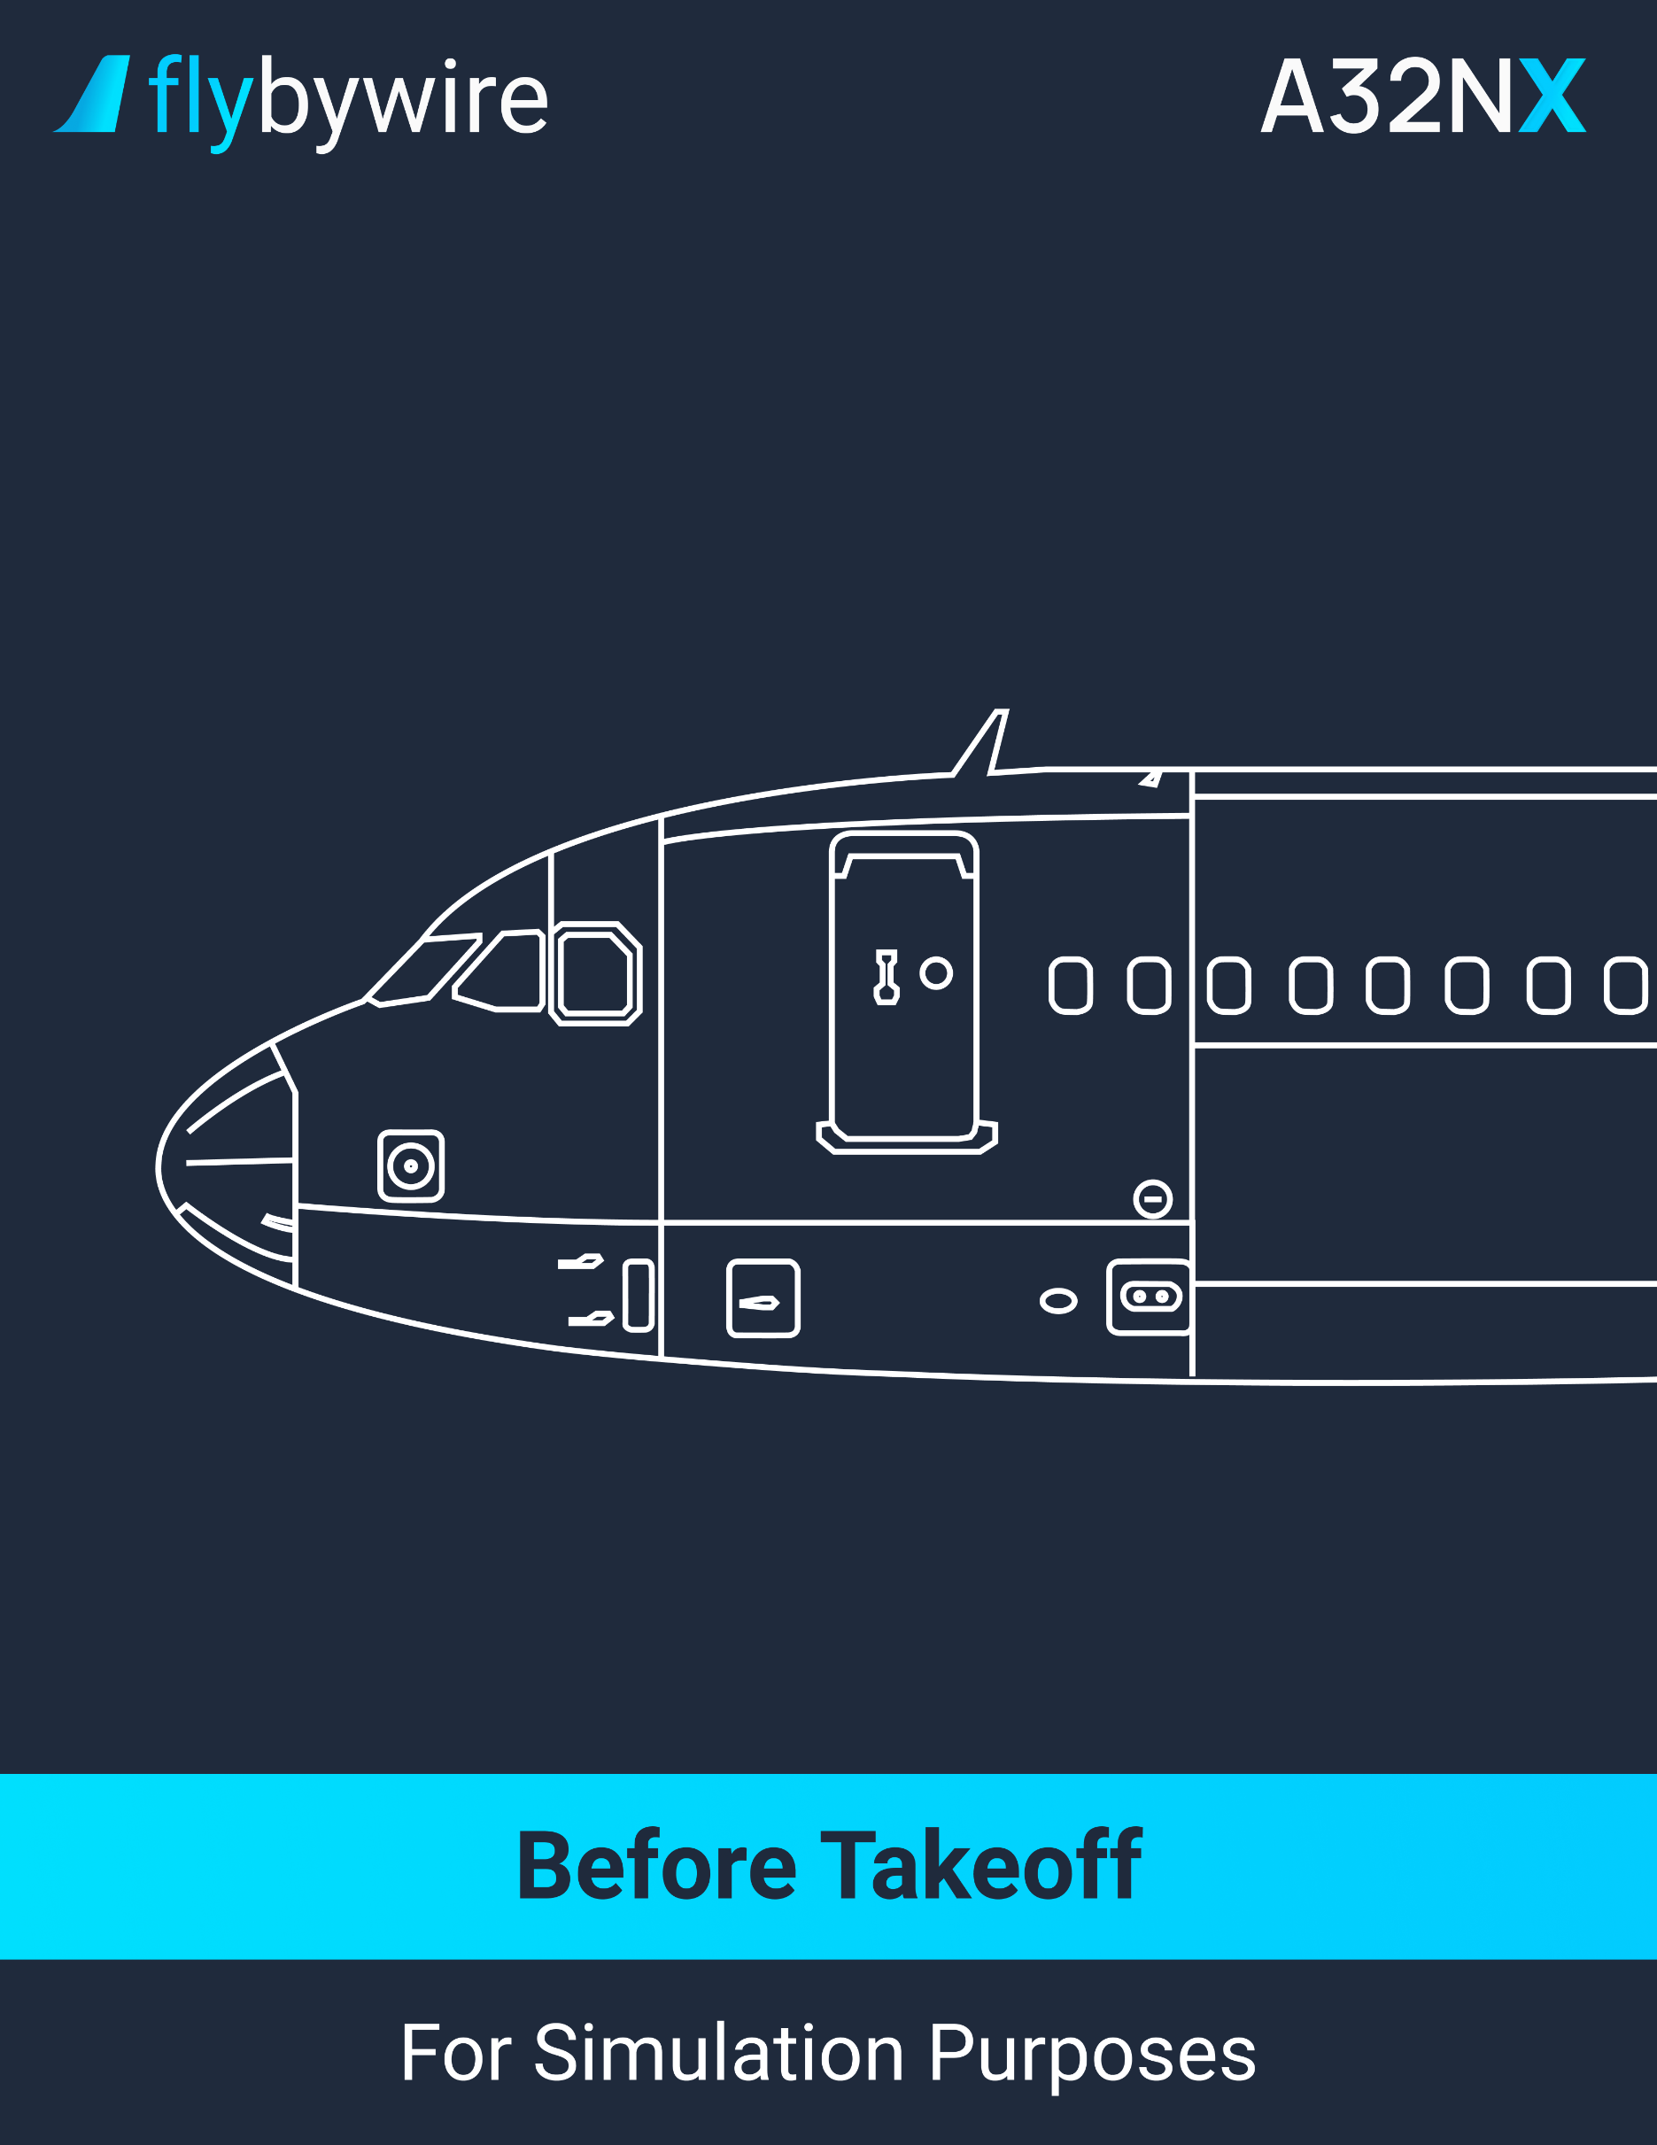

|  |
| --- |
| **Before Takeoff** |

**Brake Fans**

* + **If the brake fans are currently running:**

PM | BRAKE TEMPERATURE. . . . . . . . . . . . . . . . . . . . . . . . . . . . . **VERIFY**

If the brake temperature is below 150°C, the flight crew can select the brake fans OFF. If the brake temperature is above 150°C, it is recommended to delay the takeoff.

**Line-Up Clearance**

PM | LINE-UP CLEARANCE. . . . . . . . . . . . . . . . . . . . . . . . . . . . . . . . . . . . **OBTAIN**

**Exterior Lights**

PF | STROBE switch. . . . . . . . . . . . . . . . . . . . . . . . . . . . . . . . . . . . . . . . . . . . . . **ON**

The flight crew can turn off the strobe lights if it causes any visual trouble.

**TCAS**

PM | TCAS mode selector. . . . . . . . . . . . . . . . . . . . . . . . . . . . . . . . . . **TA or TA/RA**

It is recommended the use of **TA/RA** for normal situations. If it is inappropriate, such as converging runways or parallel runways, the use of TA ONLY mode is recommended.

**Approach Path**

CM | APROACH PATH. . . . . . . . . . . . . . . . . . . . . . . . . . . **CLEARED OF TRAFFIC**

Ensure there is no traffic incoming, both from visual confirmation and using the TCAS display on the ND.

PM | Cabin Crew. . . . . . . . . . . . . . . . . . . . . . . . . . . . . . . . . . . . . . . . . . . . . . . . . . . **ADVISE**

**Sliding Table/EFB**

CM | SLIDING TABLE. . . . . . . . . . . . . . . . . . . . . . . . . . . . . . . . . . . . . . . . . . **STOW**

CM | ALL EFB transmitting mode. . . . . . . . . . . . . . . . . . . . . . . . . . **AS REQUIRED**

CM | TAKEOFF RUNWAY. . . . . . . . . . . . . . . . . . . . . . . . . . . . . . . . . . . . . . . . . **CONFIRM**

PM | PACK 1 and 2. . . . . . . . . . . . . . . . . . . . . . . . . . . . . . . . . . . . . . . . . . . **AS REQUIRED**

It is recommended to select the packs OFF or put the APU bleed ON. This should improve performance when using TOGA thrust. Furthermore, it can reduce maintenance cost due to the takeoff EGT reduction. However, if the wing anti-ice is used, it is not recommended to use the APU bleed.

CM | BEFORE TAKEOFF CHECKLIST below the line. . . . . . . . . . . . . . . . . . **COMPLETE**

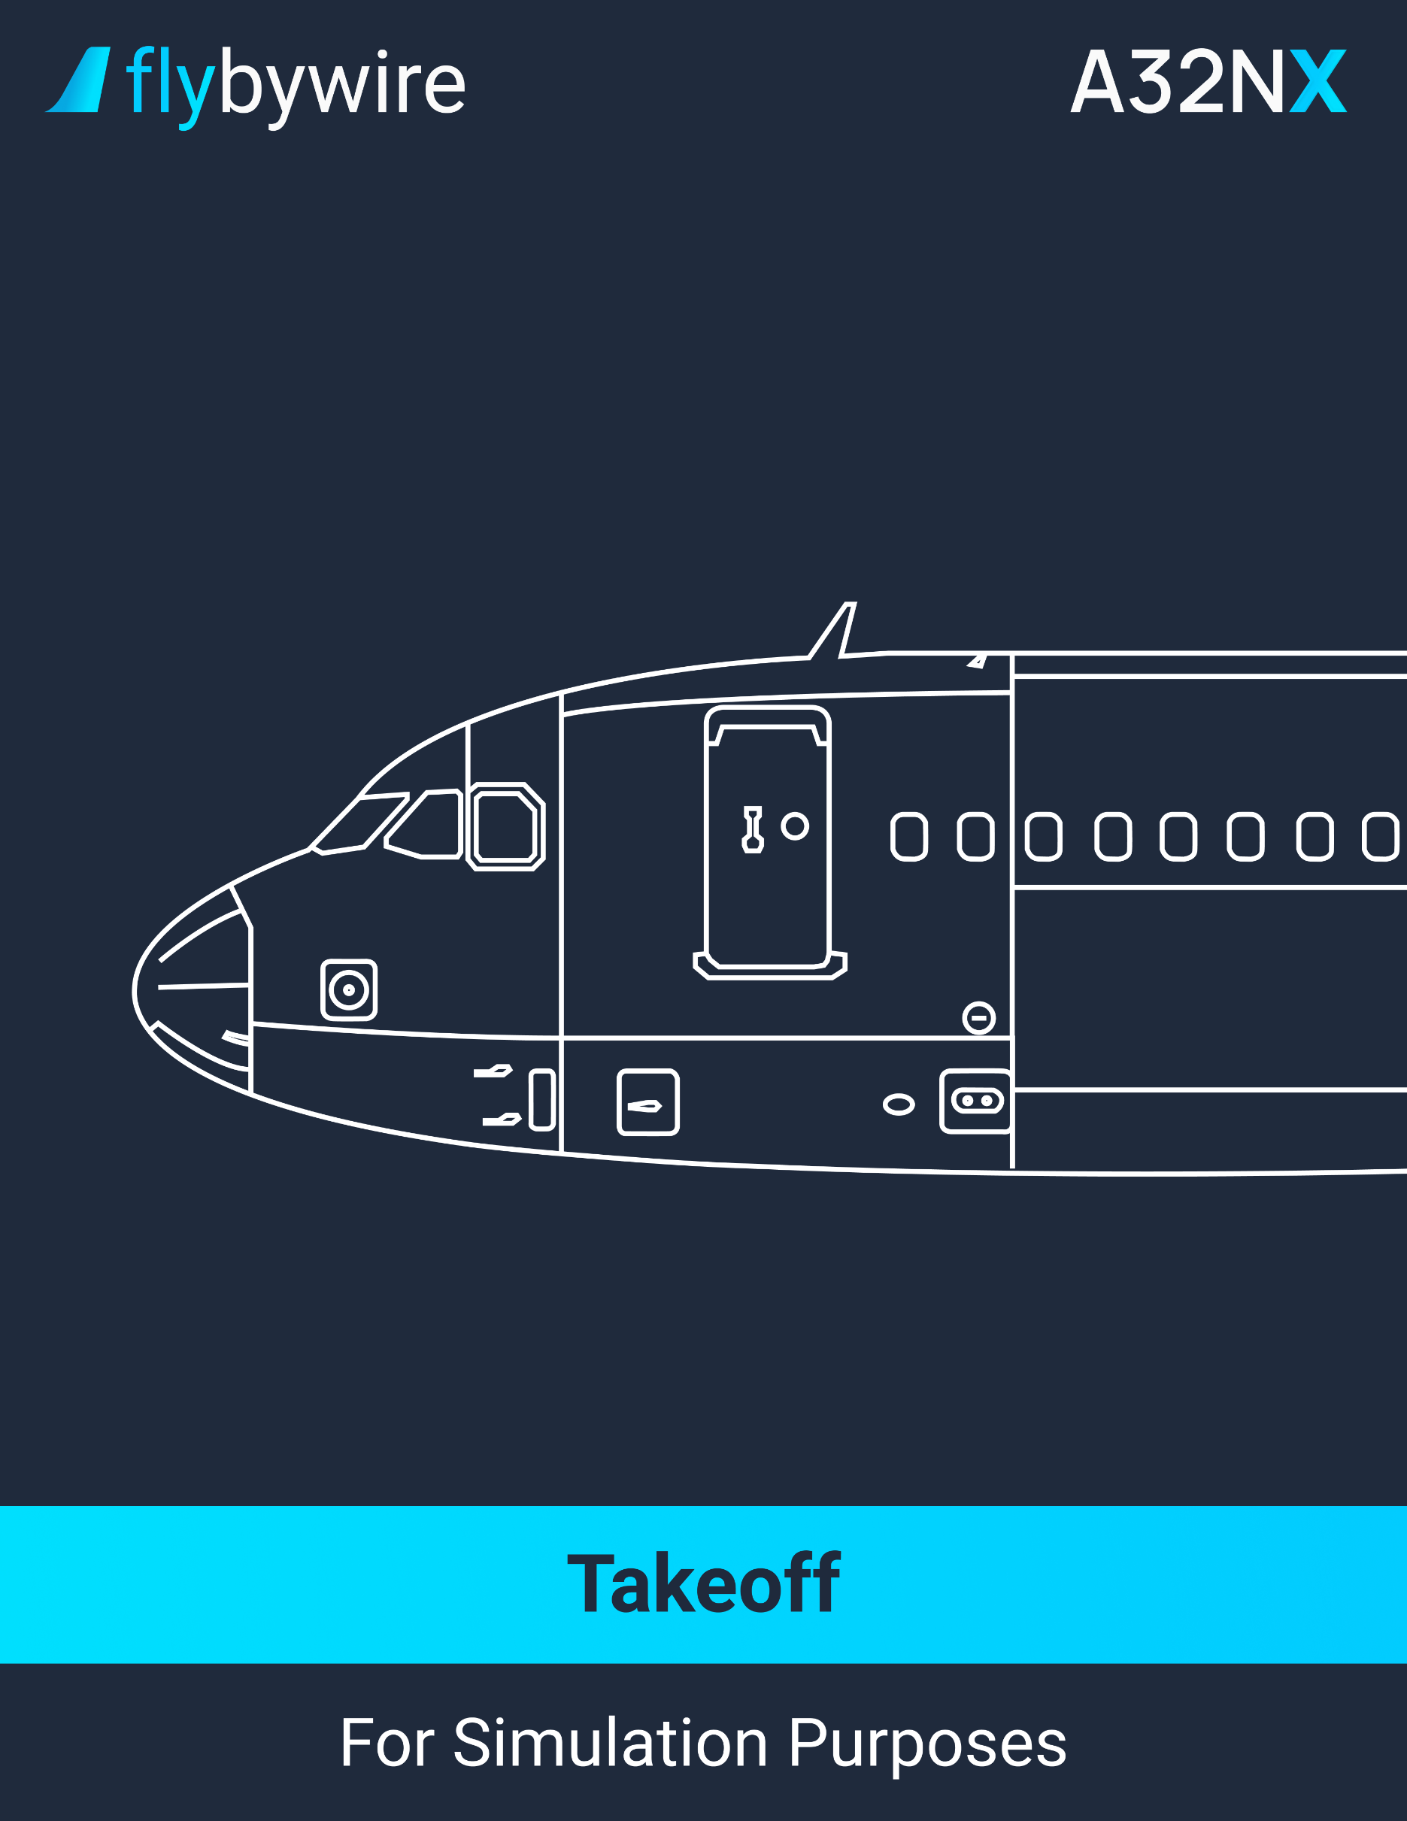

|  |
| --- |
| **Takeoff** |

**Takeoff Clearance**

PM | TAKEOFF CLEARANCE. . . . . . . . . . . . . . . . . . . . . . . . . . . . . . . . **OBTAINED**

**Exterior Lights**

PF | NOSE switch . . . . . . . . . . . . . . . . . . . . . . . . . . . . . . . . . . . . . . . . . . . . . . . **T.O**

PF | RWY TURN OFF switch . . . . . . . . . . . . . . . . . . . . . . . . . . . . . . . . . . . . . . . **ON**

PF | LAND LIGHTS switch . . . . . . . . . . . . . . . . . . . . . . . . . . . . . . . . . . . . . . . . . **ON**

**Thrust Setting**

PF | TAKEOFF . . . . . . . . . . . . . . . . . . . . . . . . . . . . . . . . . . . . . . . . . . **ANNOUNCE**

PF | THRUST LEVERS . . . . . . . . . . . . . . . . . . . . . . . . . . . . . . . . . . . . . . . . **50% N1**

* + **If the crosswind is at or below 20 knots and there is no tailwind:**

It is recommended to apply half forward sidestick until the aircraft reach the airspeed of 80 knots to counter the nose-up effect. At 80 knots, release gradually the sidestick. The sidestick must be neutral at 100 knots.

PF | BRAKES . . . . . . . . . . . . . . . . . . . . . . . . . . . . . . . . . . . . . . . . **RELEASE**

PF | THRUST LEVERS. . . . . . . . . . . . . . . . . . . . . . . . . . . . . . **FLX or TOGA**

* + **If the crosswind is greater than 20 knots, or there is tailwind:**

It is recommended to apply full forward sidestick until the aircraft reach the airspeed of 80 knots. At 80 knots, release gradually the sidestick. The sidestick must be neutral at 100 knots.

PF | BRAKES. . . . . . . . . . . . . . . . . . . . . . . . . . . . . . . . . . . . . . . . **RELEASE**

PF | THRUST LEVERS. . . . . . . . . . . . . . . . . . . . . . . . . . . . . . **FLX or TOGA**

Note: Expect the ENG SD page to replace the WHEEL SD page on the lower ECAM display.

PF | DIRECTIONAL CONTROL. . . . . . . . . . . . . . . . . . . . . . . . . . . . . . . . **RUDDER**

Once the wheel reach 130 knots, there is an automatic disconnection between the nosewheel steering and the rudder pedals.

PM | CHRONO. . . . . . . . . . . . . . . . . . . . . . . . . . . . . . . . . . . . . . . . . . . . . . . **START**

CM | PFD/ND. . . . . . . . . . . . . . . . . . . . . . . . . . . . . . . . . . . . . . . . . . . . . . **MONITOR**

Ensure that either of the following modes are displayed on the FMA: MAN TOGA (or MAN FLX xx) / SRS / RWY / A/THR / Blank. Also, verify the FMS position on the ND.

PF | FMA. . . . . . . . . . . . . . . . . . . . . . . . . . . . . . . . . . . . . . . . . . . . . . . **ANNOUNCE**

**Below 80 knots**

PM | TAKEOFF N1. . . . . . . . . . . . . . . . . . . . . . . . . . . . . . . . . . . . . . . . . . . **VERIFY**

Ensure that the actual N1 of each engine has reached the N1 rating limit before the aircraft reach the airspeed of 80 knots.

PM | THRUST SET. . . . . . . . . . . . . . . . . . . . . . . . . . . . . . . . . . . . . . . **ANNOUNCE**

PM | PFD/ENG indications. . . . . . . . . . . . . . . . . . . . . . . . . . . . . . . . . . . . **MONITOR**

**Reaching 100 knots**

PM | ONE HUNDRED KNOTS. . . . . . . . . . . . . . . . . . . . . . . . . . . . . . . **ANNOUNCE**

It is recommended rejecting the takeoff under 100 knots. However, rejecting takeoff above 100 knots is a more serious case.

**At V1**

PM | V1. . . . . . . . . . . . . . . . . . . . . . . . . . . . . . . . . . . . . . . . . . . . . . . . . **ANNOUNCE**

**At VR**

PM | ROTATION. . . . . . . . . . . . . . . . . . . . . . . . . . . . . . . . . . . . . . . . . . . . . **ORDER**

PF | ROTATION. . . . . . . . . . . . . . . . . . . . . . . . . . . . . . . . . . . . . . . . . . . **PERFORM**

It is recommended to have a rotation speed of 3°/s until the aircraft is at a pitch attitude of 15°. It is recommended to minimize any lateral inputs as it can extend spoilers. After lift-off, it is recommended to follow the SRS pitch command bar.

Note: In case of an engine failure, the recommended pitch attitude is 12.5°.

**When Positive Climb**

PM | POSITIVE CLIMB. . . . . . . . . . . . . . . . . . . . . . . . . . . . . . . . . . . . **ANNOUNCE**

PF | LANDING GEAR UP. . . . . . . . . . . . . . . . . . . . . . . . . . . . . . . . . . . . . . **ORDER**

PM | LANDING GEAR. . . . . . . . . . . . . . . . . . . . . . . . . . . . . . . . . . . . . **SELECT UP**

PF | AUTOPILOT. . . . . . . . . . . . . . . . . . . . . . . . . . . . . . . . . . . . . . . **AS REQUIRED**

The autopilot can be engaged above 100 feet AGL.

**At Thrust Reduction Altitude**

PF | THRUST LEVERS. . . . . . . . . . . . . . . . . . . . . . . . . . . . . . . . . . . . . . . . . . . . **CL**

On the FMA, when the message “LVR CLB” appear flashing, move the thrust levers to the CL detent. The autothrottle will activate.

PM | PACK 1 & 2 . . . . . . . . . . . . . . . . . . . . . . . . . . . . . . . . . . . . . . . . . . . . . . . . **ON**

It is recommended to select PACK 2 at least 10 seconds after PACK 1 has been selected. This is for passenger comfort.

**At Acceleration Altitude**

PM | TARGET SPEED. . . . . . . . . . . . . . . . . . . . . . . . . . . . . . . . . . . . . . **MODIFIED**

Ensure that the speed target changes from V2 +10 to the first CLB speed.

**Above Acceleration Altitude / Climb Phase**

* + **At F speed:**

The F speed will only appear if the aircraft is in a higher configuration than 1+F.

PF | FLAPS 1. . . . . . . . . . . . . . . . . . . . . . . . . . . . . . . . . . . . . . . . . . **ORDER**

PM | FLAPS 1. . . . . . . . . . . . . . . . . . . . . . . . . . . . . . . . . . . . . . . . . **SELECT**

* + **At S speed:**

PF | FLAPS 0. . . . . . . . . . . . . . . . . . . . . . . . . . . . . . . . . . . . . . . . . . **ORDER**

PM | FLAPS 0. . . . . . . . . . . . . . . . . . . . . . . . . . . . . . . . . . . . . . . . . **SELECT**

PM | GND SPLRS. . . . . . . . . . . . . . . . . . . . . . . . . . . . . . . . . . . . . . **DISARM**

PM | NOSE switch. . . . . . . . . . . . . . . . . . . . . . . . . . . . . . . . . . . . . . . . . **OFF**

PM | RWY TURN OFF switch. . . . . . . . . . . . . . . . . . . . . . . . . . . . . . . . . **OFF**

PM | EXTERIOR LIGHTS. . . . . . . . . . . . . . . . . . . . . . . . . . . **AS REQUIRED**

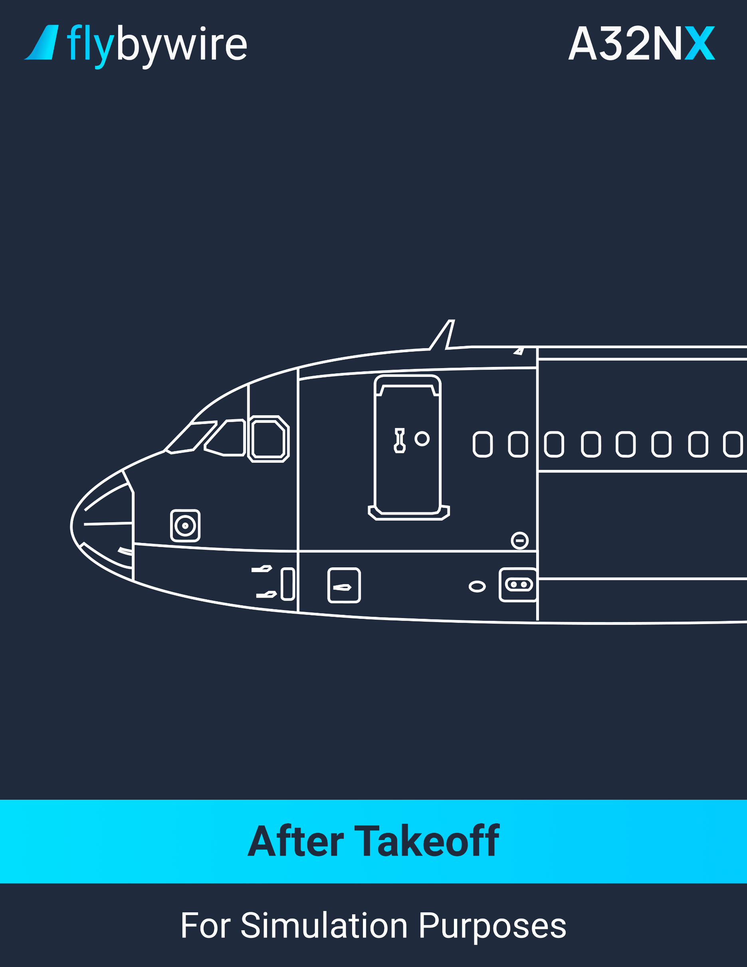

|  |
| --- |
| **After Takeoff** |

PM | APU BLEED pushbutton. . . . . . . . . . . . . . . . . . . . . . . . . . . . . . . . . . . **AS REQUIRED**

PM | APU MASTER pushbutton. . . . . . . . . . . . . . . . . . . . . . . . . . . . . . . . . **AS REQUIRED**

PM | TCAS mode selector. . . . . . . . . . . . . . . . . . . . . . . . . . . . . . . . . . . . . . . . . . . . **TA/RA**

If the takeoff was performed using TA only, select the TA/RA mode.

PM | ENG ANTI-ICE pushbutton. . . . . . . . . . . . . . . . . . . . . . . . . . . . . . . . . . **AS REQUIRED**  
It is recommended to set the engine anti-ice to ON when flying through icing condition, or anticipated icing condition, except when the SAT is below -40°C.

PM | WING ANTI-ICE pushbutton. . . . . . . . . . . . . . . . . . . . . . . . . . . . . . . . **AS REQUIRED**

It is recommended to set the wing anti-ice to ON when flying through icing conditions. It prevents ice accretion on the wing leading edge.

CM | AFTER TAKEOFF/CLIMB CHECKLIST down to the line. . . . . . . . . . . . **COMPLETE**

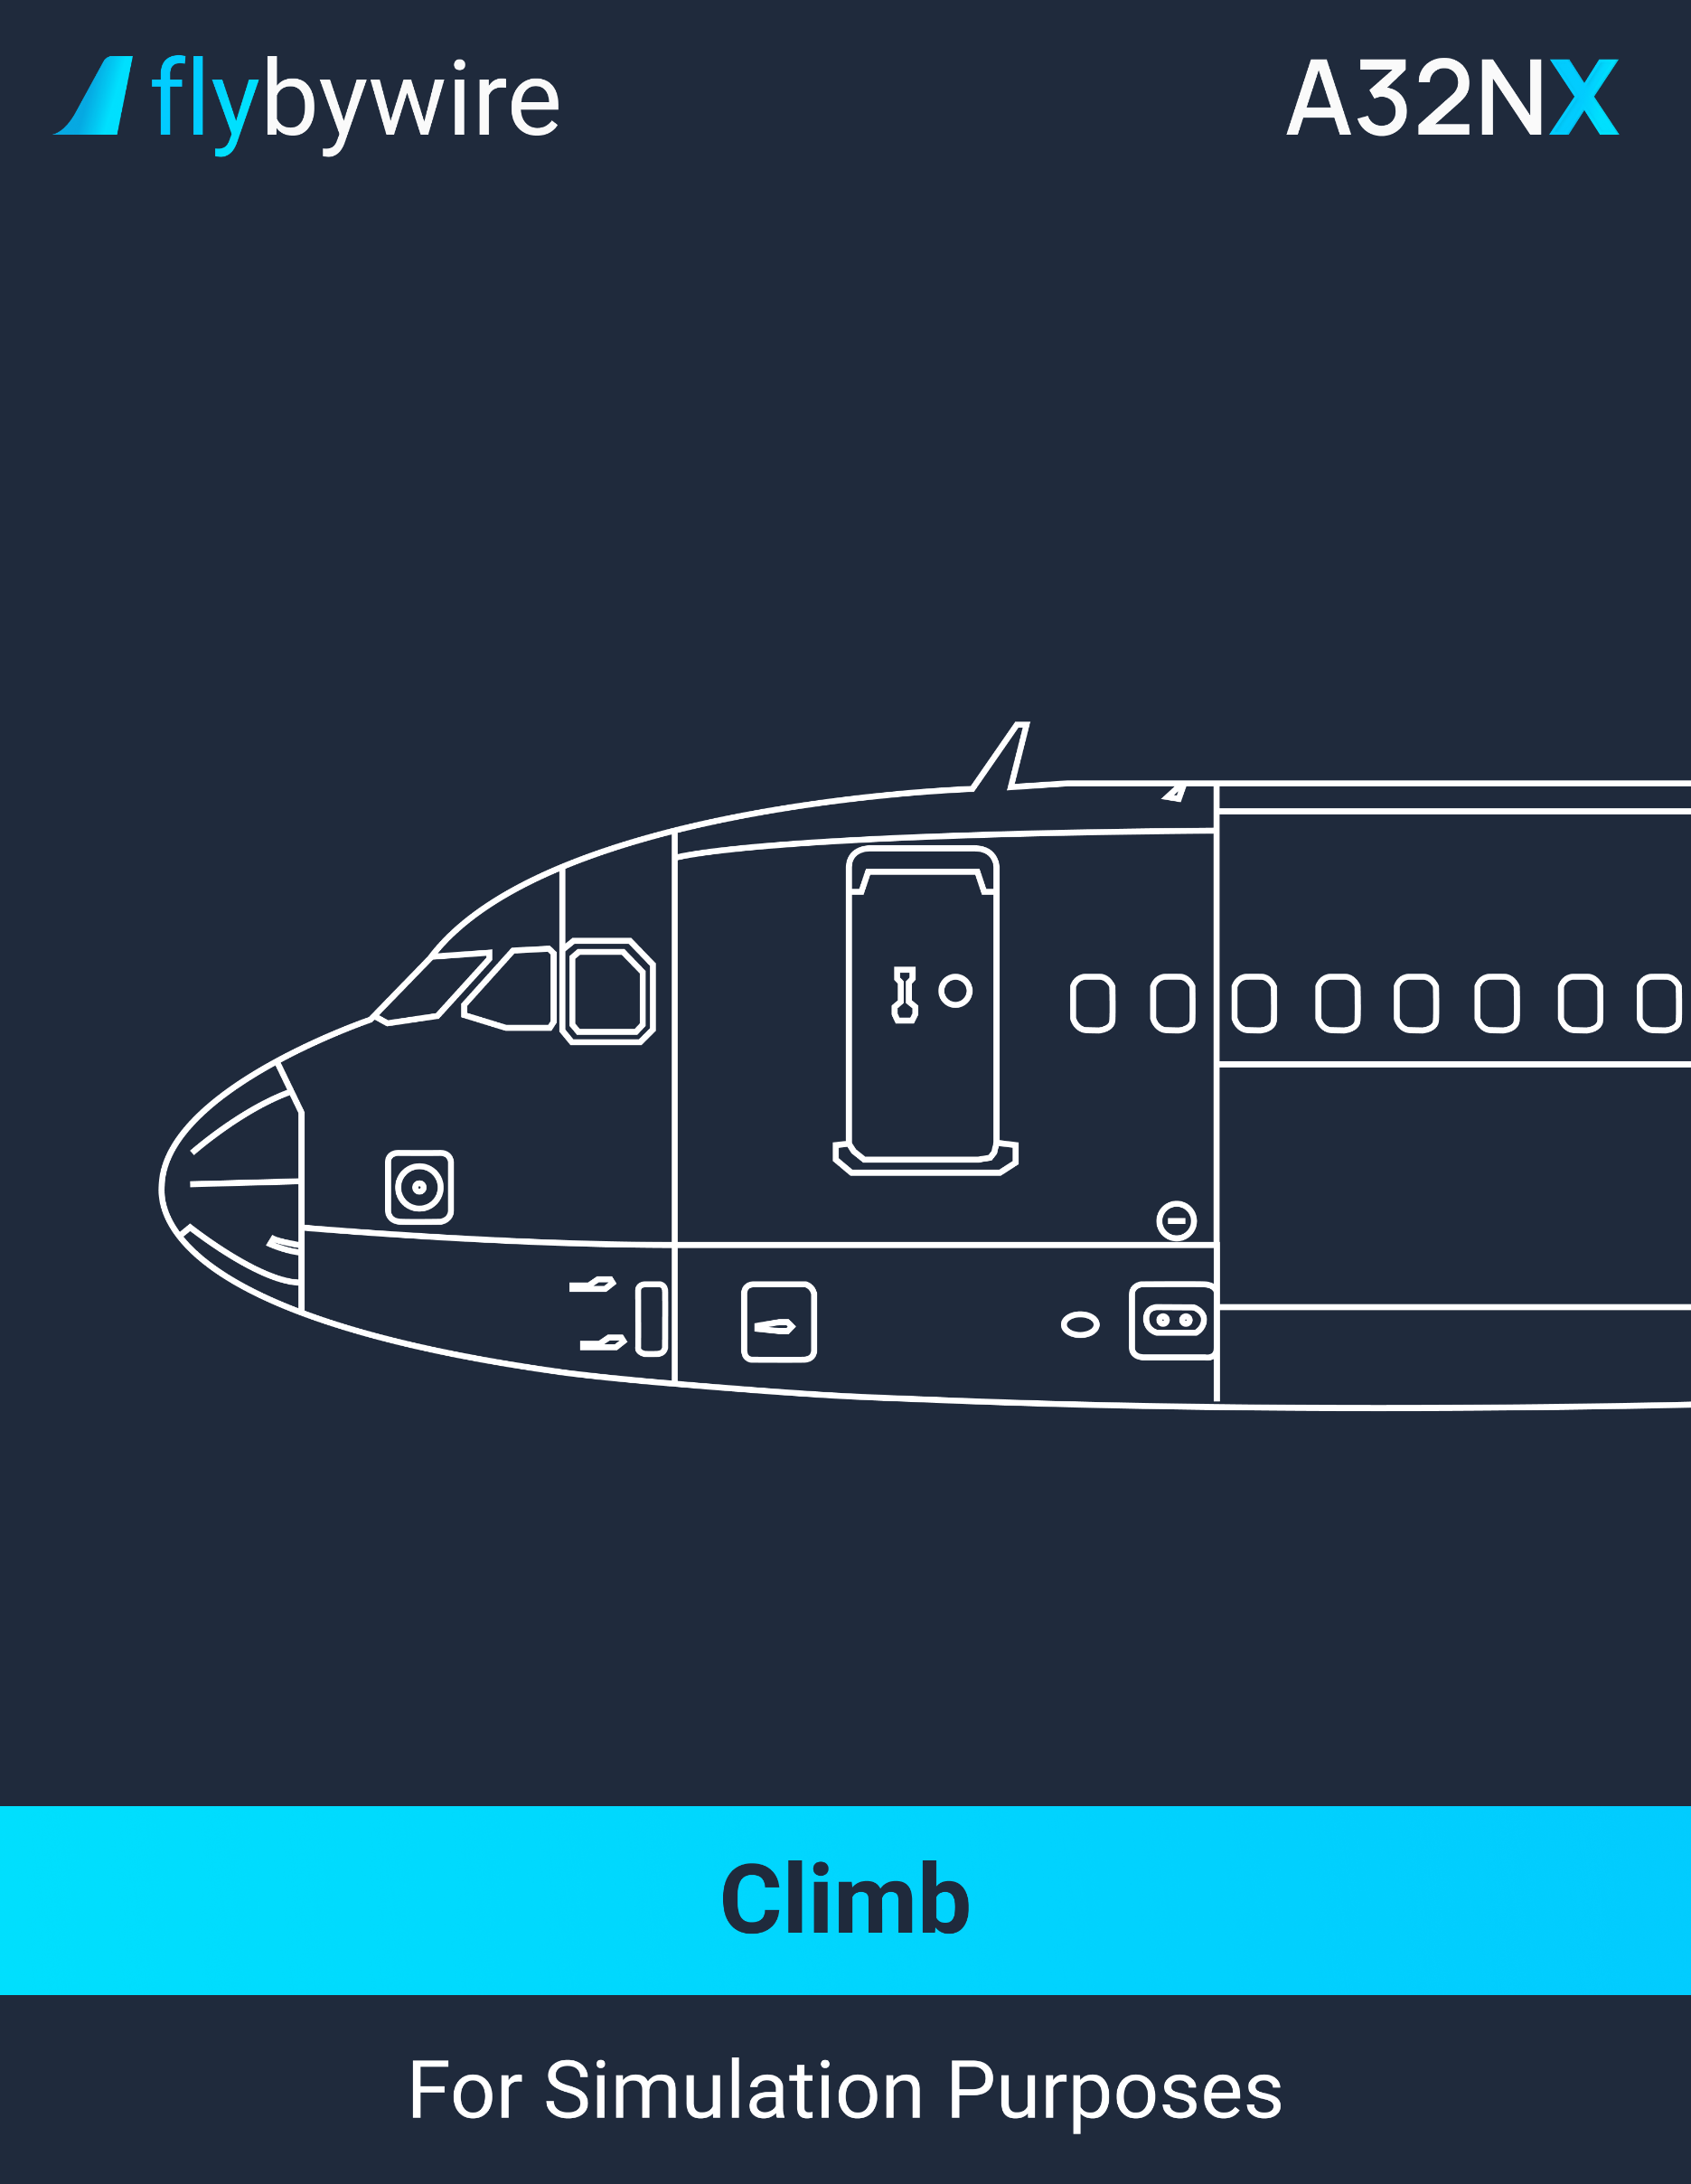

|  |
| --- |
| **Climb** |

PF | MCDU. . . . . . . . . . . . . . . . . . . . . . . . . . . . . . . . . . . . . . . . . . . . . . . . . . . . **PERF CLB**

It is recommended for the PF MCDU to display the PERF CLB page. This allows the PF to monitor the aircraft when it reaches the FCU selected altitude.

PM | MCDU. . . . . . . . . . . . . . . . . . . . . . . . . . . . . . . . . . . . . . . . . . . . . . . . . . . . . . . . **F-PLN**

It is recommended for the PM MCDU to display the F-PLN page. This allows the PM to enter a long-term revision to the lateral or vertical flight plan.

**Climb Speed Modifications**

PF | FCU SPD. . . . . . . . . . . . . . . . . . . . . . . . . . . . . . . . . . . . . **SELECT AND PULL**

By pulling the FCU SPD knob, the speed target is in the selected mode. To return in managed speed mode, push the FCU SPD knob.

**Expedite Climb**

* + **If the ATC requires a rapid climb through a particular level:**

PF | EXP pushbutton. . . . . . . . . . . . . . . . . . . . . . . . . . . . . . . . . . . . . . **PUSH**

By pushing the EXP pushbutton, the aircraft enters the expedite climb mode. To return to the ECON CLB mode, push the ALT knob.

CM | BAROMETRIC REFERENCE. . . . . . . . . . . . . . . . **SET STD/CROSSCHECK**

Once the aircraft reach the transition altitude, set STD on the EFIS control panel and on the ISIS.

PF | CRZ FL. . . . . . . . . . . . . . . . . . . . . . . . . . . . . . . . . . . . . . . **SET AS REQUIRED**

**Checklist**

CM | AFTER TAKEOFF/CLIMB CHECKLIST below the line. . . . . . . . **COMPLETE**

PM | ENG ANTI-ICE pushbutton. . . . . . . . . . . . . . . . . . . . . . . . . . . **AS REQUIRED**

It is recommended to set the engine anti-ice to ON when icing conditions are present or are anticipated.

PF | RADAR. . . . . . . . . . . . . . . . . . . . . . . . . . . . . . . . . . . . . . . **AS APPROPRIATE**

**At 10 000 Feet**

PM | LAND LIGHTS selector. . . . . . . . . . . . . . . . . . . . . . . . . . . . . . . . . . **RETRACT**

PM | SEAT BELTS switch. . . . . . . . . . . . . . . . . . . . . . . . . . . . . . . . **AS REQUIRED**

CM | EFIS options. . . . . . . . . . . . . . . . . . . . . . . . . . . . . . . . . . . . . . **AS REQUIRED**

It is recommended to select CSTR on one ND and ARPT on the other ND.

PM | ECAM MEMO. . . . . . . . . . . . . . . . . . . . . . . . . . . . . . . . . . . . . . . . . . . **REVIEW**

PM | NAVAIDS. . . . . . . . . . . . . . . . . . . . . . . . . . . . . . . . . . . . . . . . . . . . . . . **CLEAR**

It is recommended to clear the manually tuned VORs from the MCDU RAD NAV page.

PM | SEC F-PLN page. . . . . . . . . . . . . . . . . . . . . . . . . . . . . . . . . . . **AS REQUIRED**

It is recommended to recopy the active flight plan in the secondary flight plan.

PM | OPT/MAX ALT. . . . . . . . . . . . . . . . . . . . . . . . . . . . . . . . . . . . . . . . . . . **VERIFY**

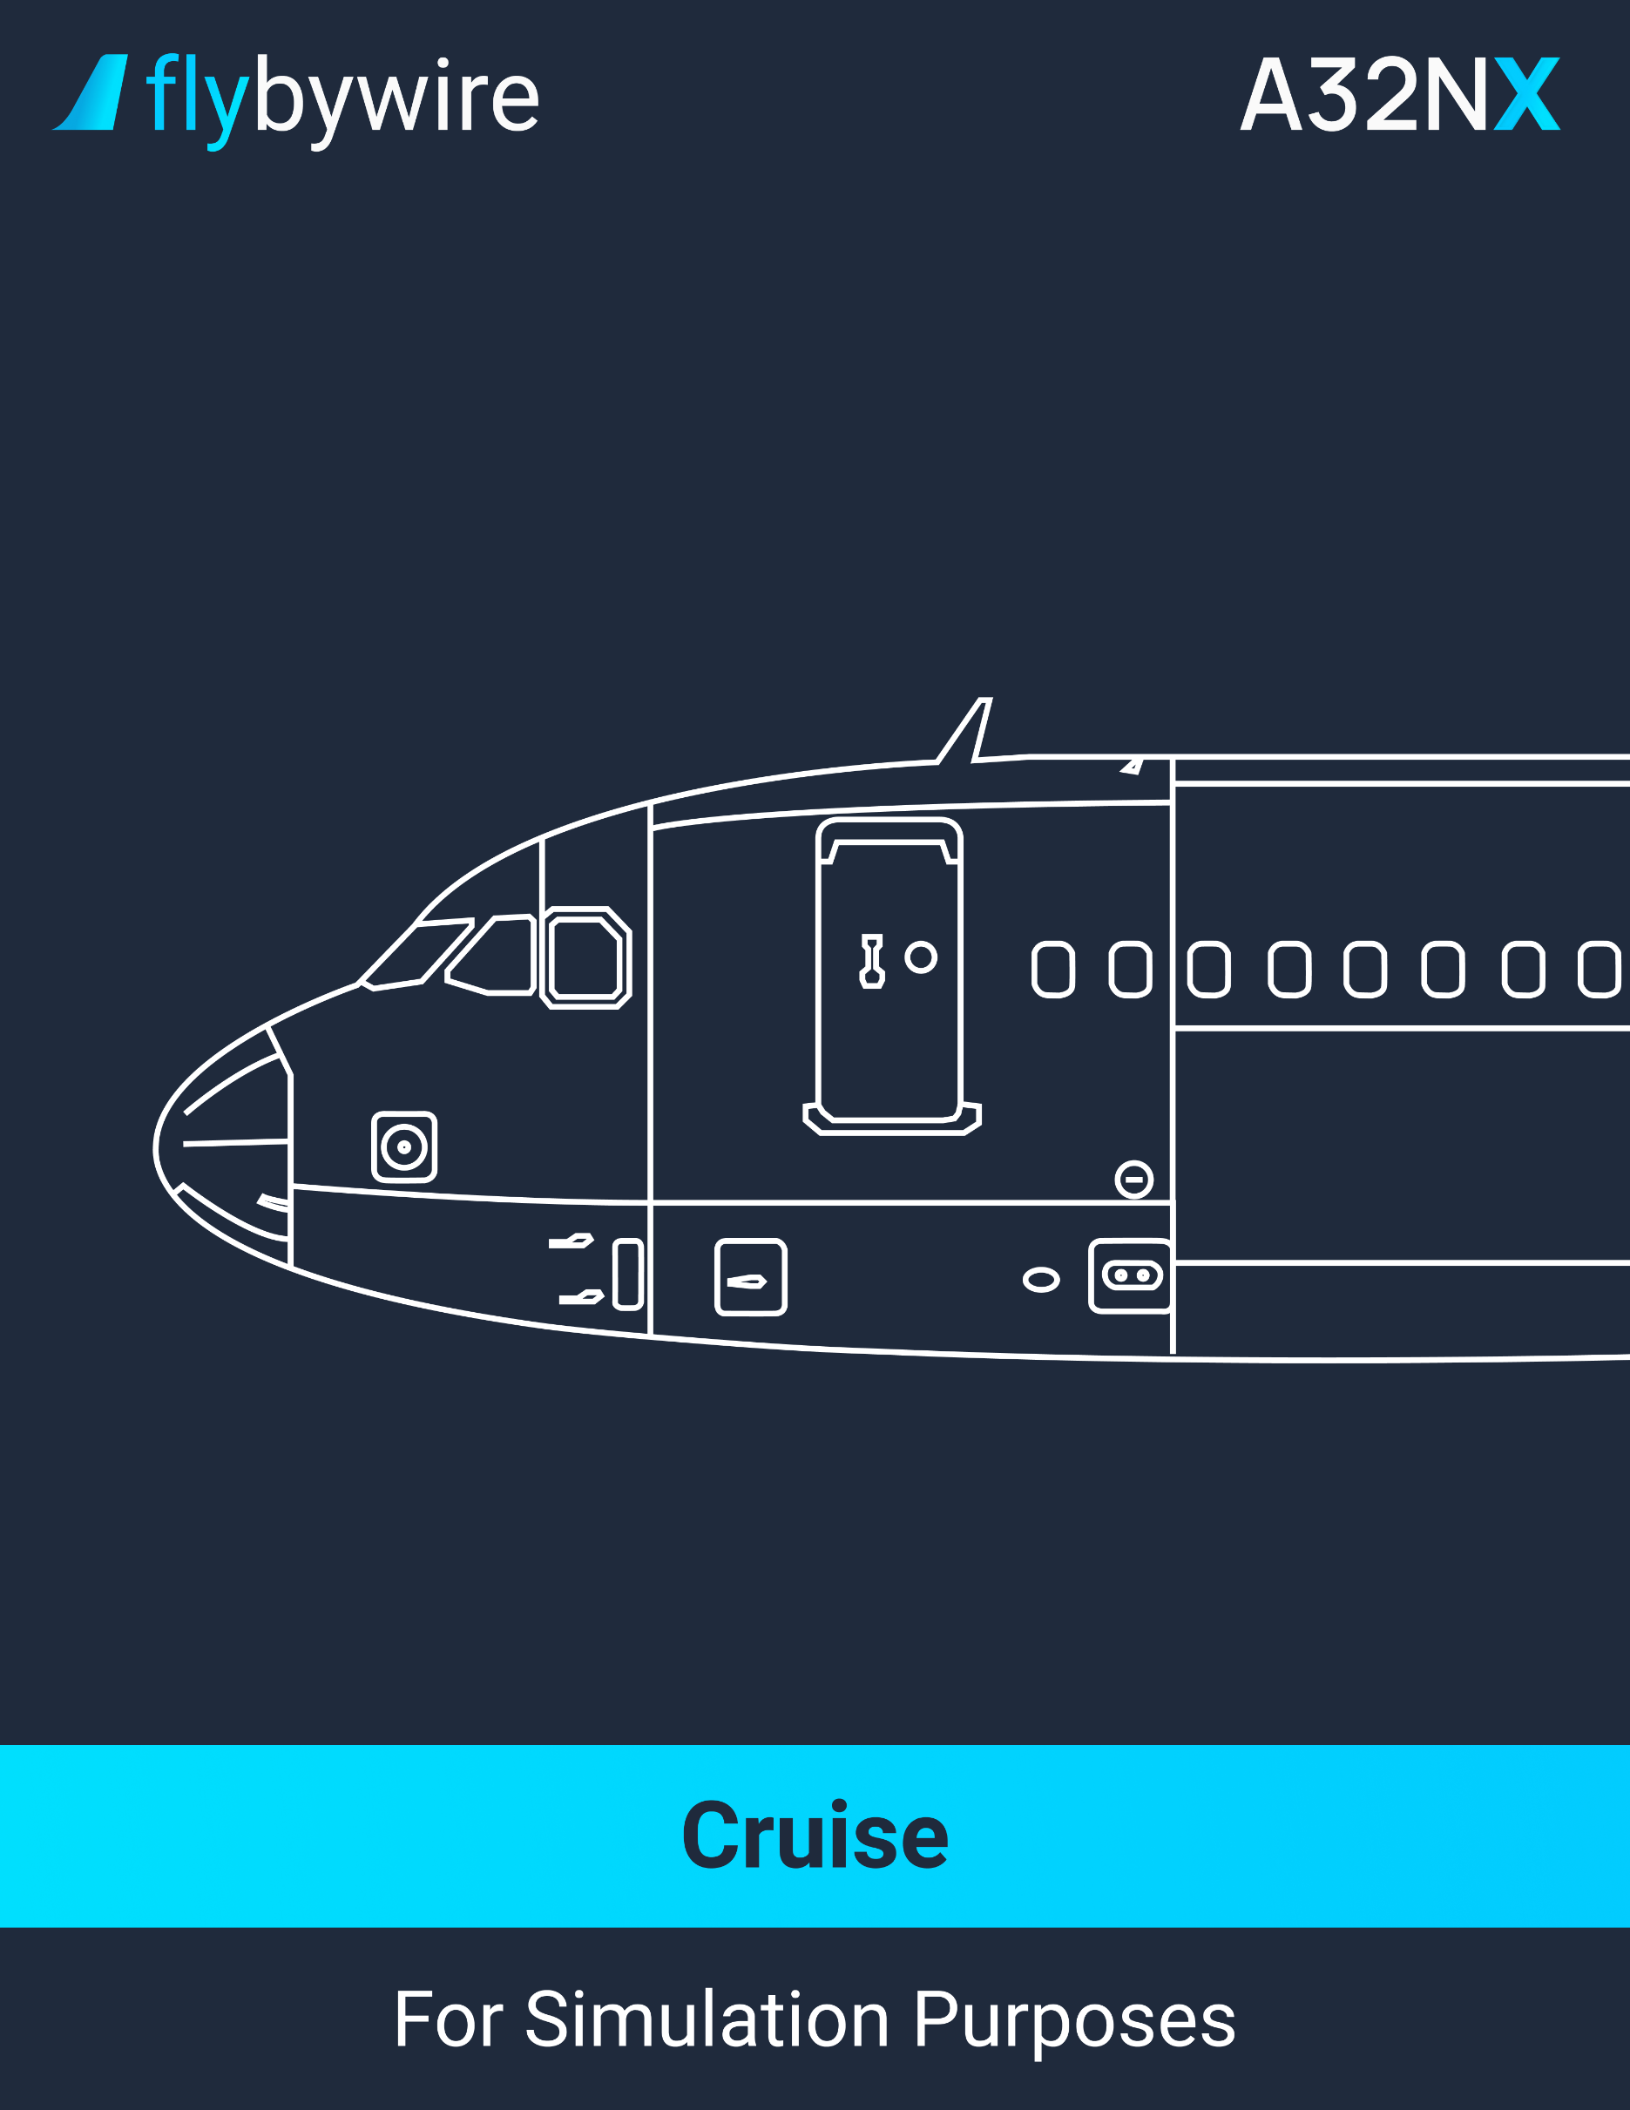

|  |
| --- |
| **Cruise** |

PF | ECAM MEMO. . . . . . . . . . . . . . . . . . . . . . . . . . . . . . . . . . . . . . . . . . . . . . . . . **REVIEW**

PF | ECAM SD PAGES. . . . . . . . . . . . . . . . . . . . . . . . . . . . . . . . . . . . . . . . . . . . . **REVIEW**

It is recommended to review regularly the following pages: ENG, BLEED, ELEC, HYD, FUEL, COND, FLT CTL, and DOOR.

PF | FLIGHT PROGRESS. . . . . . . . . . . . . . . . . . . . . . . . . . . . . . . . . . . . . . . . . . . . **VERIFY**

It is recommended to monitor the flight progress. When overflying a waypoint, verify the track and distance to the next waypoint. Each 30 minutes, verify the fuel on board from the ECAM, the fuel prediction from the FMGC, and compare the data with the flight plan. Ensure that the fuel on board and fuel consumed is consistent with the fuel on board at departure.

PF | STEP FLIGHT LEVEL. . . . . . . . . . . . . . . . . . . . . . . . . . . . . . . . . **AS APPROPRIATE**

PF | RADAR. . . . . . . . . . . . . . . . . . . . . . . . . . . . . . . . . . . . . . . . . . . . . **AS APPROPRIATE**

* + **If the oxygen mask has been used:**

CM | OXYGEN MASK. . . . . . . . . . . . . . . . . . . . . . . . . . . . . . . . . . . . **VERIFY**

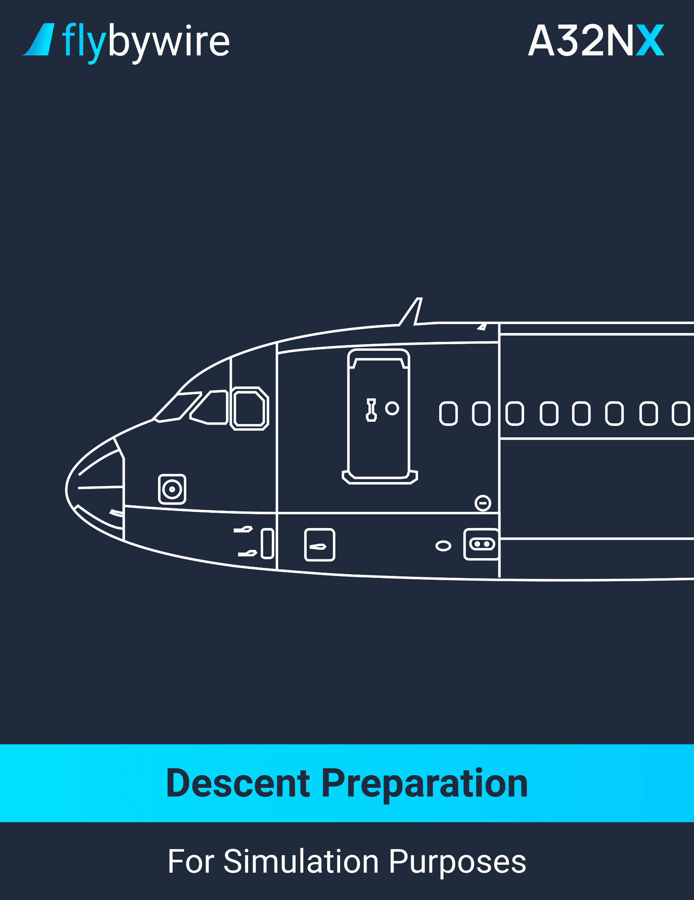

|  |
| --- |
| **Descent Preparation** |

PM | WEATHER AND LANDING INFORMATION. . . . . . . . . . . . . . . . . . . . . . . . . **OBTAIN**

Verify the weather reports at the destination and the alternate airport. This should include the runway in use for the arrival.

CM | NAV CHARTS. . . . . . . . . . . . . . . . . . . . . . . . . . . . . . . . . . . . . . . . . . . . . . **PREPARE**

PM | LDG PERFORMANCE. . . . . . . . . . . . . . . . . . . . . . . . . . . . . . . . . . . . . . . **COMPUTE**

It is recommended to perform an in-flight landing performance calculation in case the landing conditions has changed since departure. If the landing conditions are expected to change, it is recommended to compute with the worst possible runway conditions. Furthermore, the selection of REV MAX is the standard practice for landing.

CM | LDG PERFORMANCE. . . . . . . . . . . . . . . . . . . . . . . . . . . . . . . . . . . . . . . . . . **VERIFY**

CM | ARRIVAL page. . . . . . . . . . . . . . . . . . . . . . . . . . . . . . . . . . . . . **COMPLETE/VERIFY**

If possible, insert the APPR, STAR, APPR VIA and TRANS.

CM | F-PLN A page. . . . . . . . . . . . . . . . . . . . . . . . . . . . . . . . . . . . . . . . . . . . . . . . . **VERIFY**

Ensure that the inserted flight plan agrees with the planned and missed approach. Ensure that they respect the restrictions from the charts. The flight crew may require adding a new speed or altitude constraint.

It is not recommended to modify the final approach fix (FAF to runway or MAP).

In case of a “TOO STEEP PATH” message appearing, do not use the FINAL APP guidance for approach.

CM | DES WIND page. . . . . . . . . . . . . . . . . . . . . . . . . . . . . . . . . . . . . . . . . . . . . . **VERIFY**

CM | PERF CRUISE page. . . . . . . . . . . . . . . . . . . . . . . . . . . . . . . . . . . . . . . . . . . **VERIFY**

CM | PERF DES page. . . . . . . . . . . . . . . . . . . . . . . . . . . . . . . . . . . . . . . . . . . . . . **VERIFY**

Before starting the descent, it is recommended to access the PERF DES page and verify the ECON MACH/SPD. If any other speed is required other than the ECON speed, insert that MACH or SPD into the ECON field. This allows the system to calculate the descent path and the top of descent.

Note: The default speed limit is 250 knots below 10 000 feet. The flight crew may modify on the VERT REV at the DEST page.

CM | PERF APPR page. . . . . . . . . . . . . . . . . . . . . . . . . . . . . . . . . . . **COMPLETE/VERIFY**

Insert the QNH, the temperature, the wind at destination and the minimum. It is not recommended to insert gust values.

Note: If there is a change of runway or a change in the approach type, it will automatically erase the inserted minimum.

CM | PERF GO-AROUND page. . . . . . . . . . . . . . . . . . . . . . . . . . . . . . . **VERIFY/MODIFY**

Verify the thrust reduction altitude and the acceleration altitude. The flight crew may modify if necessary.

CM | RAD NAV page. . . . . . . . . . . . . . . . . . . . . . . . . . . . . . . . . . . . . . . . . . . . . . .**VERIFY**

Set the navaids as required. Verify the idents on the navigation display and on the primary flight display. If a VOR/DME exists close to the airfield, it is recommended to select it and enter its ident in the BRG/DIST field of the PROG page. This allows the monitoring of NAV ACCY during descent.

CM |SEC F-PLN page. . . . . . . . . . . . . . . . . . . . . . . . . . . . . . . . . . . . . . . . . **AS REQUIRED**

It is recommended to set the secondary flight plan to the alternate runway for destination, or to the landing runway in case of a circling approach.

PM | GPWS LDG FLAP 3 pushbutton. . . . . . . . . . . . . . . . . . . . . . . . . . . . **AS REQUIRED**

If the flight crew plans on landing with the FLAPS 3 configuration, the GPWS LDG FLAP 3 must be set to ON.

PF | LDG ELEV. . . . . . . . . . . . . . . . . . . . . . . . . . . . . . . . . . . . . . . . . . . . . . . . . . . . **VERIFY**

Ensure that the LDG ELEV AUTO displays in green on the ECAM CRUISE page and verify the associated value.

PF | AUTO BRK. . . . . . . . . . . . . . . . . . . . . . . . . . . . . . . . . . . . . . . . . . . . . **AS REQUIRED**

It is recommended to use the autobrakes. For short or contaminated runways, the MED mode is recommended. For long runways, the LO mode is recommended. It is not recommended to use the MAX mode.

CM | APPROACH BRIEFING. . . . . . . . . . . . . . . . . . . . . . . . . . . . . . . . . . . . . . **PERFORM**

CM | TERR ON ND. . . . . . . . . . . . . . . . . . . . . . . . . . . . . . . . . . . . . . . . . . . **AS REQUIRED**

It is recommended to set the weather radar to the PF side and the TERR ON ND on the PM side. It is not recommended to use the TERR ON ND if the nav accuracy is low.

PF | RADAR. . . . . . . . . . . . . . . . . . . . . . . . . . . . . . . . . . . . . **ADJUST AS APPROPRIATE**

PM | ENG ANTI-ICE pushbutton. . . . . . . . . . . . . . . . . . . . . . . . . . . . . . . . . **AS REQUIRED**

It is recommended to set the engine anti-ice to ON, even if the SAT is below -40°C. This ensures a better protection against flame-out.

PM | WING ANTI-ICE pushbutton. . . . . . . . . . . . . . . . . . . . . . . . . . . . . . . . **AS REQUIRED**

Note: When turning the anti-ice on, it reduces the descent path angle. The pilot can therefore compensate by increasing the descent speed or by extending up to half speedbrakes.

PM | DESCENT CLEARANCE. . . . . . . . . . . . . . . . . . . . . . . . . . . . . . . . . . . . . . . . **OBTAIN**

PF | CLEARED ALTITUDE ON FCU. . . . . . . . . . . . . . . . . . . . . . . . . . . . . . . . . . . . . . **SET**

Ensure that the cleared altitude is lower than the ATC-cleared altitude.

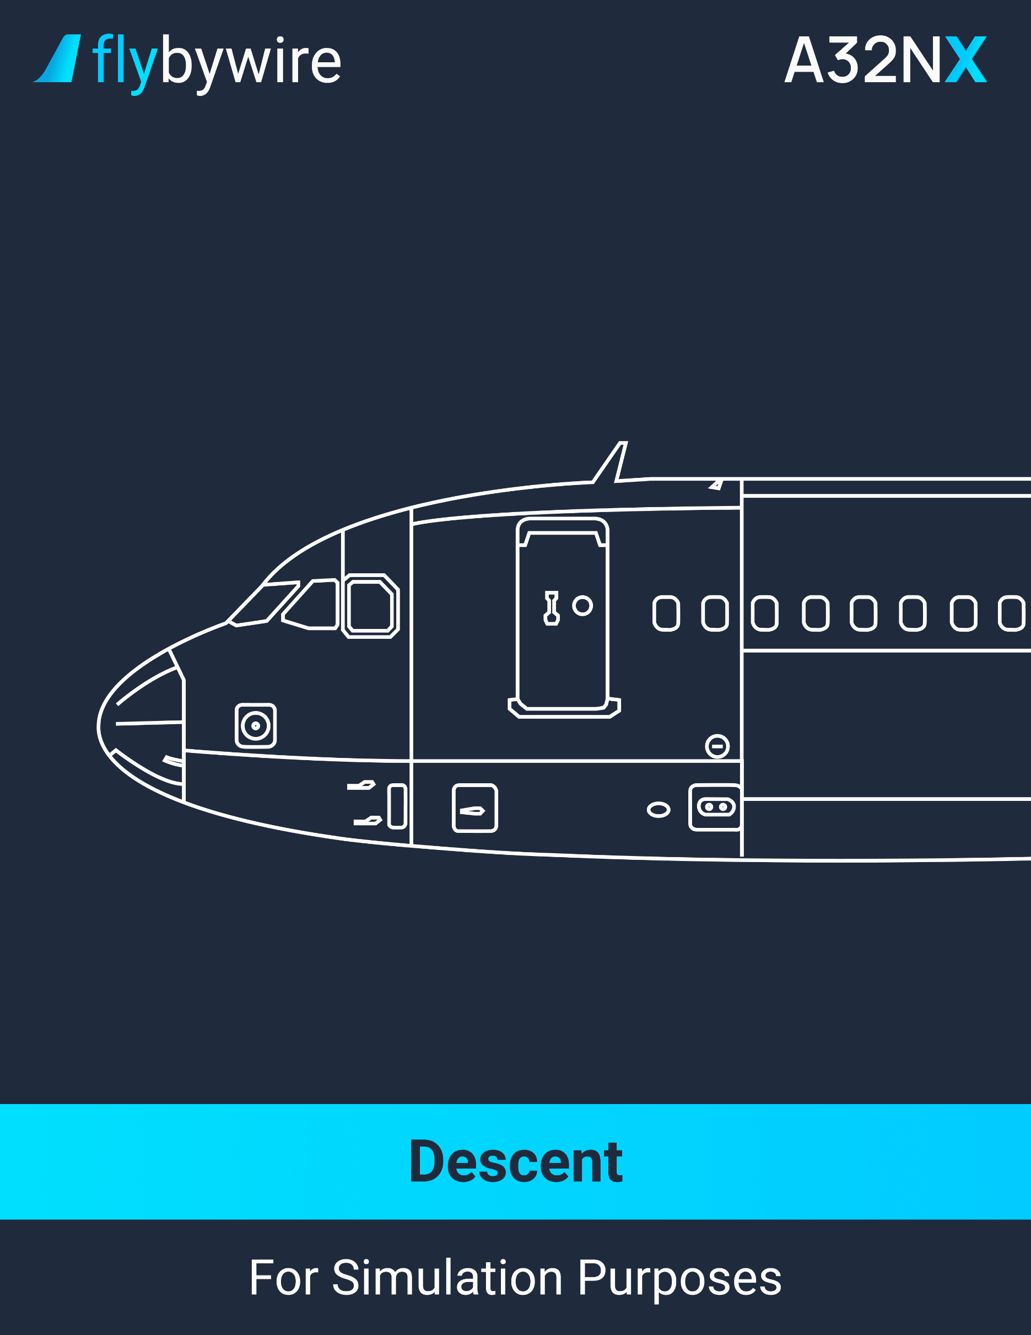

|  |
| --- |
| **Descent Initiation** |

PF | DESCENT. . . . . . . . . . . . . . . . . . . . . . . . . . . . . . . . . . . . . . . . . . . . . . . . . . . **INITIATE**

It is recommended to select the DES mode at the top of descent.

|  |
| --- |
| **Descent Monitoring** |

PF | MCDU. . . . . . . . . . . . . . . . . . . . . . . . . . . . . . . . . . . . . . . . . . . . . . . **PROG/PERF DES**

It is recommended for the PF to display the PROG page to get the VDEV or RQD DIST TO LAND/DIRECT DIST TO LAND information. The PF can also select the PERF DES page to get predictions to any inserted altitude in the DES/OP DES and EXP mode.

PM | MCDU. . . . . . . . . . . . . . . . . . . . . . . . . . . . . . . . . . . . . . . . . . . . . . . . . . . . . . . . **F-PLN**

PF | DESCENT. . . . . . . . . . . . . . . . . . . . . . . . . . . . . . . . . . . . . . . . . . **MONITOR/ADJUST**

It is recommended to use the DES mode when flying in the NAV mode. This allows the aircraft to descend along the descent flight path, considering all constraints.

Note: When the aircraft is flying in HDG or TRK mode, the DES mode is not available.

|  |
| --- |
| **Descent Adjustment** |

To increase the rate of descent, it is recommended to increase the descent speed using selected speed. It allows better fuel economy than other techniques.

CM | BAROMETRIC REFERENCE. . . . . . . . . . . . . . . . . . . . . . . . . . . . . . . . . . . . . . . **SET**

Set the QNH on the EFIS control panel and on the ISIS at the transition altitude.

PM | ECAM STATUS. . . . . . . . . . . . . . . . . . . . . . . . . . . . . . . . . . . . . . . . . . . . . . . **VERIFY**

Ensure that there is no status reminder on the upper ECAM display. Note any degradation in landing capability or affecting approach and landing.

**At 10 000 feet**

PM | LAND lights. . . . . . . . . . . . . . . . . . . . . . . . . . . . . . . . . . . . . . . . . . . . . . . . **SET**

PM | SEAT BELTS switch. . . . . . . . . . . . . . . . . . . . . . . . . . . . . . . . . . . . . . . . . . **ON**

CM | EFIS options. . . . . . . . . . . . . . . . . . . . . . . . . . . . . . . . . . . . . . . . . . . . . . **CSTR**

It is recommended to select CSTR on both sides.

CM | ILS/LS pushbutton. . . . . . . . . . . . . . . . . . . . . . . . . . . . . . . . . . **AS REQUIRED**

It is recommended to turn on the ILS/LS if an ILS, GLS, MLS, ILS G/S out, LOC only, LOC/BC or FLS approaches. The flight crew must ensure that the deviation scales and IDENT are displayed on the PFD.

PM | RAD NAVAIDS. . . . . . . . . . . . . . . . . . . . . . . . . . . . . **SELECTED/IDENTIFIED**

The flight crew must ensure that the appropriate NAVAIDS are tuned and identified.

PF | NAV ACCURACY. . . . . . . . . . . . . . . . . . . . . . . . . . . . . . . . . . . . . . . . . **VERIFY**

If the GPS PRIMARY function is available, there is no accuracy check required.

|  |
| --- |
| **Approach Checklist** |

CM | APPROACH CHECKLIST. . . . . . . . . . . . . . . . . . . . . . . . . . . . . . . . . . . . . **PERFORM**

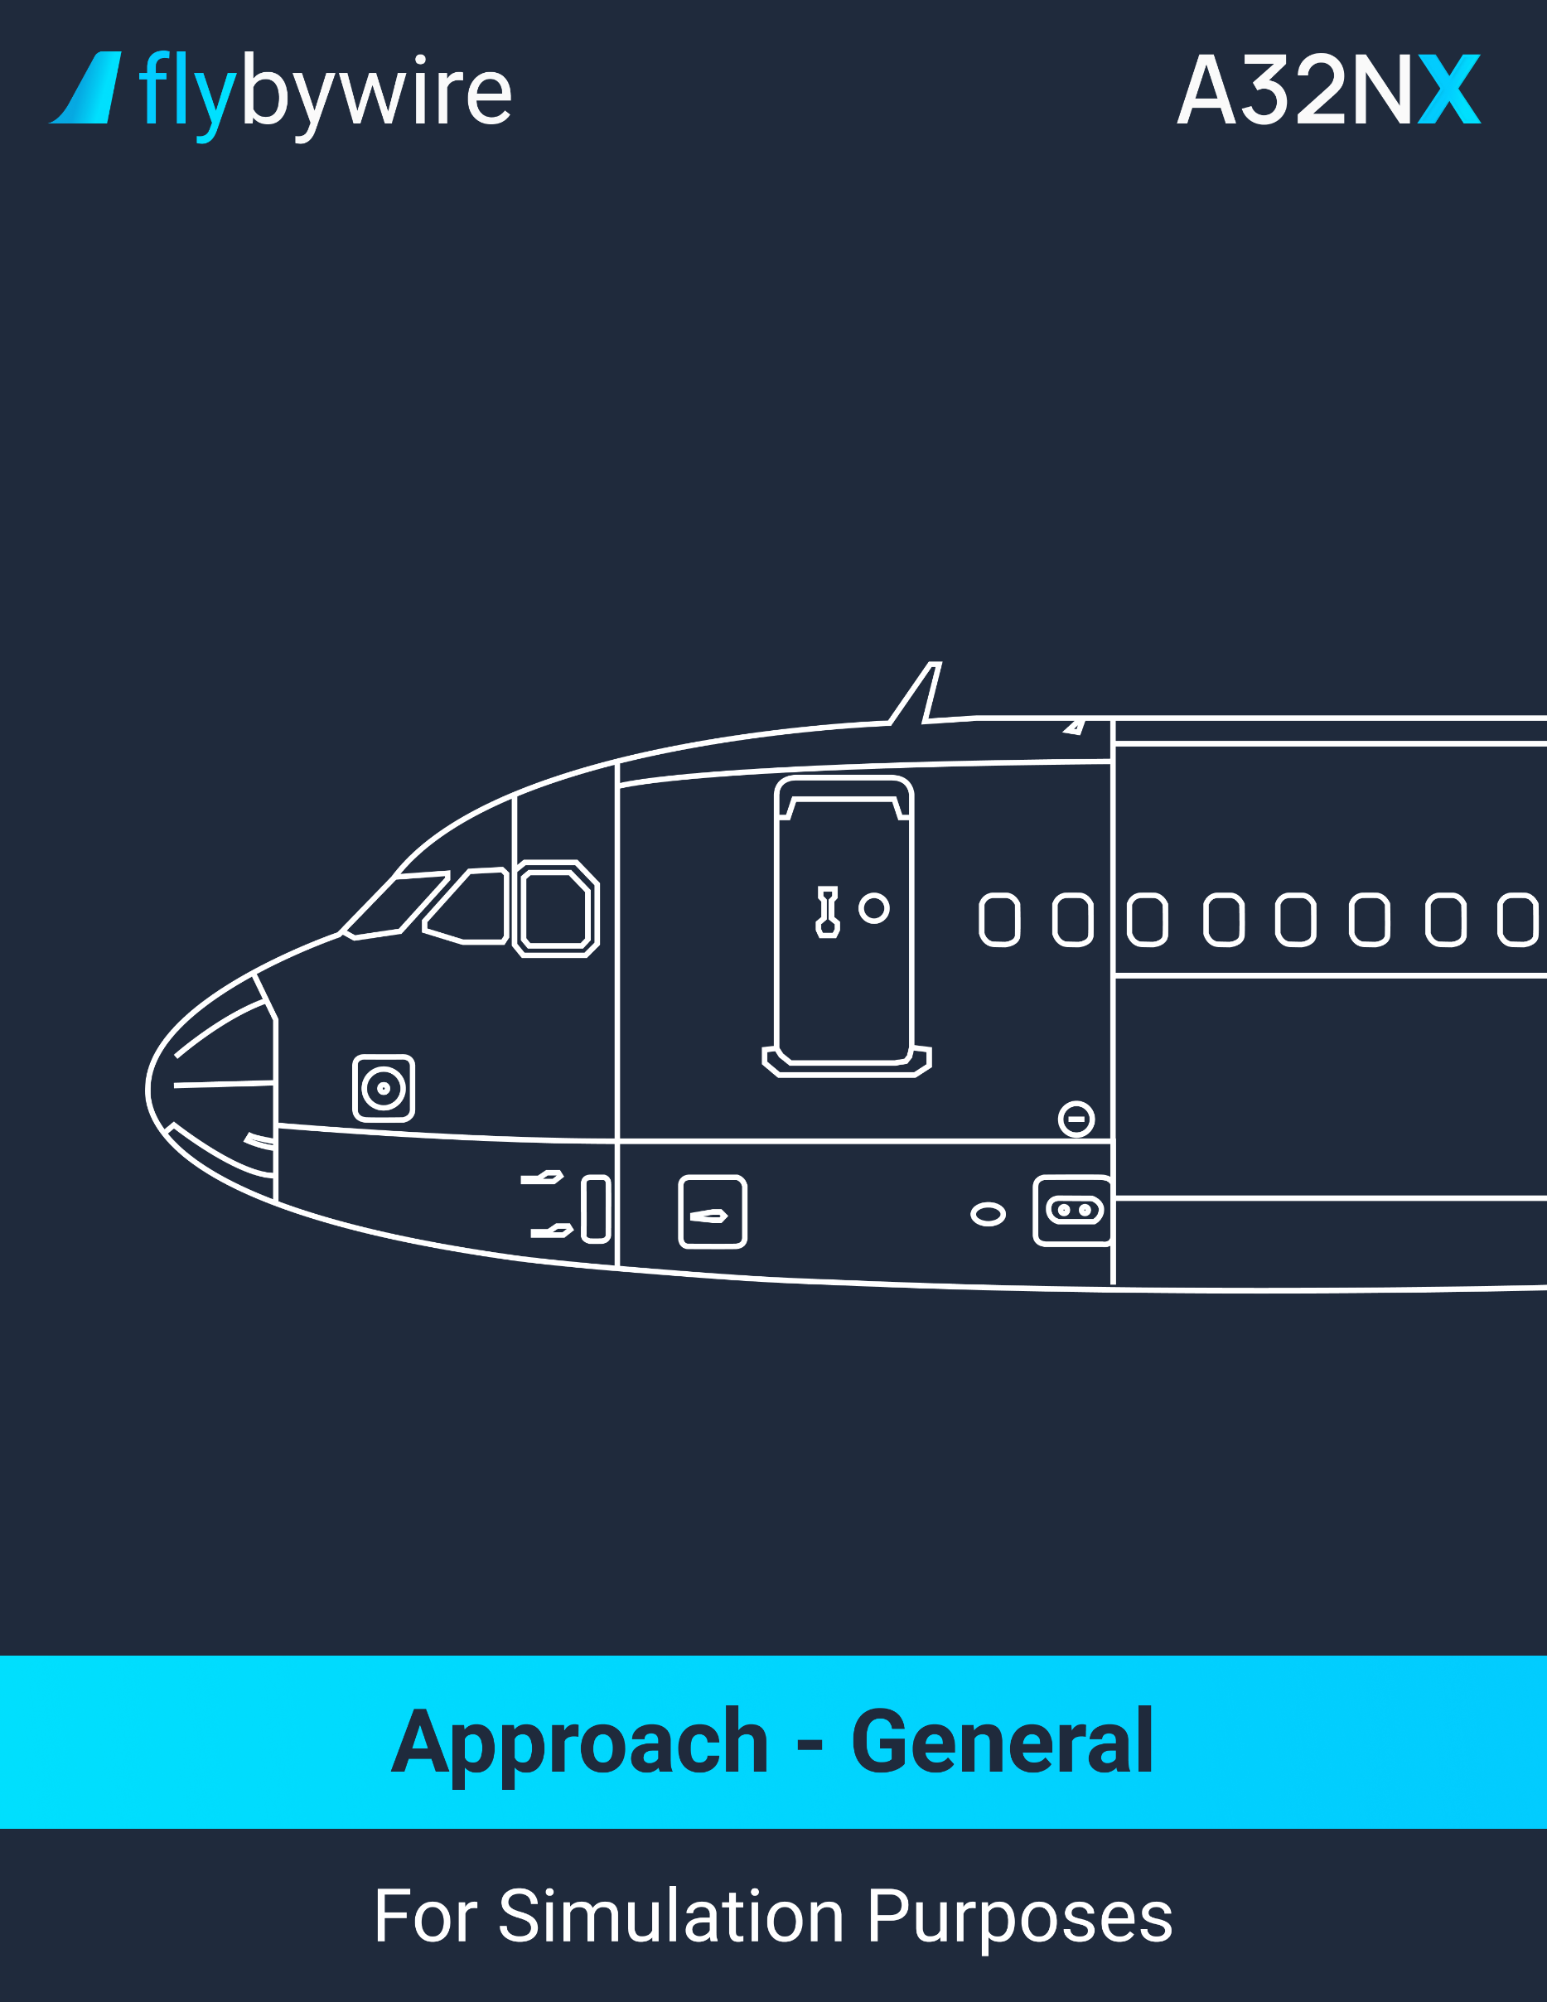

|  |
| --- |
| **Guidance Mode per Approach Types** |

|  |  |  |  |  |  |
| --- | --- | --- | --- | --- | --- |
|  | **LOC G/S** | **FINAL APP** | **LOC FPA** | **NAV FPA** | **TRK FPA** |
| **ILS / MLS / GLS** | Refer to APPR using LOC/GS | N/A | N/A | N/A | N/A |
| **LOC ONLY**  **ILS G/S OUT** | N/A | N/A | Refer to APPR using FPA Guidance | N/A | N/A |
| **LOC B/C** | N/A | N/A | N/A | N/A | Refer to APPR using FPA Guidance |
| **RNAV (GNSS) with LNAV/VNAV minima** | N/A | Refer to APPR using FINAL APP | N/A | Not authorized | Not authorized |
| **RNAV (GNSS) with LNAV minima** | N/A | Refer to APPR using FINAL APP | N/A | N/A | Not authorized |
| **RNAV (GNSS) with LPV minima** | N/A | Not authorized | N/A | Not authorized | Not authorized |
| **VOR**  **VOR-DME**  **NDB**  **NDB-DME** | N/A | Refer to APPR using FINAL APP | N/A | Refer to APP using FPA Guidance | Refer to APPR using FPA Guidance |
| **RNAV (RNP)** | N/A |  | N/A | Not Authorized | Not Authorized |

|  |
| --- |
| **Initial Approach - General** |

**Initial Approach**

PF | F-PLN SEQUENCING. . . . . . . . . . . . . . . . . . . . . . . . . . . . . . . . . . . . . **ADJUST**

The NAV mode will be automatically available after go-around if the flight plan is properly sequenced. If flying in nav mode, the F-PLN will sequence automatically. In HDG/TRK mode, the F-PLN will only sequence automatically if flying close to the F-PLN route.

CM | APPROACH PHASE. . . . . . . . . . . . . . . . . . . . . . . . . . . . . **VERIFY/ACTIVATE**

If flying in NAV mode, the approach phase will automatically activate itself if the aircraft overlies the DECEL pseudo waypoint. If flying in HDG/TRK mode, it is recommended to activate the approach phase 15 NM from touchdown.

PF | MANAGED SPEED. . . . . . . . . . . . . . . . . . . . . . . . . . . . . . . . . . . . . . . **VERIFY**

It is recommended to remain in managed speed mode. If, for any reasons, the ATC requires a different speed, use the selected speed mode.

PF | FLIGHT PATH. . . . . . . . . . . . . . . . . . . . . . . . . . . . . . . . . . . . . . . . . **MONITOR**

If flying in NAV mode, it is recommended to use the VDEV information on the PFD and PROG MCDU page. If flying in HDG/TRK mode, it is recommended to use the energy circle on the ND.

PF | SPEED BRAKES lever. . . . . . . . . . . . . . . . . . . . . . . . . . . . . . . **AS REQUIRED**

It is recommended to avoid the use of the speed brakes. In the case of the use of the speedbrakes, the flight crew should ensure that there is an appropriate speed margin before the extension of the speed brakes. The flight crew should also ensure that there is an appropriate speed margin before the beginning of a turn. This is to ensure that the Alpha-Floor protection doesn’t activate.

PF | RADAR. . . . . . . . . . . . . . . . . . . . . . . . . . . . . . . . **ADJUST AS APPROPRIATE**

PM | NAV ACCURACY. . . . . . . . . . . . . . . . . . . . . . . . . . . . . . . . . . . . . . . **MONITOR**

If the GPS PRIMARY function is available, there is no accuracy check required.

|  |
| --- |
| **Intermediate/Final Approach - General** |

**At Green Dot Speed**

PF | FLAPS 1. . . . . . . . . . . . . . . . . . . . . . . . . . . . . . . . . . . . . . . . . . . . . . . . **ORDER**

PM | FLAPS 1. . . . . . . . . . . . . . . . . . . . . . . . . . . . . . . . . . . . . . . . . . . . . . . **SELECT**

It is recommended to select the FLAPS 1 3 NM before the final descent point. The aircraft should also decelerate. If the aircraft does not decelerate, the flight crew should consider the extension of the landing gear before the extension of speedbrakes. The extension of the speedbrakes at this point will cause an increase in VLS.

PM | TCAS MODE selector. . . . . . . . . . . . . . . . . . . . . . . . . . . . . . . . . **TA or TA/RA**

It is recommended the use of **TA/RA** for normal situations. If it is inappropriate, such as converging runways or parallel runways, the use of TA ONLY mode is recommended.

**At 2 000 Feet AGL Minimum**

PF | FLAPS 2. . . . . . . . . . . . . . . . . . . . . . . . . . . . . . . . . . . . . . . . . . . . . . . . **ORDER**

PM | FLAPS 2. . . . . . . . . . . . . . . . . . . . . . . . . . . . . . . . . . . . . . . . . . . . . . . **SELECT**

The flight crew must notice a deceleration toward the F speed. The flight crew should consider extending the landing gear to reduce the airspeed. The use of speedbrakes is not recommended.

**When Flaps Are At 2**

PF | L/G DOWN. . . . . . . . . . . . . . . . . . . . . . . . . . . . . . . . . . . . . . . . . . . . . . **ORDER**

PM | L/G lever. . . . . . . . . . . . . . . . . . . . . . . . . . . . . . . . . . . . . . . . . **SELECT DOWN**

PM | AUTO BRK. . . . . . . . . . . . . . . . . . . . . . . . . . . . . . . . . . . . . . . . . . . . **CONFIRM**

PM | GROUND SPOILERS. . . . . . . . . . . . . . . . . . . . . . . . . . . . . . . . . . . . . . . . **ARM**

**Exterior Lights**

PM | NOSE switch. . . . . . . . . . . . . . . . . . . . . . . . . . . . . . . . . . . . . . . . . . . . . . . **T.O**

PM | RWY TURN OFF switch. . . . . . . . . . . . . . . . . . . . . . . . . . . . . . . . . . . . . . . **ON**

**When Landing Gear is Down**

PF | FLAPS 3. . . . . . . . . . . . . . . . . . . . . . . . . . . . . . . . . . . . . . . . . . . . . . . . **ORDER**

PM | FLAPS 3. . . . . . . . . . . . . . . . . . . . . . . . . . . . . . . . . . . . . . . . . . . . . . . **SELECT**

PM | ECAM WHEEL SD page. . . . . . . . . . . . . . . . . . . . . . . . . . . . . . . . . . . **CHECK**

PM | L/G lights. . . . . . . . . . . . . . . . . . . . . . . . . . . . . . . . **CONFIRM THREE GREEN**

PF | FLAPS FULL. . . . . . . . . . . . . . . . . . . . . . . . . . . . . . . . . . . . . . . . . . . . **ORDER**

PM | FLAPS FULL. . . . . . . . . . . . . . . . . . . . . . . . . . . . . . . . . . . . . . . . . . . **SELECT**

It is recommended to retract the speedbrakes before selecting the FLAPS full. This prevents the aircraft to pitch down when the speedbrakes retracts automatically.

PM | A/THR. . . . . . . . . . . . . . . . . . . . . . . . . . . **VERIFY IN SPEED MODE OR OFF**

PM | WING ANTI-ICE pushbutton. . . . . . . . . . . . . . . . . . . . . . . . . . . . . . . . . . . **OFF**

Only turn the wing anti-ice ON when there are severe icing conditions.

CM | SLIDING TABLE. . . . . . . . . . . . . . . . . . . . . . . . . . . . . . . . . . . . . . . . . . . **STOW**

CM | ALL EFB. . . . . . . . . . . . . . . . . . . . . . . . . . . . . . . . . . . . . . . . . . . . . . . . **STOW**

PM | LDG MEMO. . . . . . . . . . . . . . . . . . . . . . . . . . . . . . . . . . . . **VERIFY NO BLUE**

CM | CABIN REPORT. . . . . . . . . . . . . . . . . . . . . . . . . . . . . . . . . . . . . . . . **RECEIVE**

PM | CABIN CREW. . . . . . . . . . . . . . . . . . . . . . . . . . . . . . . . . . . . . . . . . . . **ADVISE**

CM | LANDING CHECKLIST. . . . . . . . . . . . . . . . . . . . . . . . . . . . . . . . . **COMPLETE**

PM | FLIGHT PARAMETERS. . . . . . . . . . . . . . . . . . . . . . . . . . . . . . . . . . **MONITOR**

The PF should announce any FMA modification. The PM should call out in the following conditions:

* the speed goes lower than the speed target -5 kt, or greater than the speed target +10 kt;
* The pitch attitude is lower than -2.5° or greater than 7.5°;
* The bank angle is greater than 7°;
* The descent rate is greater than 1 000 ft/min.

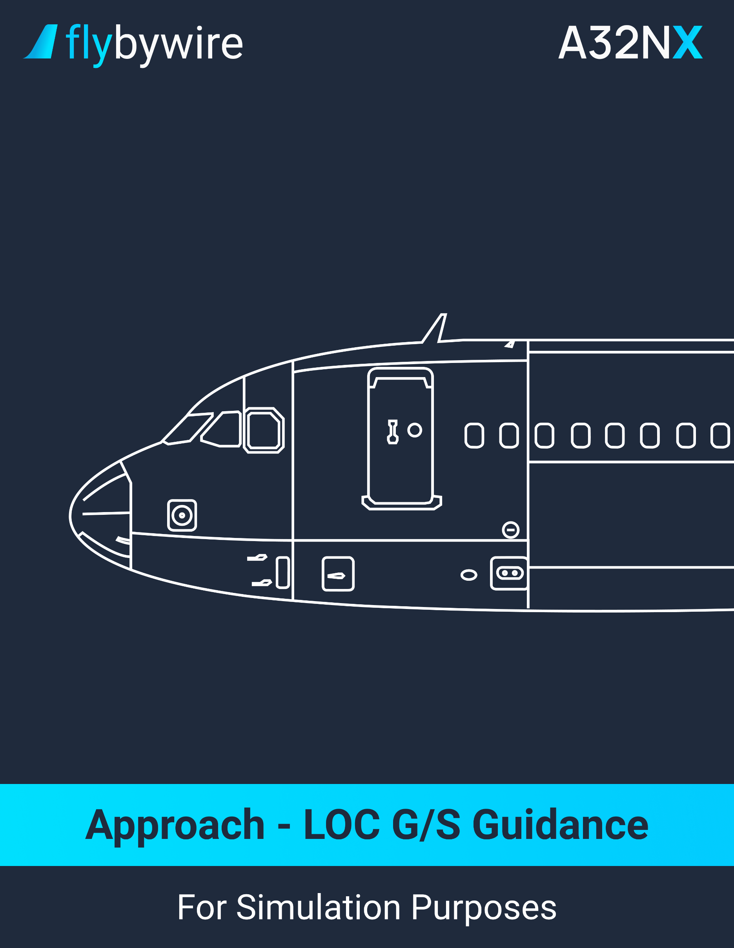

|  |
| --- |
| **Approach Using LOC G/S Guidance** |

**Descent Preparation**

PF | APPROACH MINIMUM. . . . . . . . . . . . . . . . . . . . . . . . . . . . . . . . **DETERMINE**

It is recommended to insert “NO” in the DH field of the MCDU to avoid any false auto callouts for a CATIII approach.

PF | APPROACH BRIEFING. . . . . . . . . . . . . . . . . . . . . . . . . . . . . . . . . **PERFORM**

**Initial/Intermediate Approach**

PF | APPR pushbutton. . . . . . . . . . . . . . . . . . . . . . . . . . . . . . . . . . . . . . . . . **PRESS**

The APPR should be activated when the aircraft is cleared for the approach, the aircraft is on the intercept trajectory for the final approach course and the LOC deviation is available.

PF | BOTH APs. . . . . . . . . . . . . . . . . . . . . . . . . . . . . . . . . . . . . . . . . . . . . **ENGAGE**

It is recommended to engage the AP1 and AP2 when the APPR mode is selected. The FMA will display CAT 1 above 5 000 feet AGL. Below 5 000 feet AGL, the FMA will display the intended approach.

PF | LOC. . . . . . . . . . . . . . . . . . . . . . . . . . . . . . . . . . . . . . . . . . . . **VERIFY ARMED**

PF | G/S. . . . . . . . . . . . . . . . . . . . . . . . . . . . . . . . . . . . . . . . . . . . . **VERIFY ARMED**

PF | LOC CAPTURE. . . . . . . . . . . . . . . . . . . . . . . . . . . . . . . . . . . . . . . . **MONITOR**

PF | G/S CAPTURE. . . . . . . . . . . . . . . . . . . . . . . . . . . . . . . . . . . . . . . . . **MONITOR**

GO-AROUND ALTITUDE. . . . . . . . . . . . . . . . . . . . . . . . . . . . . . . . . . . . . . . . . **SET**

**Glide Interception from Above**

PF | APPR mode. . . . . . . . . . . . . . . . . . . . . . . . . . . . . . . . **ARM / VERIFY ARMED**

PF | FCU altitude. . . . . . . . . . . . . . . . . . . . . . . . . . . . **SET ABOVE A/C ALTITUDE**

PF | V/S MODE. . . . . . . . . . . . . . . . . . . . . . . . . . . . . . . . . . . . . . . . . . . . . . **SELECT**

It is recommended to select a V/S of 1 500 ft/min. If the V/S is above 2 000 ft/min, the airspeed will increase toward VFE.

**Final Approach**

PM | FLIGHT PARAMETERS. . . . . . . . . . . . . . . . . . . . . . . . . . . . . . . . . **MONITOR**

The PM should call out if ½ dot of LOC or GLIDE deviation.

**At 350 ft RA**

PF | LAND mode. . . . . . . . . . . . . . . . . . . . . . . . . **VERIFY ENGAGED/ANNOUNCE**

If there is no LAND mode, the Autoland function is not authorized.

**For CAT I, CAT II, CAT III with DH Approach**

**At entered minimum + 100 ft**

PM | ONE HUNDRED ABOVE. . . . . . . . . . . . . **MONITOR OR ANNOUNCE**

**At entered minimum**

PM | MINMUM. . . . . . . . . . . . . . . . . . . . . . . . . . **MONITOR OR ANNOUNCE**

* + **If visual references are sufficient:**

PF | CONTINUE. . . . . . . . . . . . . . . . . . . . . . . . . . . . . . . . . . . . **ANNOUNCE**

PM | AP. . . . . . . . . . . . . . . . . . . . . . . . . . . . . . . . . . . . . . . . . **AS REQUIRED**

* + **If visual references are not sufficient:**

PF | GO AROUND. . . . . . . . . . . . . . . . . . . . . . . . . . . . . . . . . . . **ANNOUNCE**

**For CAT III Without DH Approach**

**At 100 ft (Alert height) if no failure**

PF | CONTINUE. . . . . . . . . . . . . . . . . . . . . . . . . . . . . . . . . . . . . . . . . . **ANNOUNCE**

**Degraded Guidance Procedures**

**For CAT II, CAT III Operations**

* **In case of:**
  + Amber caution, or
  + Landing capability degradation.

**Above 1 000 ft:**

CM | ECAM / QRH PROCEDURE. . . . . . . . . . . . . . . . . . . . . . . . . . . . **COMPLETE**

PM | REQUIRED EQUIPMENT. . . . . . . . . . . . . . . . . . . . . . . . . . . . . . . . . . **VERIFY**

PM | APPROACH AND LANDING CAPABILITY. . . . . . . . . . . . . . . . . . . . . **VERIFY**

**If required:**

PM | RVR. . . . . . . . . . . . . . . . . . . . . . . . . . . . . . . . . . . . . . . . . . . . . . . . . . . **VERIFY**

PM | DH. . . . . . . . . . . . . . . . . . . . . . . . . . . . . . . . . . . . . . . . . . . . . . . . . . . **ADJUST**

CM | BRIEFING. . . . . . . . . . . . . . . . . . . . . . . . . . . . . . . . . . . . . . . . . . . . **CONFIRM**

* **If the flight crew does not complete all the above actions above 1000 feet:**

PF | GO AROUND. . . . . . . . . . . . . . . . . . . . . . . . . . . . . . . . . . . . **PERFORM**

**Below 1 000 ft:**

* **If external visual is not sufficient:**

PF | GO AROUND. . . . . . . . . . . . . . . . . . . . . . . . . . . . . . . . . . . . **PERFORM**

**Below 100 feet (Alert height) for CAT 3 DUAL:**

* **In the case of Autoland warning light:**
  + **Visual references not sufficient:**

PF | GO AROUND. . . . . . . . . . . . . . . . . . . . . . . . . . . . . . . **PERFORM**

* + **Visual references are sufficient:**

PF | LANDING. . . . . . . . . . . . . . . . . . . . . . . . . . . . . . . . . . **PERFORM**

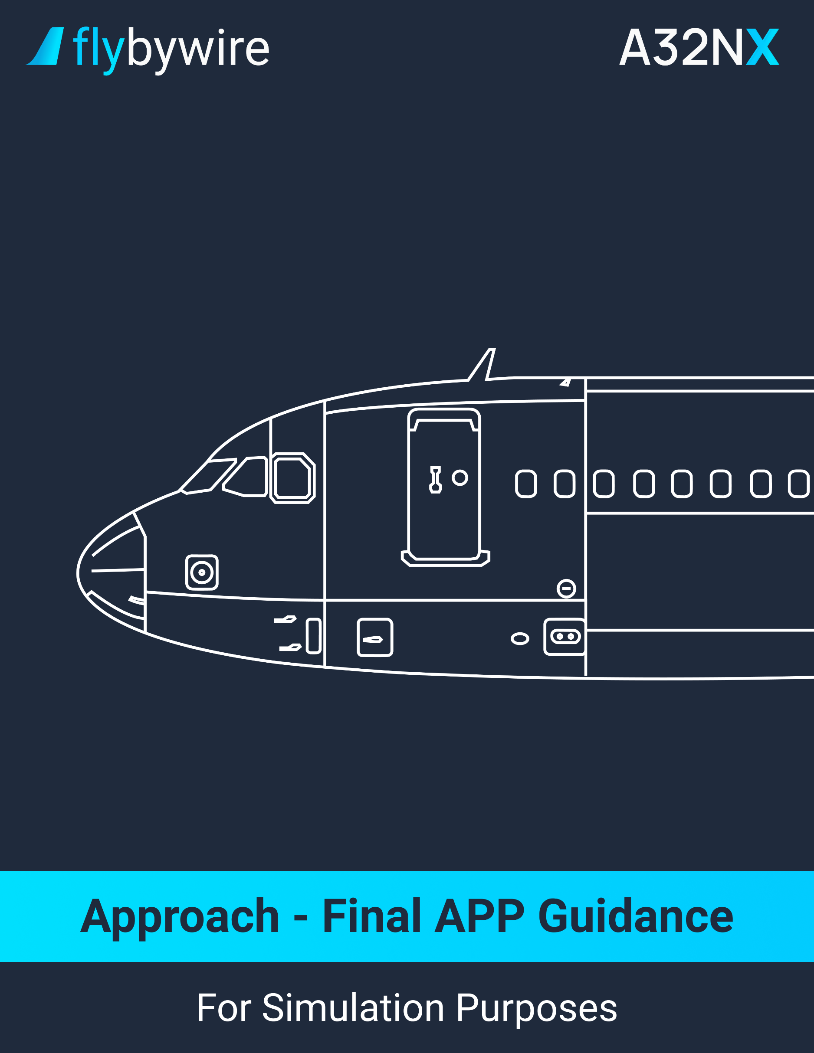

|  |
| --- |
| **Approach Using Final APP Guidance** |

**Descent Preparation**

PM | WEATHER AND LANDING INFORMATION. . . . . . . . . . . . . . . . . . . **OBTAIN**

It is not recommended to use the vertical managed guidance if the OAT is below the minimum temperature indicated on the chart or when the temperature corrections are required.

PF | F-PLN A page. . . . . . . . . . . . . . . . . . . . . . . . . . . . . . . . . . . . . . . . . . . . **VERIFY**

It is not recommended to use FINAL APP guidance if a TOO STEEP PATH is displayed after the Final Descent Point.

PF | PROG page. . . . . . . . . . . . . . . . . . . . . . . . . . . . . . . . . . . . . . . . . . **COMPLETE**

Insert the reference runway threshold in the BRG/DIST field. This allows the monitoring of position during approach.

PF | GO-AROUND STRATEGY. . . . . . . . . . . . . . . . . . . . . . . . . . . . . . . . . **REVIEW**

**Descent**

**At 10 000 feet:**

PF | NAV ACCURACY. . . . . . . . . . . . . . . . . . . . . . . . . . . . . . . . . . . . . . . . . **VERIFY**

If the nav accuracy is low, it is recommended to use TRK FPA mode for approach.

* **For RNAV (GNSS) approach:**

PF | GPS PRIMARY. . . . . . . . . . . . . . . . . . . . . . . . . . . . . . . . . . . . . **VERIFY**

The GPS PRIMARY must be available on at least one FMS.

PF | BARO REF. . . . . . . . . . . . . . . . . . . . . . . . . . . . . . . . . . . . . . . . . . . . . . . . . **SET**

**Initial/Intermediate/Final Approach**

PF | POSITION. . . . . . . . . . . . . . . . . . . . . . . . . . . . . . . . . . . . . . . . . . . . **MONITOR**

PF | APPR pushbutton. . . . . . . . . . . . . . . . . . . . . . . . . . . . . . . . . . . . . . . . . **PRESS**

Turn the on the APPR mode only when the aircraft is cleared for approach and the TO waypoint is the Final Descent Point.

PF | APP NAV. . . . . . . . . . . . . . . . . . . . . . . . . . . . **VERIFY ARMED or ENGAGED**

PF | FINAL. . . . . . . . . . . . . . . . . . . . . . . . . . . . . . . . . . . . . . . . . . . **VERIFY ARMED**

Verify that the V/DDEV scale is displayed on the PFD. Ensure the display of a blue arrow on ND. This indicates that FINAL APP engagement conditions are fulfilled.

**At the Final Descent Point**

PF | FINAL APP. . . . . . . . . . . . . . . . . . . . . . . . . . . . . . . . . . . . **VERIFY ENGAGED**

CM | GO AROUND ALTITUDE. . . . . . . . . . . . . . . . . . . . . . . . . . . . . . . . . . . . . **SET**

PM | FLIGHT PARAMETERS. . . . . . . . . . . . . . . . . . . . . . . . . . . . . . . . . **MONITOR**

**At Entered Minimum +100 feet**

PM | ONE HUNDRED ABOVE. . . . . . . . . . . . . . . . . . **MONITOR OR ANNOUNCE**

**At Entered Minimum**

PM | MINIMUM. . . . . . . . . . . . . . . . . . . . . . . . . . . . . . **MONITOR OR ANNOUNCE**

* **If visual references are sufficient:**

PF | CONTINUE. . . . . . . . . . . . . . . . . . . . . . . . . . . . . . . . . . . . **ANNOUNCE**

* + **At the latest at the MAP or Minimum Use Height of the AP (Whichever occurs first):**

PF | AP. . . . . . . . . . . . . . . . . . . . . . . . . . . . . . . . . . . . . . . . . . . . . **OFF**

PF | FD. . . . . . . . . . . . . . . . . . . . . . . . . . . . . . . . . . . . **AS REQUIRED**

* **If visual references are not sufficient:**

PF | GO AROUND. . . . . . . . . . . . . . . . . . . . . . . . . . . . . . . . . . . **ANNOUNCE**

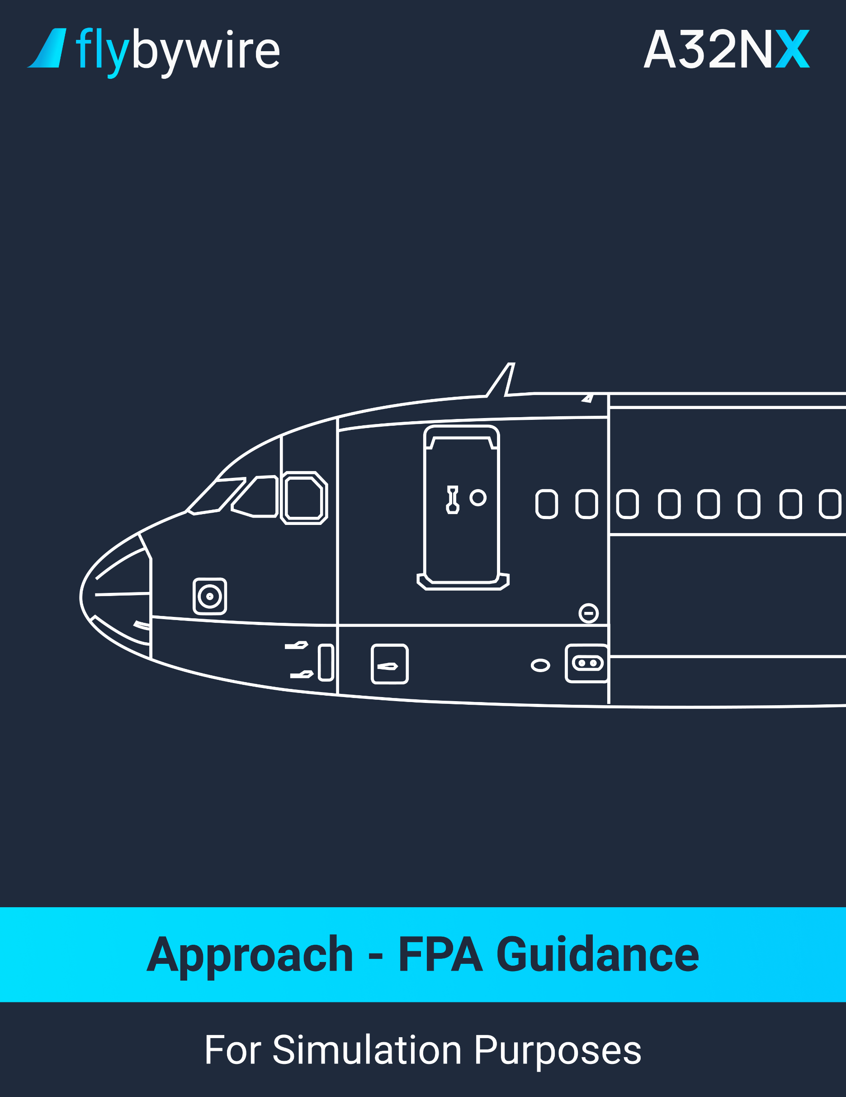

|  |
| --- |
| **Approach Using FPA Guidance** |

**Descent Preparation**

CM | F-PLN A page. . . . . . . . . . . . . . . . . . . . . . . . . . . . . . . . . . . . . . . . . . . . . . . . . **VERIFY**

It is recommended to disregard the V/DEV information on the PFD if the message TOO STEEP PATH is displayed after the Final Descent Point. For the approaches using the NAV FPA mode, 1 degree of difference between the MCDU and the charted final lateral track is acceptable. For conventional radio NAVAID approach, 3 degrees of difference between the MCDU and the charted final lateral track is acceptable. For all other cases, it is recommended to use TRK FPA mode.

CM | PROG page. . . . . . . . . . . . . . . . . . . . . . . . . . . . . . . . . . . . . . . . . **COMPLETE**

Insert the reference runway threshold in the BRG/DIST field. This allows the monitoring of position during approach.

PF | GO AROUND STRATEGY. . . . . . . . . . . . . . . . . . . . . . . . . . . . . . . . . **REVIEW**

**Descent**

**At 10 000 feet :**

PF | NAV ACCURACY. . . . . . . . . . . . . . . . . . . . . . . . . . . . . . . . . . . . . . . . . **VERIFY**

If the nav accuracy is low, it is recommended to use TRK FPA mode for approach.

* **For RNAV (GNSS) approach:**

PF | GPS PRIMARY. . . . . . . . . . . . . . . . . . . . . . . . . . . . . . . . . . . . . **VERIFY**

The GPS PRIMARY must be available on at least one FMS.

**Initial/Intermediate/Final Approach**

PF | LATERAL GUIDANCE MODE. . . . . . . . . . . . . . . . . . . **SET FOR APPROACH**

Arm the NAV or LOC mode as appropriate.

* **For LOC ONLY and ILS G/S OUT:**

PF | LOC pushbutton. . . . . . . . . . . . . . . . . . . . . . . . . . . . . . . . . . . . . **PRESS**

It is recommended to press the LOC pushbutton when cleared for approach and the aircraft is on the intercept trajectory for the final approach course.

PF | LOC. . . . . . . . . . . . . . . . . . . . . . . . . . . . . . . . . . . . . . . **VERIFY ARMED**

* **For back course localizer approaches:**

PF | TRK FPA MODE. . . . . . . . . . . . . . . . . . . . . . . . **USE FOR APPROACH**

PF | LATERAL PATH. . . . . . . . . . . . . . . . . . . . . . . . . . . . . . . . . . . . . . **INTERCEPT**

The flight crew should monitor the NAV or LOC engagement.

PF | TRK FPA pushbutton. . . . . . . . . . . . . . . . . . . . . . . . . . . . . . . . . . . . . **SELECT**

PF | FPA FOR FINAL APPROACH. . . . . . . . . . . . . . . . . . . . . . . . . . . . . . . . . . **SET**

**At 0.3 NM from the Final Descent Point**

PF | FPA selector. . . . . . . . . . . . . . . . . . . . . . . . . . . . . . . . . . . . . . . . . . . . . . **PULL**

PF | FPA MODE. . . . . . . . . . . . . . . . . . . . . . . . . . . . . . . . . . . . **VERIFY ENGAGED**

PF | POSITION/FLIGHT PATH. . . . . . . . . . . . . . . . . . . . . . . . . **MONITOR/ADJUST**

CM | GO AROUND ALTITUDE. . . . . . . . . . . . . . . . . . . . . . . . . . . . . . . . . . . . . . **SET**

PM | FLIGHT PARAMETERS. . . . . . . . . . . . . . . . . . . . . . . . . . . . . . . . . . **MONITOR**

**At Entered Minimum + 100 Feet**

PM | ONE HUNDRED ABOVE. . . . . . . . . . . . . . . . . . **MONITOR OR ANNOUNCE**

**At Entered Minimum**

PM | MINIMUM. . . . . . . . . . . . . . . . . . . . . . . . . . . . . . **MONITOR OR ANNOUNCE**

* **If visual references are sufficient:**

PF | CONTINUE. . . . . . . . . . . . . . . . . . . . . . . . . . . . . . . . . . . . **ANNOUNCE**

PF | AP. . . . . . . . . . . . . . . . . . . . . . . . . . . . . . . . . . . . . . . . . . . . . . . . . . **OFF**

If the autopilot is still engaged at minimum – 50 feet, the FMA will display the message DISCONNECT AP FOR LDG.

PF | FD. . . . . . . . . . . . . . . . . . . . . . . . . . . . . . . . . . . . . . . . . . . . . . . . . . **OFF**

PF | RUNWAY TRACK. . . . . . . . . . . . . . . . . . . . . . . . . . . . . . . . . . **VERIFY/SET**

* **If visual references are not sufficient:**

PF | GO AROUND. . . . . . . . . . . . . . . . . . . . . . . . . . . . . . . . . . . **ANNOUNCE**

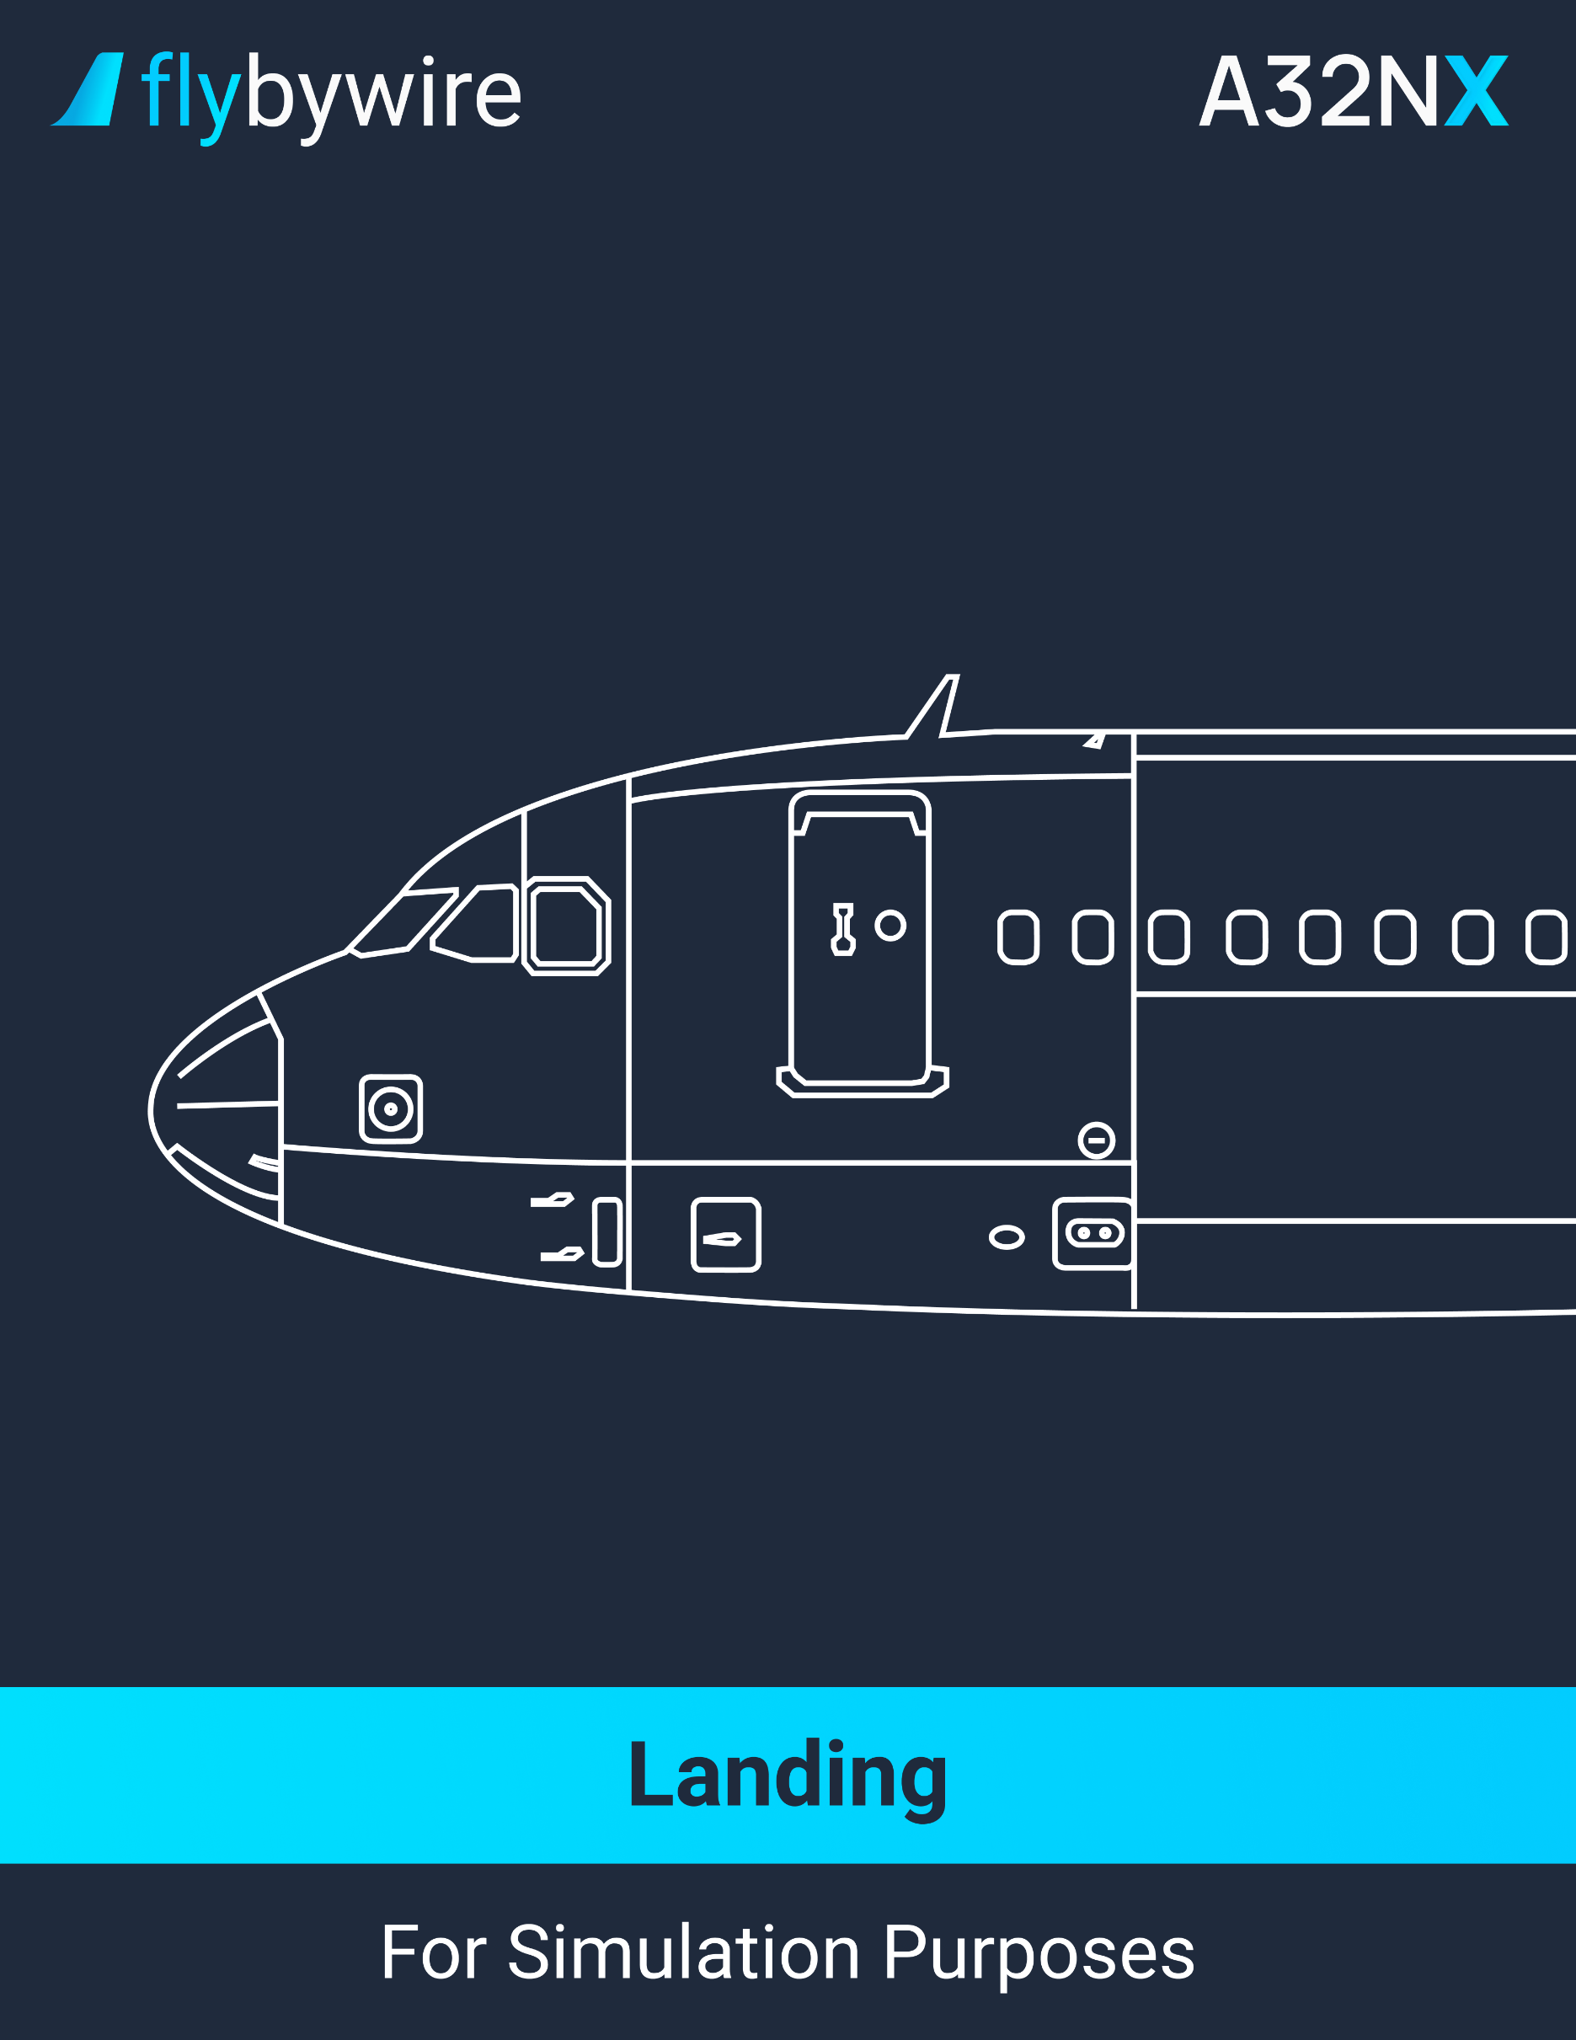

|  |
| --- |
| **Manual Landing** |

**Flare**

* **In stabilized approach conditions, the flare height is approximately 30 feet:**

PF | FLARE. . . . . . . . . . . . . . . . . . . . . . . . . . . . . . . . . . . . . . . . . **PERFORM**

PM | ATTITUDE. . . . . . . . . . . . . . . . . . . . . . . . . . . . . . . . . . . . . . **MONITOR**

PF | THRUST levers. . . . . . . . . . . . . . . . . . . . . . . . . . . . . . . . . . . . . . . **IDLE**

The autopilot will automatically disengage when the thrust levers are set to IDLE.

**At Touchdown**

PF | DEROTATION. . . . . . . . . . . . . . . . . . . . . . . . . . . . . . . . . . . . . . . . . . **INITIATE**

PF | ALL THRUST LEVERS. . . . . . . . . . . . . . . . . . . . . . . . **REV MAX or REV IDLE**

The flight crew must select the reverse thrust immediately after the main landing gear touches the ground.

PM | GROUND SPOILERS. . . . . . . . . . . . . . . . . . . . . . . . . . **VERIFY/ANNOUNCE**

Verify the ground spoilers on the WHEEL SD page.

PM | REVERSERS. . . . . . . . . . . . . . . . . . . . . . . . . . . . . . . . . **VERIFY/ANNOUNCE**

Ensure that the ECAM E/WD displays the reverse deployment (REV in green).

PF | DIRECTIONAL CONTROL. . . . . . . . . . . . . . . . . . . . . . . . **MONITOR/ENSURE**

It is recommended to use the rudder until reaching taxi speed.

PF | BRAKES. . . . . . . . . . . . . . . . . . . . . . . . . . . . . . . . . . . . . . . . . . **AS REQUIRED**

If there are no ground spoilers extended, the autobrakes are not activated. The use of manual braking is therefore recommended in this situation.

PM | DECELERATION. . . . . . . . . . . . . . . . . . . . . . . . . . . . . . **VERIFY/ANNOUNCE**

**At 70 knots**

PM | SEVENTY KNOTS. . . . . . . . . . . . . . . . . . . . . . . . . . . . . . . . . . . . **ANNOUNCE**

PF | BOTH THRUST LEVERS. . . . . . . . . . . . . . . . . . . . . . . . . . . . . . . . . **REV IDLE**

It is recommended to reduce thrust when passing 70 knots. Keeping a high level of reverse thrust may result in an engine stall due to excessive EGT.

**At Taxi Speed**

PF | REVERSERS. . . . . . . . . . . . . . . . . . . . . . . . . . . . . . . . . . . . . . . . . . . . . **STOW**

On snow-covered ground, it is recommended to stow the reversers when the aircraft reaches 25 knots. It is not recommended to use the reversers on taxiways. This may ingest fine sand, debris, or snow.

**Before 20 Knots**

PF | AUTO BRK. . . . . . . . . . . . . . . . . . . . . . . . . . . . . . . . . . . . . . . . . **DISENGAGE**

|  |
| --- |
| **Autoland** |

**At 350 feet RA**

PF | ILS/GLS/MLS COURSE ON PFD. . . . . . . . . . . . . . . . . . . . . . . . . . . . . **VERIFY**

**At 40 feet RA**

PM | FLARE mode. . . . . . . . . . . . . . . . . . . . . . . **VERIFY ENGAGED/ANNOUNCE**

**At 30 feet RA**

PM | THRUST IDLE. . . . . . . . . . . . . . . . . . . . . . . . . . . . . . . . . . . . . . . . . . . **VERIFY**

The flight crew should notice a thrust reduction.

**At 10 feet RA**

PF | BOTH THRUST LEVERS. . . . . . . . . . . . . . . . . . . . . . . . . . . . . . . . . . . . . **IDLE**

Retard the thrust levers at the “RETARD” auto-callout.

PF | LATERAL GUIDANCE. . . . . . . . . . . . . . . . . . . . . . . . . . . . . . . . . . . **MONITOR**

**At Touchdown**

PM | ROLL OUT mode. . . . . . . . . . . . . . . . . . . . . **VERIFY ENGAGED/ANNOUNCE**

PF | BOTH THRUST LEVERS. . . . . . . . . . . . . . . . . . . . . . **REV MAX or REV IDLE**

PM | GROUND SPOILERS. . . . . . . . . . . . . . . . . . . . . . . . . . . . . **VERIFY/ANNOUNCE**

Verify the ground spoilers on the WHEEL SD page.

PM | REVERSERS. . . . . . . . . . . . . . . . . . . . . . . . . . . . . . . . . **VERIFY/ANNOUNCE**

Ensure that the ECAM E/WD displays the reverse deployment (REV in green).

CM | DIRECTIONAL CONTROL. . . . . . . . . . . . . . . . . . . . . . . **MONITOR/ENSURE**

It is recommended to use the rudder until reaching taxi speed.

PF | BRAKES. . . . . . . . . . . . . . . . . . . . . . . . . . . . . . . . . . . . . . . . . . **AS REQUIRED**

If there are no ground spoilers extended, the autobrakes are not activated. The use of manual braking is therefore recommended in this situation.

PM | DECELERATION. . . . . . . . . . . . . . . . . . . . . . . . . . . . . . **VERIFY/ANNOUNCE**

**At 70 knots**

PM | SEVENTY KNOTS. . . . . . . . . . . . . . . . . . . . . . . . . . . . . . . . . . . . **ANNOUNCE**

PF | BOTH THRUST LEVERS. . . . . . . . . . . . . . . . . . . . . . . . . . . . . . . . . **REV IDLE**

It is recommended to reduce thrust when passing 70 knots. Keeping a high level of reverse thrust may result in an engine stall due to excessive EGT.

**Before 20 Knots**

PF | AUTO BRK. . . . . . . . . . . . . . . . . . . . . . . . . . . . . . . . . . . . . . . . . . **DISENGAGE**

**End or Roll Out**

PF | REVERSERS. . . . . . . . . . . . . . . . . . . . . . . . . . . . . . . . . . . . . . . . . . . . . **STOW**

On snow-covered ground, it is recommended to stow the reversers when the aircraft reaches 25 knots. It is not recommended to use the reversers on taxiways. This may ingest fine sand, debris, or snow.

PF | AP. . . . . . . . . . . . . . . . . . . . . . . . . . . . . . . . . . . . . . . . . . . . . . . . . . . . . . . **OFF**

It is recommended to disengage the AP at the end of the roll out, before leaving the runway.

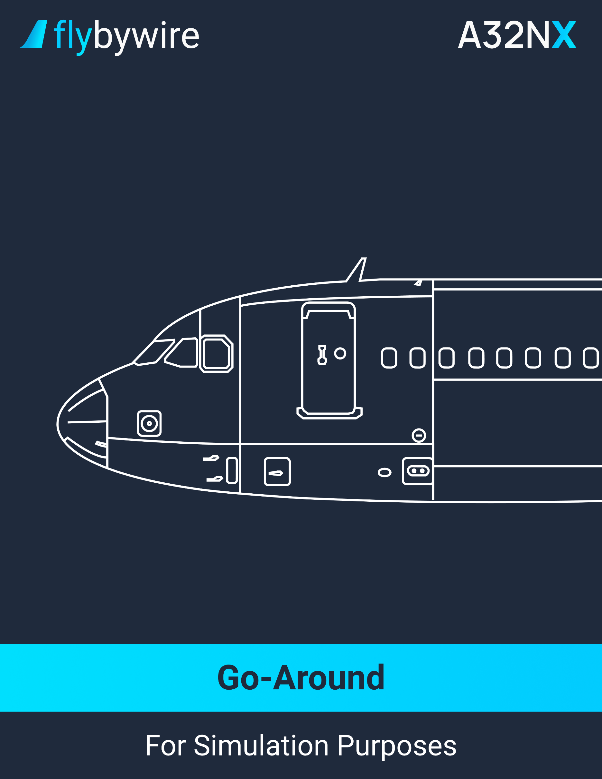

|  |
| --- |
| **Go Around With FD** |

**Apply the following three actions simultaneously:**

PF | THRUST LEVERS. . . . . . . . . . . . . . . . . . . . . . . . . . . . . . . . . . . . . . . . . . . . . . . **TOGA**

The flight crew must set the thrust levers to the TOGA detent. This ensures the engagement of SRS GA mode. The flight crew can then set the thrust levers to FLX/MCT to engage the GA SOFT mode.

PF | ROTATION. . . . . . . . . . . . . . . . . . . . . . . . . . . . . . . . . . . . . . . . . . . . . . . . . **PERFORM**

It is recommended to have an initial rotation to 15°. When getting a positive rate of climb, follow the SRS Flight Director.

PF | GO AROUND. . . . . . . . . . . . . . . . . . . . . . . . . . . . . . . . . . . . . . . . . . . . . . **ANNOUNCE**

PM | FLAPS lever. . . . . . . . . . . . . . . . . . . . . . . . . . . . . . . . . . . . . **SELECT AS REQUIRED**

It is recommended to retract one step of flaps.

PF | FMA. . . . . . . . . . . . . . . . . . . . . . . . . . . . . . . . . . . . . . . . . . . . . . **VERIFY/ANNOUNCE**

In case the FMA does not display MAN GA SOFT or MAN TOGA, set the thrust levers to the TOGA detent.

PM | POSITIVE CLIMB. . . . . . . . . . . . . . . . . . . . . . . . . . . . . . . . . . . . . . . . . . **ANNOUNCE**

PF | L/G UP. . . . . . . . . . . . . . . . . . . . . . . . . . . . . . . . . . . . . . . . . . . . . . . . . . . . . . . **ORDER**

PM | L/G. . . . . . . . . . . . . . . . . . . . . . . . . . . . . . . . . . . . . . . . . . . . . . . . . . . . . . **SELECT UP**

PF | NAV or HDG mode. . . . . . . . . . . . . . . . . . . . . . . . . . . . . . . . . . . . . . . **AS REQUIRED**

PF | AP. . . . . . . . . . . . . . . . . . . . . . . . . . . . . . . . . . . . . . . . . . . . . . . . . . . . **AS REQUIRED**

**At Go Around Thrust Reduction Altitude**

PF | THRUST levers. . . . . . . . . . . . . . . . . . . . . . . . . . . . . . . . . . . . . . . . . . . . . . . **CL**

**At Go Around Acceleration Altitude**

* **If the target speed does not increase to green dot:**

PF | ALT knob. . . . . . . . . . . . . . . . . . . . . . . . . . . . . . . . **VERIFY AND PULL**

* **At F speed:**

PF | FLAPS 1. . . . . . . . . . . . . . . . . . . . . . . . . . . . . . . . . . . . . . . . . . **ORDER**

PM | FLAPS 1. . . . . . . . . . . . . . . . . . . . . . . . . . . . . . . . . . . . . . . . . . **SELECT**

* **At S speed:**

PF | FLAPS 0. . . . . . . . . . . . . . . . . . . . . . . . . . . . . . . . . . . . . . . . . . **ORDER**

PM | FLAPS 0. . . . . . . . . . . . . . . . . . . . . . . . . . . . . . . . . . . . . . . . . **SELECT**

PM | GND SPLRS. . . . . . . . . . . . . . . . . . . . . . . . . . . . . . . . . . . . . . . . . . . . **DISARM**

PM | NOSE switch. . . . . . . . . . . . . . . . . . . . . . . . . . . . . . . . . . . . . . . . . . . . . . . **OFF**

PM | RWY TURN OFF switch. . . . . . . . . . . . . . . . . . . . . . . . . . . . . . . . . . . . . . **OFF**

PM | OTHER EXTERIOR LIGHTS. . . . . . . . . . . . . . . . . . . . . . . . . . **AS REQUIRED**

CM | AFTER TAKEOFF/CLIMB CHECKLIST down to the line. . . . . . . **COMPLETE**

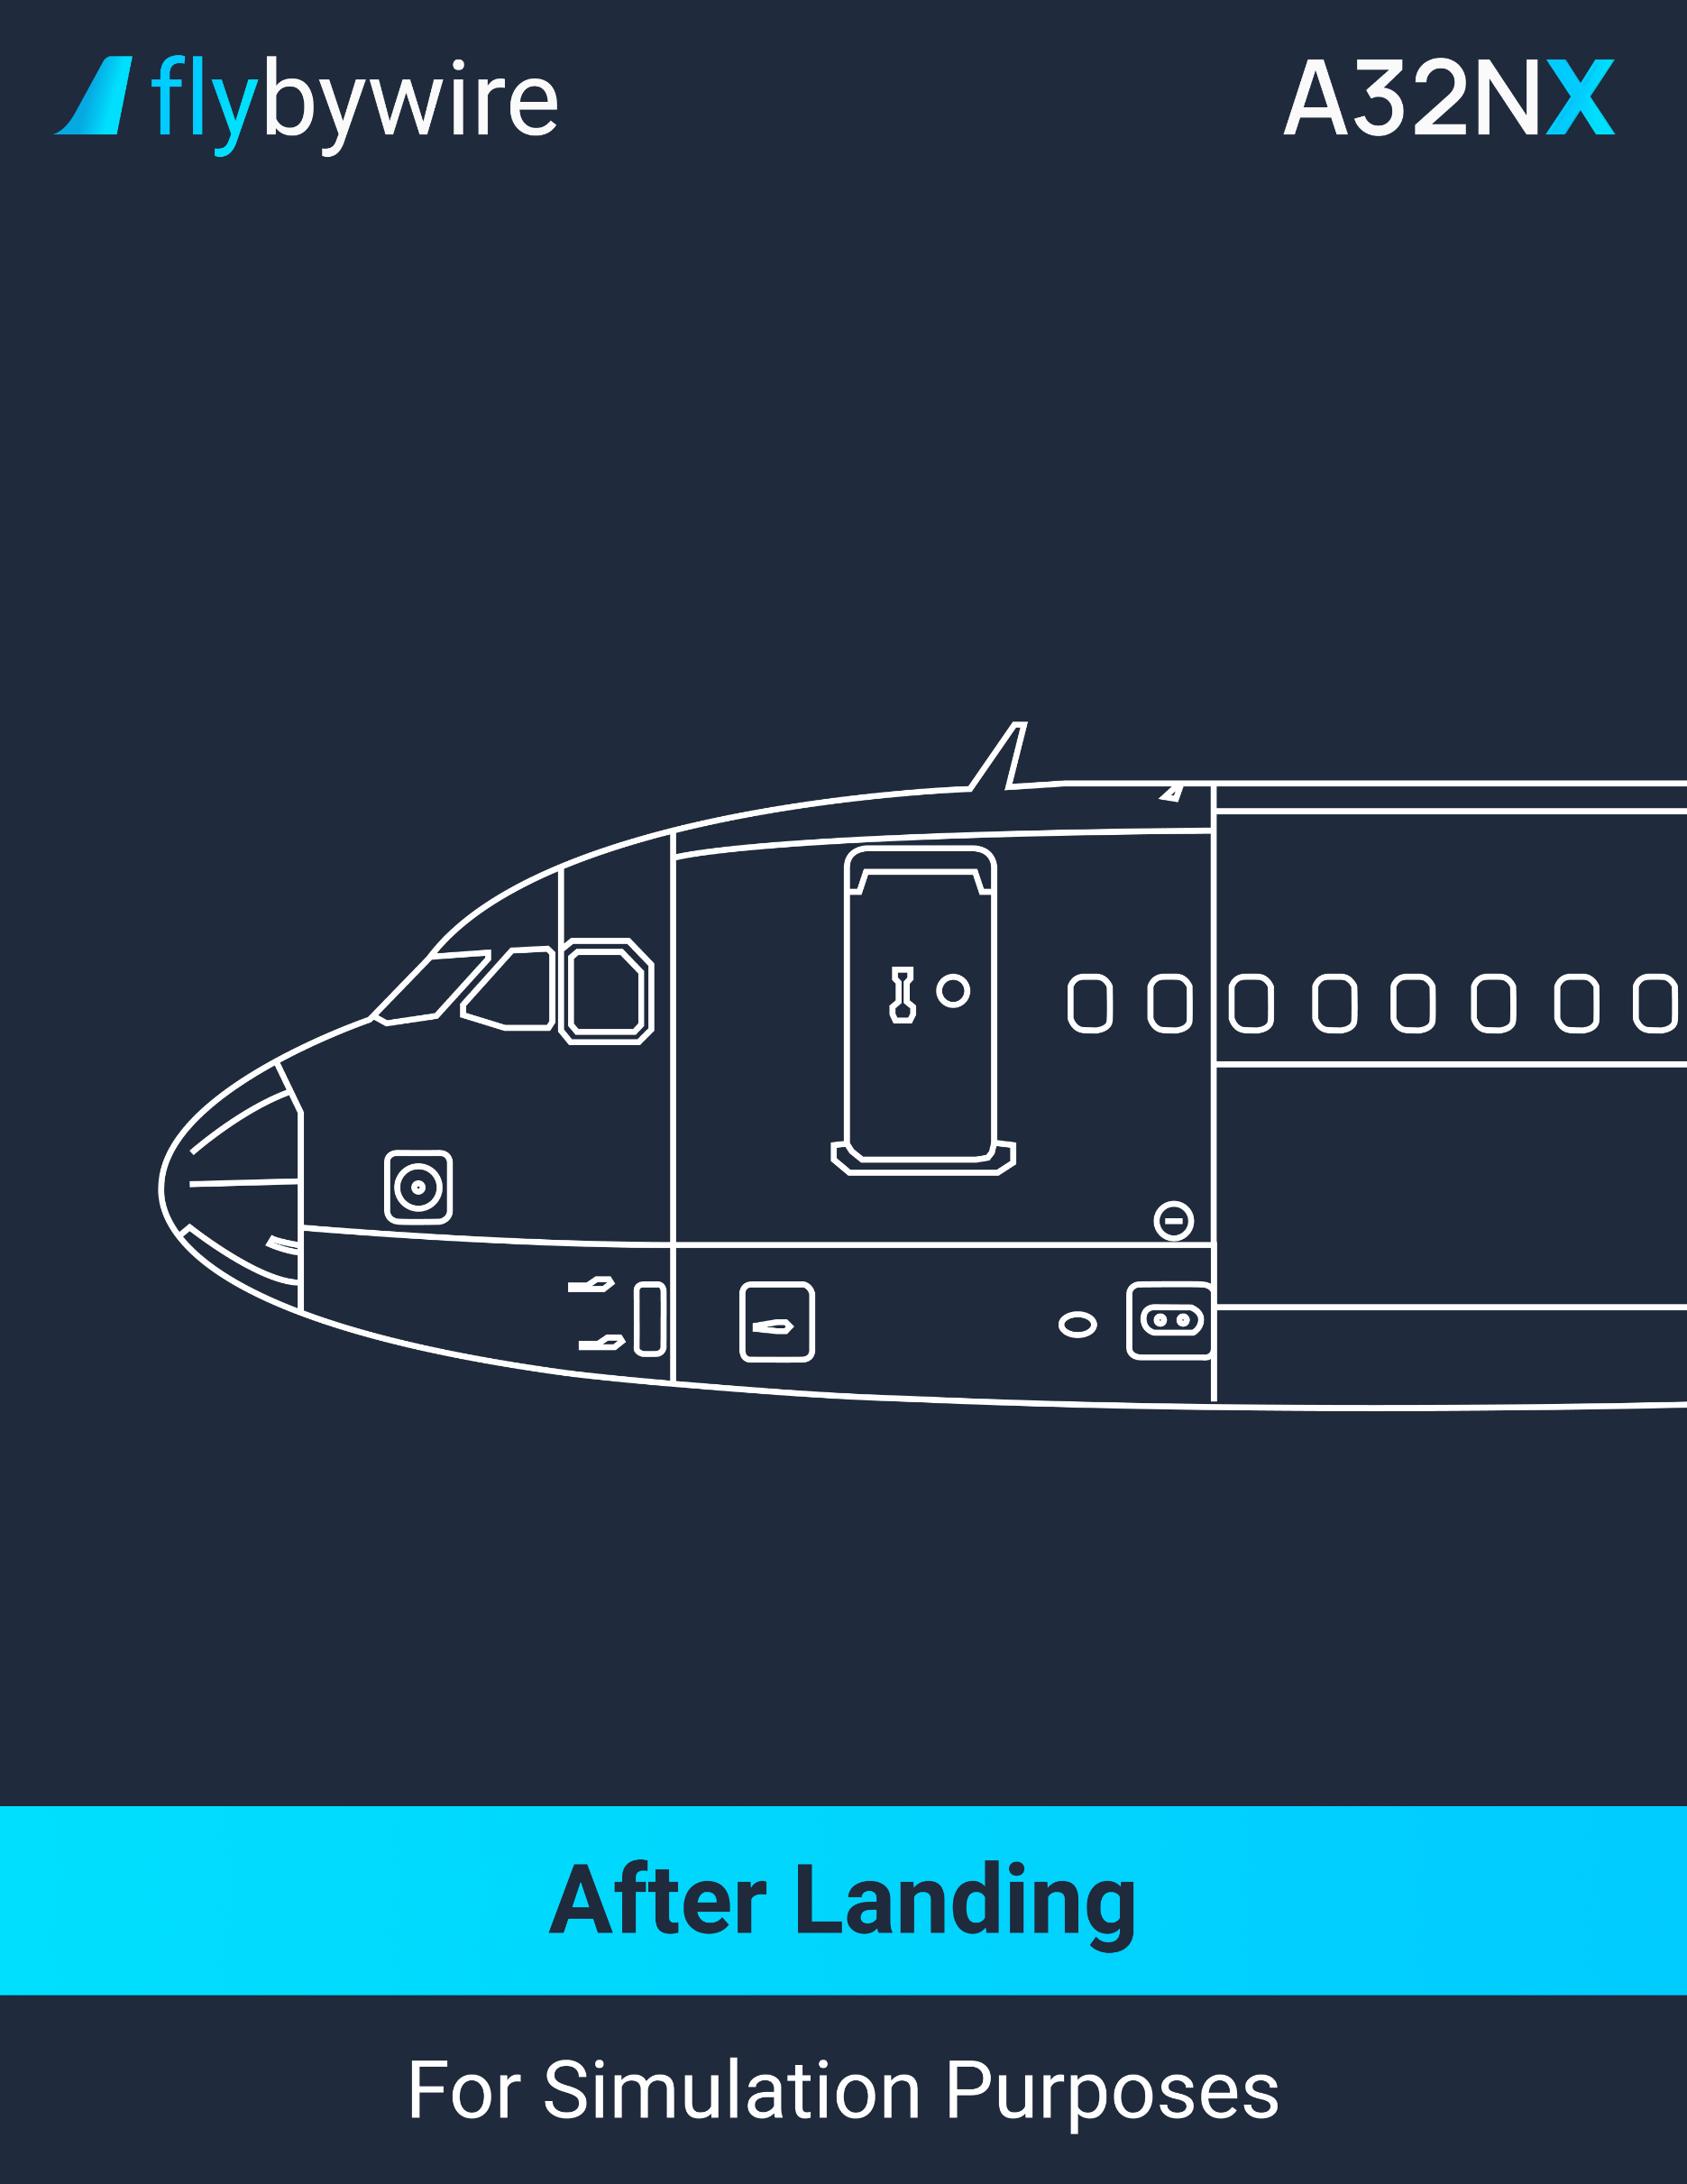

|  |
| --- |
| **After Landing** |

PF |GRND SPLRS. . . . . . . . . . . . . . . . . . . . . . . . . . . . . . . . . . . . . . . . . . . . . . . . . **DISARM**

**Exterior lights**

PF | LAND lights. . . . . . . . . . . . . . . . . . . . . . . . . . . . . . . . . . . . . . . . . . . . **RETRACT**

* + **When leaving the runway:**

PF | STROBE switch. . . . . . . . . . . . . . . . . . . . . . . . . . . . . . . . . . . . . . **AUTO**

PF | NOSE switch. . . . . . . . . . . . . . . . . . . . . . . . . . . . . . . . . . . . . . . . . . **TAXI**

* + **When crossing a runway:**

PF | STROBE switch. . . . . . . . . . . . . . . . . . . . . . . . . . . . . . . . . . . . . . . . **ON**

PF | OTHER EXTERIOR LIGHTS. . . . . . . . . . . . . . . . . . . . . . . . . . **AS REQUIRED**

PM | RADAR. . . . . . . . . . . . . . . . . . . . . . . . . . . . . . . . . . . . . . . . . . . . . . . . . . . . . . . . . **OFF**

PM | PREDICTIVE WINDSHEAR SYSTEM. . . . . . . . . . . . . . . . . . . . . . . . . . . . . . . . . . . **OFF**

It is highly recommended to turn the radar and predictive windshear system to off to avoid any risk of radiating the ground crew.

PM | ENG MODE selector. . . . . . . . . . . . . . . . . . . . . . . . . . . . . . . . . . . . . . . . . . . . **NORM**

PM | FLAPS. . . . . . . . . . . . . . . . . . . . . . . . . . . . . . . . . . . . . . . . . . . . . . . . . . . . . **RETRACT**

If the approach was made in icing conditions, do not retract the flaps or slats until the ground crew confirms the flaps and slats are cleared of ice.

PM | TCAS. . . . . . . . . . . . . . . . . . . . . . . . . . . . . . . . . . . . . . . . . . . . . . . . . . . . . . . . . **STBY**

PM | ATC. . . . . . . . . . . . . . . . . . . . . . . . . . . . . . . . . . . . . . . . . . . . . . . . . . . **AS REQUIRED**

PM | APU. . . . . . . . . . . . . . . . . . . . . . . . . . . . . . . . . . . . . . . . . . . . . . . . . . . . . . . . . **START**

Note: The use of the APU for a prolonged time may cause a fuel imbalance.

PM | ANTI-ICE. . . . . . . . . . . . . . . . . . . . . . . . . . . . . . . . . . . . . . . . . . . . . . **AS REQUIRED**

It is recommended to pay close attention when taxiing. The N1 ground idle is increased if the anti-ice is on.

PM | BRAKE TEMPERATURE. . . . . . . . . . . . . . . . . . . . . . . . . . . . . . . . . . . . . . . . **VERIFY**

Verify the brake temperature on the WHEEL SD page. If temperature difference between two brakes of a gear is more than 150°C, and the temperature of one of these brakes is above or equal to 600°C, or the temperature difference between two brakes of a gear is more than 150°C, and the temperature of one of these brakes is equal to 60°C or the difference between the average temperature of the left gear brakes and the right brakes are above or equal to 200°C, or the temperature of one brake exceeds 800°C, maintenance is due.

PM | BRK FAN pushbutton. . . . . . . . . . . . . . . . . . . . . . . . . . . . . . . . . . . . . **AS REQUIRED**

It is recommended to delay the use of fan brakes to 5 minutes after landing.

CM | AFTER LANDING CHECKLIST. . . . . . . . . . . . . . . . . . . . . . . . . . . . . . . **COMPLETE**

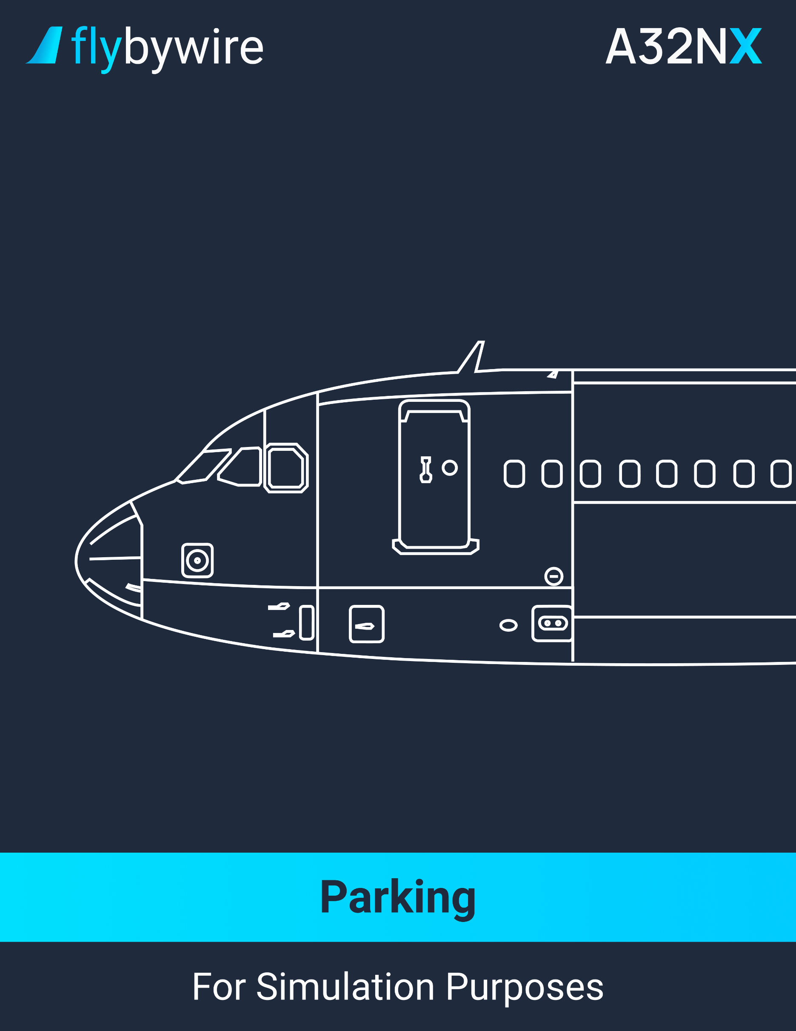

|  |
| --- |
| **Parking** |

PF | ACCU PRESS indicator. . . . . . . . . . . . . . . . . . . . . . . . . . . . . . . . . . . . . . . . . **VERIFY**

Ensure that the ACCU PRESS indicates in the green band. If this isn’t the case, chocks are required before engine 1 shutdown.

PF | PARKING BRAKE handle. . . . . . . . . . . . . . . . . . . . . . . . . . . . . . . . . . . . . . . . . . . . **ON**

It is not recommended to set the parking brakes if one brake temperature is above 500°C or above 350°C if the brakes fan is on.

PF | BRAKE PRESS indicator. . . . . . . . . . . . . . . . . . . . . . . . . . . . . . . . . . . . . . . . **VERIFY**

Ensure that the BRAKE PRESS indicates within normal range.

PM | ANTI-ICE. . . . . . . . . . . . . . . . . . . . . . . . . . . . . . . . . . . . . . . . . . . . . . . . . . . . . . . **OFF**

PM | APU BLEED pushbutton. . . . . . . . . . . . . . . . . . . . . . . . . . . . . . . . . . . . . . . . . . . . **ON**

It is recommended to set the APU BLEED to ON before the engine shutdown. This minimizes the odors of engine exhaust fumes in the air conditioning.

* + **If the APU is not available:**

PM | EXT PWR pushbutton. . . . . . . . . . . . . . . . . . . . . . . . . . . . . . . . . . . . **ON**

* + **No less than 3 minutes after high thrust operations:**

PF | ALL ENG MASTERS. . . . . . . . . . . . . . . . . . . . . . . . . . . . . . . . . . . . **OFF**

It is recommended to operate the engines at or near idle for 3 minutes before shutting down the engines. This stabilizes the engine thermal performance. The use of normal thrust for taxi or idle reverse thrust is not considered high thrust operations.

PF | SLIDES. . . . . . . . . . . . . . . . . . . . . . . . . . . . . . . . . . . . . . . . . . . . **VERIFY DISARMED**

Ensure that the slides are disarmed by looking at the DOOR/OXY SD page. If any slide is not disarmed, warn the cabin crew.

PF | SEAT BELTS switch. . . . . . . . . . . . . . . . . . . . . . . . . . . . . . . . . . . . . . . . . . . . . . . **OFF**

PF | BEACON lights. . . . . . . . . . . . . . . . . . . . . . . . . . . . . . . . . . . . . . . . . . . . . . . . . . . **OFF**

When the engines are spooled down, turn off the beacon lights.

PF | OTHER EXTERIOR LIGHTS. . . . . . . . . . . . . . . . . . . . . . . . . . . . . . . **AS REQUIRED**

PF | GROUND CONTACT. . . . . . . . . . . . . . . . . . . . . . . . . . . . . . . . . . . . . . . . **ESTABLISH**

Ensure that the chocks are in place.

PM | FUEL PUMPS/CTR XFR VALVES. . . . . . . . . . . . . . . . . . . . . . . . . . . . . . . . . . . . **OFF**

PM | ATC. . . . . . . . . . . . . . . . . . . . . . . . . . . . . . . . . . . . . . . . . . . . . . . . . . . . . . . . . . **STBY**

PM | IRS PERFORMANCE. . . . . . . . . . . . . . . . . . . . . . . . . . . . . . . . . . . . . . . . . . . **VERIFY**

Verify the NAV accuracy in the MCDU POSITION MONITOR page.

PM | FUEL QUANTITY. . . . . . . . . . . . . . . . . . . . . . . . . . . . . . . . . . . . . . . . . . . . . . **VERIFY**

Ensure that the sum of fuel on board and the used fuel quantity is consistent with the fuel on board at departure.

PM | STS pushbutton. . . . . . . . . . . . . . . . . . . . . . . . . . . . . . . . . . . . . . . . . . . . . . . **PRESS**

Verify the STATUS page.

PM | BRAKE FAN. . . . . . . . . . . . . . . . . . . . . . . . . . . . . . . . . . . . . . . . . . . . . . . . . . . . . **OFF**

PF | PARKING BRAKE. . . . . . . . . . . . . . . . . . . . . . . . . . . . . . . . . . . . . . . . **AS REQUIRED**

It is recommended to release the parking brakes when the chocks are in place.

CM | DISPLAY UNIT BRIGHNESS. . . . . . . . . . . . . . . . . . . . . . . . . . . . . . . . . . . . . . . . **DIM**

CM | PARKING CHECKLIST. . . . . . . . . . . . . . . . . . . . . . . . . . . . . . . . . . . . . . **COMPLETE**

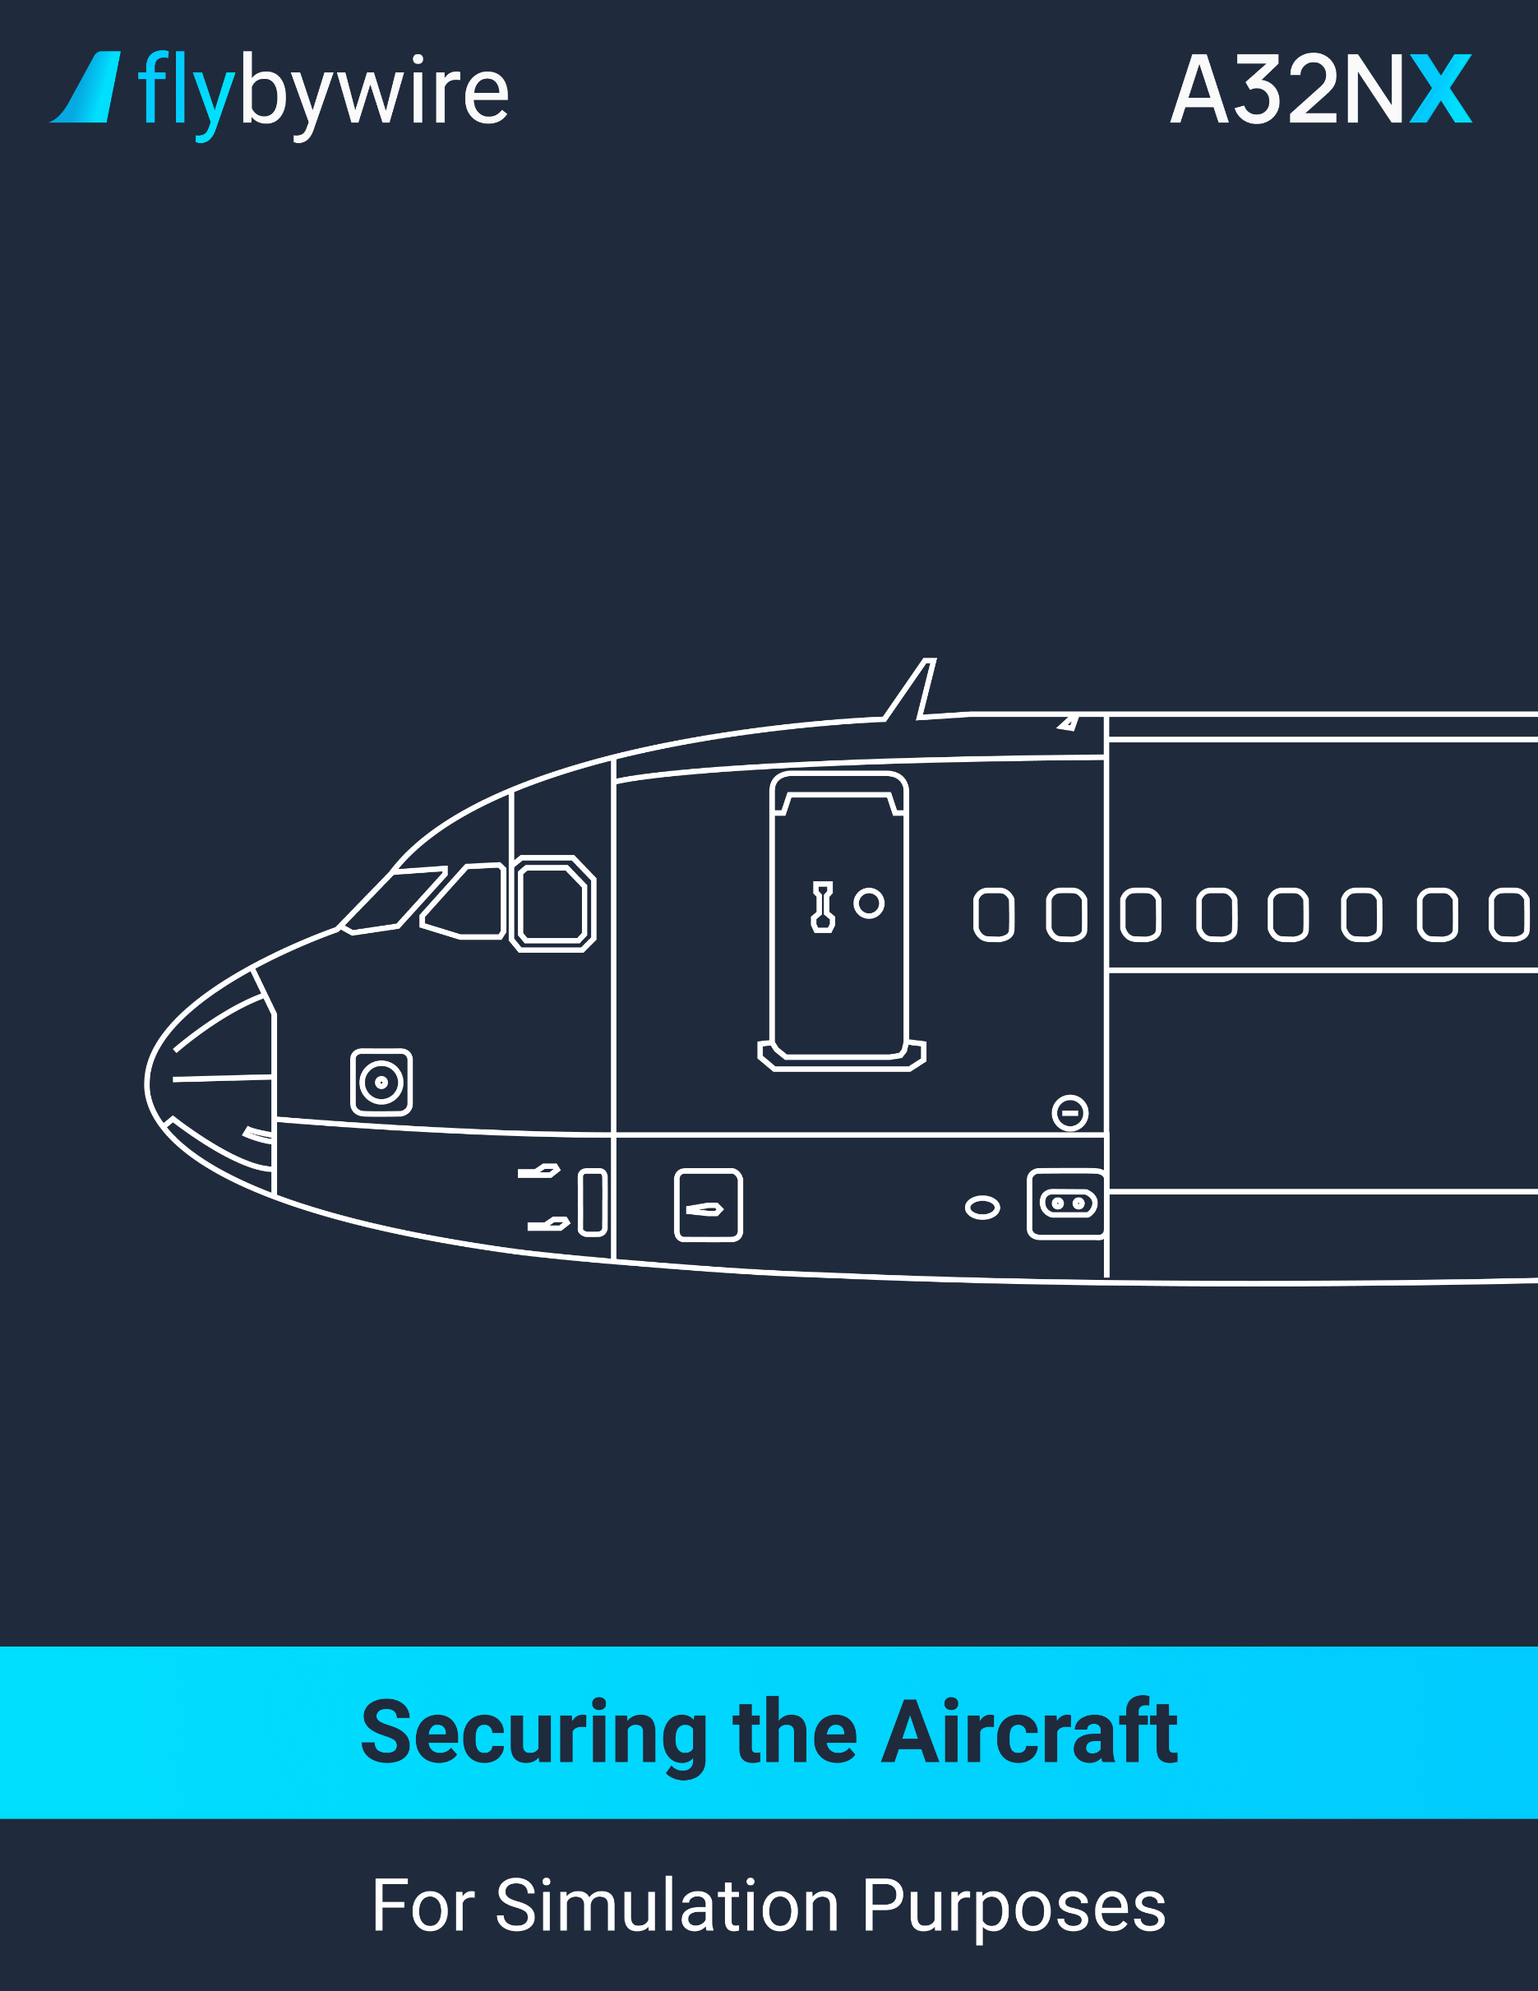

|  |
| --- |
| **Securing the Aircraft** |

**Parking Brake**

PF | PARKING BRAKE handle. . . . . . . . . . . . . . . . . . . . . . . . . . . . . . . . . . . . . . **ON**

It is recommended to keep the parking brake to ON to reduce the hydraulic leak.

**Oxygen Crew Supply**

PM | OXYGEN CREW SUPPLY pushbutton. . . . . . . . . . . . . . . . . . . . . . . . . . . **OFF**

**ADIRS**

PF | ALL IR MODE selectors. . . . . . . . . . . . . . . . . . . . . . . . . . . . . . . . . . . . . . . **OFF**

**Exterior Lights**

PM | EXTERIOR LIGHTS. . . . . . . . . . . . . . . . . . . . . . . . . . . . . . . . . . . . . . . . . **OFF**

**Maintenance Bus**

PM | MAINT BUS switch. . . . . . . . . . . . . . . . . . . . . . . . . . . . . . . . . **AS REQUIRED**

**APU**

PM | APU BLEED pushbutton. . . . . . . . . . . . . . . . . . . . . . . . . . . . . . . . . . . . . . **OFF**

PM | APU MASTER switch. . . . . . . . . . . . . . . . . . . . . . . . . . . . . . . . . . . . . . . . **OFF**

Switch the APU to off only when all the passengers have disembarked.

PM | EMER EXIT LT switch. . . . . . . . . . . . . . . . . . . . . . . . . . . . . . . . . . . . . . . . . . . . . **OFF**

PM | SIGNS switch. . . . . . . . . . . . . . . . . . . . . . . . . . . . . . . . . . . . . . . . . . . . . . . . . . . . **OFF**

**External Power**

PM | EXT PWR pushbutton. . . . . . . . . . . . . . . . . . . . . . . . . . . . . . . **AS REQUIRED**

**Batteries**

PM | BAT 1 & 2 pushbuttons. . . . . . . . . . . . . . . . . . . . . . . . . . . . . . . . . . . . . . . **OFF**

**Securing the aircraft**

CM | SECURING THE AIRCRAFT CHECKLIST. . . . . . . . . . . . . . . . . **COMPLETE**